SF₆

Sulphur hexafluoride

Sounds like a science fiction serial.
No, it is probably the most dangerous greenhouse gas.

I thought that was carbon dioxide?
SF₆ is the gas with a global warming potential, measured over a 100-year span, around 20000 times greater than CO₂.

www.ghgonline.org/images/atmos.jpg


So it is a nasty substance?
Not at all, it is very unreactive. It has an atmospheric lifetime of about 3200 years; it is its lack of reactivity and persistence that magnifies the problem, as it is so slow to break down and disperse.

Where does it come from?
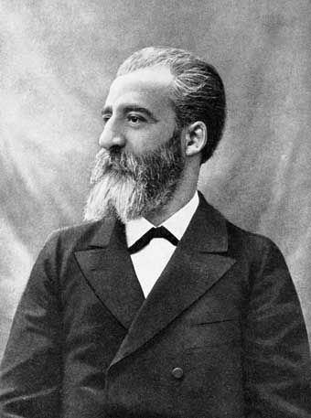
http://www.annales.org/archives/images/moissan.jpg

It was first reported in 1900 by Henri Moissan, the discoverer of fluorine. It is usually made by burning sulphur in an atmosphere of fluorine, though it can be prepared by pyrolysis of SF₅Cl (whose synthesis doers not require the use of elemental fluorine).

S + 3 F₂ → SF₆

The SF₆ has to be purified rigorously before use, to eliminate reactive fluorides; washing with a KOH spray removes S₂F₂, SO₂F₂, S₂F₂, and SF₄, followed by pyrolysis at 400 C, which converts S₂F₁₀ into a mixture of SF₄ and SF₆. This remaining SF₄ is removed with a KOH spray; the SF₆ is then dried and passed through charcoal to remove any trace impurities. The purity of the SF₆ is checked by exposing albino mice to a mixture of 21% oxygen and 79% SF₆ for 24 hours.

It is a colourless, tasteless, non-flammable, non-toxic and insoluble gas at room temperature. SF₆ is made of octahedrally shaped molecules, with a bond length of 1.561 Å (gas phase); SeF₆ and TeF₆ also exist, though these are more reactive. Other octahedral fluorides are known, but they all contain a metal, as in UF₆ and PtF₆. Like other covalent substances, there are strong covalent bonds within the molecules but only weak (Van der Waals') forces between molecules, so that it has a low boiling point and melting point (actually it sublimes, at -63.7°C). Nearly all the hexafluorides are very reactive; SF₆ is an exception.

So it really is very unreactive?
SF₆ can be heated to 500°C without any decomposition and it does not react with high-pressure steam either. It does not attack glass, even up to its softening temperature; metals like magnesium and copper do not react, even at red heat, and it does not attack molten sodium, though it does react with boiling sodium to form Na₂S and NaF. Phosphorus and arsenic distil unchanged in SF₆ vapour.

Its unreactivity is probably due to a combination of factors. Because fluorine forms strong covalent bonds, the S-F bonds have high bond energies and are difficult to break. Because there are so many fluorine atoms surrounding the sulphur atom, it is well shielded from attacking molecules too. It is likely that it simply reacts extremely slowly owing to high activation energies for its reactions, as hydrolysis is energetically extremely favourable.

SF₆(g) + 6 H₂O (g) → SO₃ (g) + 6 HF (g) ΔG^{θ} = -301.2 kJ mol⁻¹

In 2000, scientists reported the discovery of an even more potent gas in the stratosphere, SF₅CF₃. No one knows how it is formed from SF₆ – people have tried to make it in corona discharges, unsuccessfully - but it was also detected at a concentration of 0.1 parts per trillion in Antarctic snow.

So why does SF₆ get into the atmosphere?
SF₆ has found some specialist applications because of its unreactivity and lack of toxicity, and some of it escapes.

So what is it used for?
It is an extremely good electrical insulator, much better than air, so it is widely used in the electric power industry as an insulating gas in electrical transmission and distribution equipment, such as circuit breakers and switchgear. Leaks occur rarely, but they can happen when the stations are damaged or simply old. No alternative is yet available.

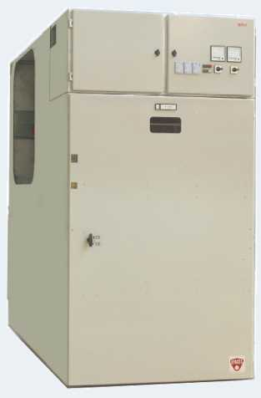

http://www.amt.efacec.pt/images/qbn7/qbn7.jpg
(lots of other images, maybe better, just Google images for SF₆)

It has also been used in the manufacture, casting and degassing of molten aluminium and magnesium; because it is so unreactive, it forms a dense blanket that keeps atmospheric oxygen and nitrogen away from the hot metals during processes like diecasting (these very reactive metals even react with nitrogen when hot).

http://www.climatetechnology.gov/images/cctp-brochure-images360pix/thumbnails/LadleCase.jpg
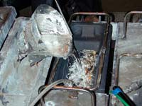

If air containing SF₆ is inhaled, the pitch of the person’s voice is lowered, as it is a large, heavy, molecule, which reduces the velocity of sound waves, the converse of the better-known phenomenon with helium. Since the 1970s, SF₆ has been used in double-glazed windows to improve sound insulation, due to the reduced velocity of sound. It is, however, no good for thermal insulation.

A rubber balloon filled with SF₆ will expand and ultimately burst, as the smaller and faster-moving O₂ and N₂ molecules diffuse through the rubber skin into the balloon very much faster than SF₆ can diffuse out.
SF₆ has been used to inflate car tyres, and Nike employed SF₆ for air cushioning its Air Max shoes from 1978 onwards, as the use of this large molecule minimised leaks from the air cushions in the heel. Though the greenhouse potential of SF₆ was recognised in 1992, it took them nearly 14 years to solve the problem; in the end, Nike used 65 layers of plastic to reduce nitrogen loss, and employed blow moulding to produce the desired product, the SF₆-free AirMax 360.

Most of these uses are now being phased out in Europe.

Lots of pictures, e.g. http://www.shoeimages.com/images/news/2006/01/stry_full_nike_am360m.jpg

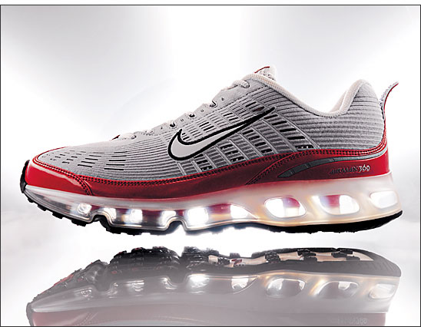

SF₆ concentrations in the ppb and even ppt range can be measured by IR spectroscopy and gas chromatography, and because of this - and also its unreactivity - SF₆ has come into fashion as an environmental tracer. Thus SF₆ has been suggested as a tracer for underground water leaks and burst water pipes; similarly, it was used in tests at St John’s Wood Underground station in North London on March 25th 2007 when its dispersion was monitored to show how a nerve gas might spread during a terrorist attack.

http://upload.wikimedia.org/wikipedia/commons/f/ff/StJohnsWood.jpg

(or www.greggayden.com/europe05/St%20Johns%20Wood.jpg )

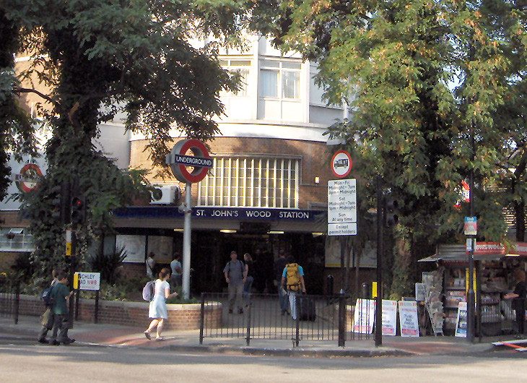

Bibliography:-

H. Moissan and P.Lebeau, Comptes Rendus, 1900, 130, 865, 984; Ann. Chim. Phys., 1902, 26, 145 (synthesis).
J.E. Macintyre (ed), Dictionary of Inorganic Compounds, Chapman and Hall, London, 1992, entry IC-018671.
Kirk-Othmer Encyclopedia of Chemical Technology, 4th edition , 1997, John Wiley & Sons, Vol 11, pp 428-435 (review)
Ullman’s Encyclopedia of Industrial Chemistry, Wiley-VCH, 6th edition, 2003, Vol 14, pp 428-429.
G. W. Rayner-Canham and A. Hewlin, SF₆: The most potent greenhouse gas, Education in Chemistry, 2000 (3), 69-70.
A. G. Massey, Main Group Chemistry, Ellis Horwood, Chichester, 1990, pp 313, 336-7.
R. J. Gillespie and I. Hargittai, The VSEPR Model of Molecular Geometry, Allyn and Bacon, Boston, 1991, pp.144-145
L. S. Bartell and S. K. Doun, J. Mol. Struct., 1978, 43, 245. (gas-phase electron-diffraction)
B. M .Powell, M. T. Dove, G. S. Pawley and L. S. Bartell, Mol. Phys., 1987, 62, 1127-1141 (powder diffraction) http://www.esc.cam.ac.uk/astaff/dove/publications/MolP_SF6_1987.pdf

Vibrational spectrum
R. S. McDowell, C. W. Patterson and W. G. Harter, Los Alamos Science, 1984, 4, pp 38-64
http://library.lanl.gov/cgi-bin/getfile?04-03.pdf

SF₅CF₃
W. T. Sturges, T. J. Wallington, M. D. Hurley, K. P. Shine, K. Sihra, A. Engel, D. E. Oram, S. A. Penkett, R. Mulvaney, and C. A. M. Brenninkmeijer, Science, 2000, 289, 611.
http://www.abc.net.au/science/news/stories/2000/157654.htm
W. Carrier, C. S. Jamieson, and R. I. Kaiser, Inorg. Chem., 2007, 46, 1332 (formation in irradiated ice)

Water leak detection
http://www.scienco.com/news1a.htm
The Use of Sulphur Hexafluoride as a Conservative Tracer in Saturated Sandy Media.
R. D. Wilson and D. M. Mackay Ground Water, 1993, 31, 719

Nike shoes
http://en.wikipedia.org/wiki/Air_Max
J.Environ. Monit., 2002, 4, 39N (sic)
BusinessWeek magazine, 25 September 2006 ; http://www.businessweek.com/magazine/content/06_39/b4002108.htm

Controlling emissions
http://www.epa.gov/electricpower-sf6/pdf/nov06/UtilityIV/Ottinger_2.pdf
http://helpdesk.ebid.net/archive/index.php/t-92470.html
http://www.epa.gov/highgwp/electricpower-sf6/pdf/dec04/horrocks-paper.pdf

