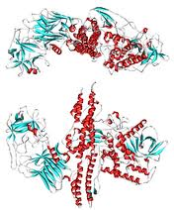
BOTULINUM TOXIN

Introduction
Botulinum toxin is the most powerful neurotoxin known up to now. Only one single molecule of it is needed to stop one neuron working. This makes the lethal dosis for a mouse 1,2ng (nanograms, 1/1.000.000.000 of a gram). This is why it is so dangerous.
Its chemical formula is C₆₇₆₀ H₁₀₄₄₇ N₁₇₄₃ O₂₀₁₀ S₃₂, nearly 21000 atoms, as it is a protein this number of atoms is normal. It consists on 1,300 Amino acids in sequence.
It is created by bacteria called Clostridium botulinum (Bacteria Kingdom, Firmicute Phylum, Clostridia class, Clostridiales order, Clostridiaceae family) it has 2 main subspecies; Clostridium botulinum A and Clostridium botulinum F. Also, 3 more bacteria are able to produce it: C. butyricum, C. baratii and C. argentinense.
The toxin has 7 different types named A to G. Most have several subtypes also.

Illness
BTX (Botulinum Toxin) causes Botulism, a serious illness which begins by causing the paralysis of the face´s muscles and then the paralysis of most of the body, even breathing muscles; this is why it is considered an emergency. The bacteria and the toxin can be killed with high pressures or high temperatures (>85°C), like cooking the food; food is a common way of intoxication.
There have been many deaths due to intoxication by food, like Mr. Caffrey in September 9, 2007, who suffered for more than one month because of BTX in a bottle of chilly (he ended up blind and could only move one finger).
The bacteria produce BTX by anaerobic respiration, so it usually lives in canned food containers; there is no O₂ there, so it is perfect for the bacteria.
There is an antitoxin for BTX, but it has to be used very quickly after the bacteria are eaten or breathed in, or it won´t be able to save the person.
The pigs and carnivores are more resistant to the illness than the herbivores, mainly in birds, mammals and fish.
The toxin inhibits acetylcholine (a neurotransmitter that makes muscles contract) release in the unions between neurons and muscles by preventing the Synaptic Vesicle which carries the acetylcholine from fusing with the Synaptic Cleft. This place contains the receptors where the neurotransmitters should go. As the acetylcholine doesn´t reach the receptors the muscles don´t receive instructions and, therefore don´t contract. Depending on the way the toxin works it is classified into each type:

- Breaks the ‘SNAP-25’
- Breaks the Synaptobrevin
- Breaks the ‘SNAP-25’ and the syntaxin
- Breaks the Synaptobrevin
- Breaks the ‘SNAP-25’
- Breaks the Synaptobrevin
- Breaks the Synaptobrevin
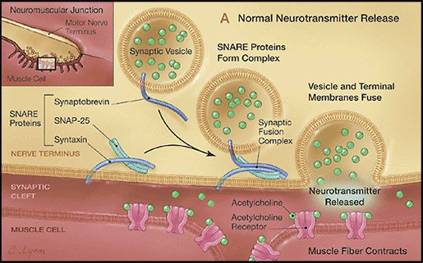
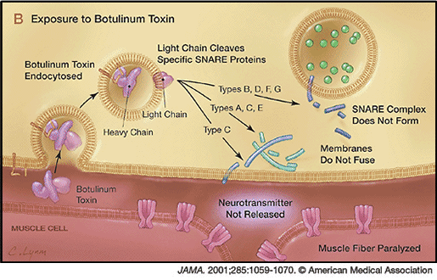

All of the 3 SNARE proteins are necessary for the formation of the Synaptic Fusion Complex. If the Fusion Complex isn’t formed, the membrane of the Synaptic Vesicle won´t be able to fuse with the Synaptic Cleft, therefore, the acetylcholine won´t be released.
The main effects of botulism are:

- Blurred vision
- Drooping eyelids
- Slurred speech
- Muscle weakness
- Difficulty swallowing
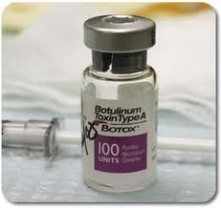
- Double vision
- Dry mouth

Beneficial uses

It was first used for medical purposes in 1981, to treat strabismus (Crossed eyes).
It is also used as a treatment for achalasia; it works well in about 65% of the treated people. These are the medical uses, but it also has cosmetic uses.
The toxin is commonly known as Botox (OnabotulinumtoxinA). Botox has some BTX, but in extremely small quantities; otherwise, most of the users of Botox would be dead. Botox is mainly used to relax the muscles that cause wrinkles so the wrinkles disappear.
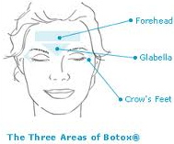
It is used to treat many other conditions, such as:
- Blepharospasm (excessive blinking)
- Hyperhidrosis (excessive sweating)
- Migraine

Harmful effects
There are only 7 companies with permission to manufacture BTX for medical uses, and many more companies which can produce it for labs and for schools (for research). But there are even more which produce it illegally; they don´t have quality control, so they are able to produce the toxin with too high concentration. The products produced with this BTX are poisonous and they can kill the customers. The illegal BTX can also have too weak concentrations, therefore it won´t have any effect.
There is an even worse use for the toxin, terrorism. On March 20th, 1995, the Japanese new religious movement Aum Shinrikyo (Supreme Truth) attacked the Tokyo subways with Sarin gas, a toxin which isn´t as powerful as BTX, but the attack failed, however 13 people were killed and more than 6000 were injured (50 severe). Most of the main perpetrators were sentenced to death or to life imprisonment. If all those people were affected using Sarin gas, imagine the number of deaths with BTX. However, the toxin, up to now, can only have effect in closed places, as the wind can mix it with the air easily, reducing the effectiveness a lot. This is the main reason why terrorist attacks with BTX probably won´t be done. But the illegal BTX still gives terrorist groups an easy and cheap way of killing people, for example, by diluting it in a city water supply.
It is the most powerful toxin known up to know, as the table shows the amount required to kill a person is extremely low.
Substance | LD₅₀, mg/kg*
Ethanol | 10000
Sodium chloride | 4000
Iron sulfate | 1500
Morphine | 900
Phenobarbital sodium | 150
Picrotoxin | 5
Strychnin sulphate | 2
Nicotine | 1
d-Turbocuranine | 0,5
Hemicholinium | 0,2
Tetrodotoxin | 0,1
Dioxin (TCDD) | 0,001
Botulinum toxin | 0,00001
*LD₅₀ (abbreviation for “Lethal Dose, 50%) is the dose required to kill half of the tested population after certain time.
This makes it an extremely deadly weapon, as 1 gram can kill between 14000 and 8300000 people, depending on the way it is dispersed:

History
- Justius Kerner named it “fatty poison” because C. botulinum is usually found in meat products which are not handled correctly.
- Kerner (physician) was the first person to conceive a medical use for the toxin.
- The name ‘botulism’ was created (form the Latin botulus, this means sausage)
- In 1897, Emile van Ermengem discovered that the bacteria C. botulinum was the producer of BTX.
- In 1928, P. Tessmer Snipe and Hermann Sommer purified the toxin.
- In 1949, Arnold Burgen's group how BTX blocks acetylcholine release.
- In the late 1960s Alan Scott (an ophthalmologist in San Francisco), and Edward Schantz worked on BTX for medical uses.
- By 1973, Alan Scott (at Smith-Kettlewell Institute) used BTX type A in experiments using monkeys
- In 1980, he used BTX-A to treat strabismus and blepharospasm in humans.
- In 1993, Pasricha and colleagues used BTX to treat achalasia, a spasm of the lower esophageal sphincter.
- In 1994 Bushara showed for the first time a non-muscular use for BTX injections, to reduce excessive sweating in humans.
- The first use for Botox (made by Allergan, Inc. one of the legal producers) which was approved by the U.S. Food and Drug Administration (FDA) was to treat of strabismus, blepharospasm, and hemifacial spasm in people older than 12.

Sources of information
- ‘INVESTIGACIÓN Y CIENCIA’ August 2010
- http://en.wikipedia.org/wiki/Botulinum_toxin
- ‘Fundamentos de toxicología’ Curtis D. Klaassen, John B. Watkins
- ‘Enciclopedia Larousse’
- ‘Muscle and Nerve’ Mitchell F. Brin
- http://www.sciencedirect.com/science/article/pii/S0016508596002119
- http://www.chm.bris.ac.uk/webprojects2002/thomas/botulinum%20toxins.htm
- http://www.wemove.org/Glossary/
- http://en.wikipedia.org/wiki/Sarin_gas_attack_on_the_Tokyo_subway

