METHANE

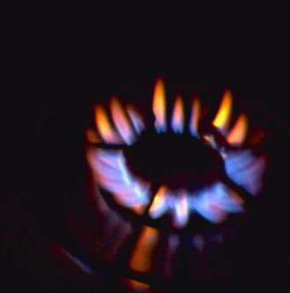

http://graphitefurnace.blogs.com/main/lo_ring_of_fire_methane.jpg

(or better alternative!)

Selfish molecule?
It’s Methane, not Me-thane. It is the smallest hydrocarbon and the lightest stable organic molecule. A methane molecule has a regular tetrahedral structure (T_{d} symmetry), its H-C-H angles are all 109 ½ °.

It is not very soluble in water, on account of its non-polar nature. It is a colourless, odourless gas at room temperature (m.p. 90K, b.p. 109K) and is less dense than air

If it is odourless, how come I can smell it when I turn the gas on?
Because methane is odourless, natural gas supplied for domestic use has a trace of an obnoxious organic sulphur compound such as Me₃CSH or Me–S–Me added for ease of detecting any leak.

And it’s a fuel, right?
The combustion of methane is a very exothermic reaction ( ΔH = –891 kJ/mol ) and on that account methane is widely used as a fuel, not least because the volatile and non-toxic products make it “clean”, though one product is a “greenhouse gas”.

CH₄ (g) + 2 O₂ (g) → CO₂ (g) + 2 H₂O (g)

Incomplete combustion yields carbon (soot) or toxic carbon monoxide.

Methane is the main component of “Natural gas”, which contains between 70 and 95% methane, often over 90%. This can be purified to remove other low-boiling components like noble gases and slightly larger alkanes, then condensed c. -160 °C as liquefied natural gas (LNG). This is a much more compact way of storing methane, and when pipelines are not available, it can be transported in cryogenic tankers by sea or road.

So North Sea Gas is largely methane
Indeed. North Sea Oil (and gas) was discovered in the early 1960s, with first supplies being piped ashore in the UK in 1975. The resource is shared between the UK, Norway, Denmark, Germany and the Netherlands, mainly the first two. Production peaked in 1999. This enabled the UK to become – briefly - an exporter of energy and also enabled the Conservative Government of the 1980s and early 1990s to move away from dependence upon coal-fired power stations towards the use of gas as a fuel (the “Dash for Gas”). The UK is now a net importer, looking to obtain supplies from sources including Russia.

Suitable picture of a platform burning off methane, though hopefully less grainy than this …
http://www.bgs.ac.uk/mineralsuk/industry/Images/jun_oil_rig.jpg

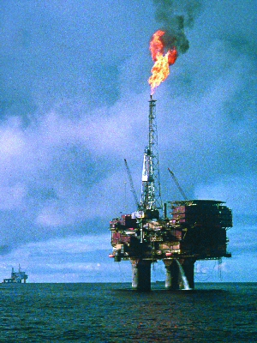

So is it any use apart from that?
Its reaction with steam in the presence of a hot nickel catalyst affords the mixture of CO and H₂ known as “synthesis gas”, widely used to make chemicals such as hydrogen, methanol and ethanoic acid, for example.

CH₄ (g) + H₂O (g) → CO (g) + 3H₂ (g)

How’s it formed?
Billions of years ago, volcanic activity was responsible for large amounts of methane in the Earth’s atmosphere; subsequently the first primitive bacteria synthesised methane from CO₂ and hydrogen, and methane levels did not fall until the arrival of the first organisms to photosynthesise, which generated oxygen. The concentration of methane in the Earth’s atmosphere is quoted as 1.75 ppb in 1998.
Nowadays, the main source of methane is “Natural Gas”, which originates in the same way as crude oil, by the anaerobic decomposition of microscopic sea animals under the pressure of layers of silt and mud over a period of millions of years. This can also occur in swamps and marshes, when plant matter decays (“marsh gas”), and in landfill sites; in digesters breaking down sewage sludge; and by enteric fermentation in livestock (e.g. ruminants such as cattle and sheep).

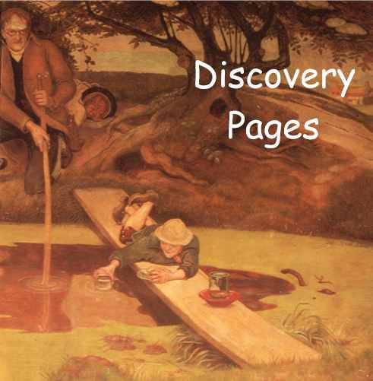
Can we maybe trim this?

Cannot find a better picture of Dalton collecting marsh gas than these – in Manchester Town Hall http://www.uasb.org/discover/discovery.htm
http://www.nature.com/nature/journal/v401/n6750/images/401217aa.eps.0.gif
(Manchester Town Hall, architect Alfred Waterhouse. The Ford Madox Brown Murals. Dalton Collecting Marsh-Fire Gas.)

It can be made in the laboratory by a variety of reactions, including the action of water and aluminium carbide (which contains discrete C⁴⁻ ions) :-

Al₄C₃ (s) + 12 H₂O (l) → 3 CH₄(g) + 4 Al(OH)₃ (s)

as well as by heating a mixture of solid sodium hydroxide with sodium ethanoate:-

CH₃COONa (s) + NaOH (s) → CH₄(g) + Na₂CO₃ (s)

And methane is a “greenhouse gas”?
Methane is classed as a greenhouse gas, and its Global Warming potential (GWP) calculated over a 100-year span is 22-23 times greater than that of CO₂. Because of this, there is concern about methane emissions from diverse natural sources, such as mud volcanoes and ruminants, together with the possibility of losses from methane hydrates, released as the oceans warm up. 1990 estimates put “Natural” methane emissions at around 155 million metric tons a year; at that time methane emissions from “man made” sources came to 350 million metric tons a year.

It has recently (2006) been suggested that trees and other green plants in aerobic environments are responsible for adding large amounts of methane to the earth’s atmosphere, but another group, using ¹³C-labelling to distinguish emissions from plants from ¹²CH₄ “background” in the atmosphere, has found no evidence for this.

How does it make flaming snowballs?
When they are under pressure, as under cold sediments at the bottom of oceans, methane molecules get locked up inside cavities within the structure of ice, forming what is known as known as methane clathrate (other alkane molecules are larger, and cannot fit into the cavities). This methane is largely formed by anaerobic bacterial breakdown of organic matter. Since methane clathrates have been estimated to store more energy than the total fossil fuel reserves of the whole world, there has been interest in harvesting this methane as an energy resource, but also concern at the prospect of oceanic warming liberating the methane causing rapid global warming.

Pictures
http://www.giss.nasa.gov/research/features/methane/
http://www.giss.nasa.gov/research/features/methane/hydrate.jpg
http://www.blog.speculist.com/archives/methanehydrate.jpg

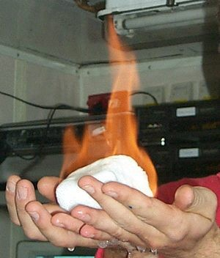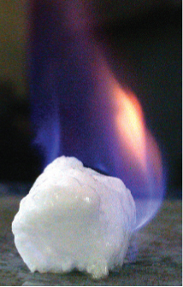

And it’s found on other planets?
There is evidence for methane being present in several planets in the solar system, particularly Mars and Titan, Saturn’s largest moon. Three groups of researchers have detected methane in spectroscopic studies of the atmosphere of Mars in 2003-4. Scientists debate whether it has a bacterial source, or if it originates in iron and magnesium containing silicate rocks, known to be capable of producing hydrogen, which could then react with carbon or its compounds forming methane.
In January 2005, the European Space Agency’s Huygens probe sampled the atmosphere of Titan by GC-MS, detecting methane, but this lacked the ¹²C enrichment associated with living organisms, making it likely that the methane originates from geological processes somewhere in the interior. There is also liquid methane on the cold (-180 °C) surface of Titan, and this has apparently carved river channels upon the surface.

What about cows and global warming?

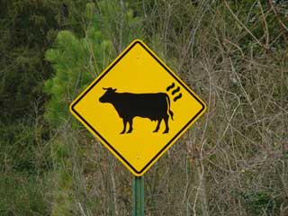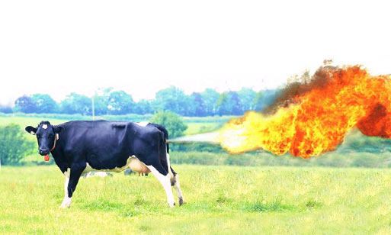

http://www.lot49.com/images/lot49/cowsign.jpg

Cows and other ruminants have methanogenic bacteria in their rumen which can turn digested carbon compounds into methane, emitted as flatus, some 200-300 litres of gas a day. Most of the flatus is nitrogen, but cases have been reported of cows’ flatus being ignited, though not explosively. It has been suggested that nearly half methane emissions come from agriculture, with livestock and cultivation of rice prime causes (60-80 million metric tons a year each). In New Zealand, where sheep and cows cause half the nation’s methane emissions, a “flatulence tax” has been suggested.

Paul – can we get away with this? (http://www.danamania.com/temp/cow-fire.jpg )

And the termites?
Termites use microorganisms – either protozoa or bacteria, depending upon the termite - in the gut to help digest plant material (cellulose). An individual termite produces around 0.5 micrograms of CH₄ per day; on scaling this up, world-wide emissions of up to 20 million metric tons a year from the “cathedral” nest mounds produced by the termite colonies have been estimated.

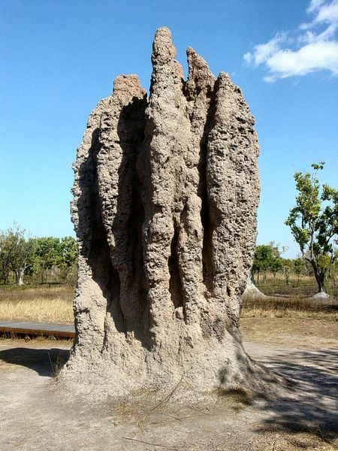

http://upload.wikimedia.org/wikipedia/commons/thumb/7/73/Termite_Cathedral_DSC03570.jpg/450px-Termite_Cathedral_DSC03570.jpg

Bibliography:-
C.Callow, Power from the Sea, Victor Gollancz, London, 1973 (North Sea Gas)
P.McGeer and E.Durbin, eds, Methane. Fuel for the Future, Plenum Press, New York and London, 1982
National Academy of Sciences, Methane Generation from Human, Animal, and Agricultural Wastes, Books for Business, New York, 2001.
J.Darley, High Noon for Natural Gas, Chelsea Green Publishing, Vermont, 2004.

http://en.wikipedia.org/wiki/Natural_gas
http://en.wikipedia.org/wiki/LNG
http://en.wikipedia.org/wiki/Methane
http://scifun.chem.wisc.edu/chemweek/METHANE/Methane.html

Methane Clathrates
E. Seuss, G. Bohrmann, J. Greinert and E. Lausch, “Flammable Ice”, Scientific American, November 1999, 52.
M.Max and W. Dillon, Chemistry and Industry, 10 January 2000, 16
http://marine.usgs.gov/fact-sheets/gas-hydrates/title.html
http://en.wikipedia.org/wiki/Methane_hydrate
http://www.pet.hw.ac.uk/research/hydrate/index.htm

Methane from plants
R. Van Noorden, Chemistry World, June 2007, 23.
F. Keppler and T. Röckmann, Scientific American, February 2007, 40. (Pro)
F. Keppler, J. T. G. Hamilton, M. Brass and T. Röckmann, Nature, 2006, 439,187. (Pro)
T. A. Dueck, R. de Visser, H. Poorter, S. Persijn, A. Gorissen, W. de Visser, A. Schapendonk, J. Verhagen, J. Snel, F. J. M. Harren, A. K. Y. Ngai, F. Verstappen, H. Bouwmeester, L. A. C. J. Voesenek and A. van der Werf, New Phytologist, 2007, 175, 29. (Con)

Planetary methane
S.K.Atreya, Scientific American, May 2007, 24.
http://en.wikipedia.org/wiki/Titan_(moon)
http://en.wikipedia.org/wiki/Atmosphere_of_Mars
http://www.spaceref.com/news/viewpr.html?pid=18410

Methane emissions
Global Climate Change and Environmental Stewardship by Ruminant Livestock Producers is a useful summary:- http://www.epa.gov/methane/pdfs/ffa.pdf

Cows and rice emissions
http://www.ghgonline.org/methanerice.htm
Y. Lu and R. Conrad, Science, 2005, 309, 985
C. Grainger, T. Clarke, S. M. McGinn, M. J. Auldis, K. A. Beauchemin, M. C. Hanna, G. C. Waghorn, H. Clark and R. J. Eckard, J. Dairy Sci., 2007. 90, 2755.
http://www.cmar.csiro.au/e-print/open/AtmosphereOct2000.pdf
http://education.arm.gov/outreach/publications/sgp/july01.pdf
http://news.bbc.co.uk/1/hi/world/asia-pacific/3066865.stm

Termites
P.R.Zimmerman, J.P.Greenberg, S.O.Wandiga and P.J.Crutzen, Science, 1982, 218, 563.
P.J.Fraser, R.A.Rasmussen, J.W.Creffield, J.R.French and M.A.K.Khalil,
J.Atmospheric Chemistry, 1986, 4, 295
http://www.epa.gov/ttn/chief/ap42/ch14/final/c14s02.pdf
http://en.wikipedia.org/wiki/Termite

Methane monooxygenase
Although methane is pretty unreactive, there exists bacteria capable of oxidising it, known as Methane monooxygenase (MMO). Such bacteria can be found at bacteria that exist at the interface of aerobic and anaerobic environments. Insoluble MMO is copper-based, having both mononuclear and copper-cluster sites, whilst soluble MMO is dinuclear, involving carboxylate bridges.

A. C. Rosenzweig, C.A. Frederick, S. J. Lippard and R.Norlund , Nature, 1993, 366, 537.
K. J. Walters, G. T. Gassner, S. J. Lippard, and G. Wagner, Proc. Nat. Acad. Sci., 1999, 96, 7877
J.C.Murrell, B.Gilbert and I.C.McDonald, Arch Microbiol., 2000, 173, 325.
R. L. Lieberman, D. B. Shrestha, P. E. Doan, B. M. Hoffman, T. L. Stemmler , and A. C. Rosenzweig, Proc. Nat. Acad. Sci., 2003, 100, 3820
http://en.wikipedia.org/wiki/Methane_monooxygenase

