BATRACHOTOXIN
Or, Just touch me and you’re dead.

Inner city gang violence ?
No, a frog in a tropical rainforest.

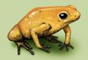
http://animaldiversity.ummz.umich.edu/site/resources/Grzimek_herps/Dendrobatidae/Phyllobates_terribilis.jpg/view.html (permission needed)
Explain, please.
When touched or threatened, tiny poisonous frogs in the jungles of Western Colombia produce venom from glands on their backs and from behind their ears. Native Indians have used this venom for hundreds of years to poison blow darts.

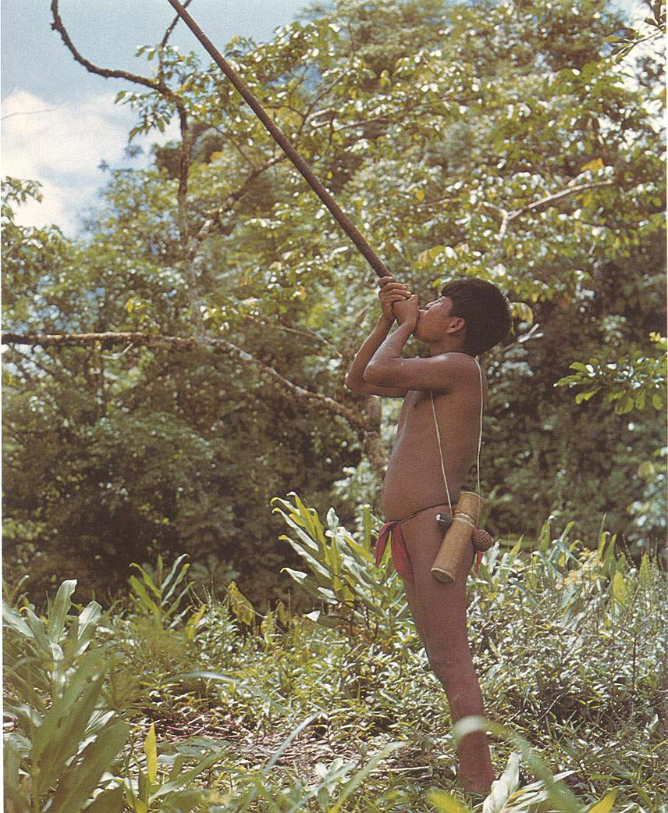

An Emberá Chocó of Colombia hunting with batrachotoxin-tipped darts from a blowpipe.
http://chemweb.calpoly.edu/chem/bailey/377/PapersF2000/Caroline/index.html

Handling one of these frogs could kill you, if the toxin were able to enter through a cut in your skin.

If the frogs are so dangerous, how do the Indians get the venom ?
It’s said that they stick the frogs on a piece of wood, then hold the frog over a fire. The toxin is “sweated out” and collected.

What is the toxin ?
It was discovered in the 1960s that these frogs- golden Phyllobates terribilis and multicoloured Phyllobates bicolor - contain substances such as batrachotoxin and homobatrachotoxin. They are among the most toxic substances known, more toxic than curare or the tetrodotoxin, used by the puffer fish (itself over 1000 times more poisonous than cyanide). Other frogs use different poisons, but none as toxic as batrachotoxin.

Where does the name batrachotoxin come from?
It’s made up of two Greek words; βάτραχος is frog in Greek, whilst the word for toxin is τοξίνη.

How poisonous is it ?
Around 136 μg (micrograms) is the lethal dose for a person weighing 150 pounds; that is, about two grains of table salt. On average one frog packs 1100 μg of batrachotoxin.

How big are the frogs ?
Small but deadly, at most a couple of inches long, and weighing a few grams.

How does the toxin work ?
The batrachotoxin increases the permeability of the outer membrane of nerve and muscle cells to sodium ions. Thus it stops these channels within muscle fibres from closing normally, allowing a big inflow of sodium ions into the cell. This causes an irreversible electrical depolarisation, blocking the nerve signals that would normally cause the muscle to relax, so the muscle remaining contracted. Certain cells within the heart are very sensitive to this, resulting in heart arrythmias, fibrillation and ultimately cardiac failure.

Why are the frogs immune to their poison ?
It seems that they have a modified sodium channel protein in their nerves and muscles, so the batrachotoxin cannot bind to a receptor.

Do the frogs make the poison themselves ?
Captive-born Phyllobates terribilis don’t have batrachotoxins in their skins; if poison frogs are caught in the wild, the amount of toxin in their skin often diminishes with keeping. This suggests a dietary origin for the toxin.
In 1989, an American ornithologist called Jack Dumbacher was doing his graduate studies in Papua New Guinea. One day, he was freeing a Pitohui bird (a native songbird about the size of a jay) from a net, when his hand was bitten and scratched by the bird. Instinctively he put his hand in his mouth and found it tingled and started to go numb. Intrigued by this, he eventually passed samples of the plumage to John W.Daly, the world expert of the chemistry of the substances secreted by poison dart frogs, who identified the presence of batrachotoxin. The natives of New Guinea have long known that these birds were inedible. More recently, batrachotoxins have been found in the feathers of another New Guinea bird, Ifrita kowaldi)

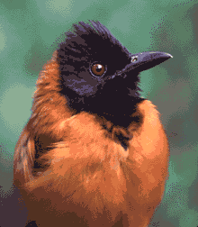

Image Credit: Photograph of Hooded Pitohui, Jack Dumbacher. Courtesy of the Smithsonian National Museum of Natural History.
http://www.sciencecases.org/badfish/badfish_anatphys2.asp
http://www.sciencenews.org/articles/20041106/fob3.asp

So what’s the link?
In 2004, it was reported that Melyrid beetles (Choresine), known to contain large amounts of batrachotoxin, were found in the stomach of Pitohui birds in New Guinea. These beetles are also found in Colombia, so they may form part of the diet of both the birds and the frogs.

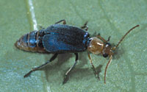

(PHOTO BY JOHN P. DUMBACHER)

Whether the beetles make the batrachotoxin themselves or obtain it from their diet is not at present known. It would be unusual for a beetle to synthesise steroid molecules like batrachotoxin; it may be that the beetles get it from small arthropods it eats, or maybe from plants.
However, it looks as if some frogs make their own alkaloids; Australian myobatrachid frogs of the genus Pseudophryne contain two types of alkaloids in their skin extracts, pseudophrynamines (PSs) and pumiliotoxins (PTXs). It seems that they biosynthesise the PSs (which are only found in these frogs), but get the PTXs from their diet (formicine ants).

What good is batrachotoxin ?
Pretty essential, if you are a frog that doesn’t want to be eaten by a predator; some snakes are resistant (but not immune) to the batrachotoxin though. Scientists are using these molecules to study the way in which nervous impulses are transmitted in animals. They are being studied for possible applications in areas like heart drugs and anaesthetics.

And what’s the chemical importance of these compounds?
These poisonous frogs use a very wide range of substances of hitherto undreamed-of structures as venoms. Goodness knows what other amazing chemicals lie in wait in the rainforests, each a potential medicine. If that isn’t a good argument for conservation, I don’t know what is.

Bibliography
E.X.Albuquerque, J.W.Daly and B.Witkop, Science, 1971, 172, 995 (Batrachotoxin)

Alkaloids in Amphibian skin
J.W.Daly, Proc Natl Acad Sci U S A, 1995, 92, 9
J.W.Daly, Pure Appl. Chem., 1998, 70, 2132.
J.W.Daly, J.Nat.Prod., 1998, 61, 162

Dietary Specialization and Chemical Defense in Poison Frogs.
C.R.Darst, P.A.Menéndez-Guerrero, L.A.Coloma, and D.C.Cannatella, American Naturalist, 2005, 165, 56.

Batrachotoxin alkaloids in birds
J.P.Dumbacher, B.M.Beehler, T.F.Spande, H.M.Garraffo, and J.W.Daly, Science, 1992, 258: 799-801.
J. P. Dumbacher, T. F. Spande, and J. W. Daly, Proc Natl Acad Sci U S A, 2000, 97, 12970
P.J.Weldon, Proc Natl Acad Sci U S A, 2000, 97, 12948

Beetles as a source of batrachotoxin
J.P.Dumbacher, A.Wako, S.R.Derrickson, A.Samuelson, T.F.Spande, and J.W.Daly, Proc Natl Acad Sci U S A, 2004, 101, 15857

Pumiliotoxins and their source
S.Q.Smith and T.H.Jones, Proc Natl Acad Sci U S A,. 2004, 101, 7841
B.P.Smith, M.J.Tyler, T.Kaneko, H.M.Garraffo, T.F.Spande, and J.W.Daly, J.Nat.Prod., 2002, 65, 439
R.A.Saporito, H.M.Garraffo, M.A.Donnelly, A.L.Edwards, J.T.Longino, and J.W.Daly, Proc Natl Acad Sci U S A., 2004, 101, 8045

Batrachotoxin and the voltage-gated sodium channel
N.J.Linford, A.R.Cantrell, Y.Qu, T.Scheuer, and W.A.Catterall , Proc Natl Acad Sci U S A, 1998, 95, 13947

S.Cestèle and W.A.Catterall, Biochimie, 2000, 82, 883.

Web links

Frog toxins.
http://www.chm.bris.ac.uk/motm/htx/htx_h.htm (Histrionicotoxin)
http://www.phc.vcu.edu/Feature/oldfeature/epi/ (Epibatidine)
http://wwwchem.csustan.edu/chem4400/sjbr/strong98.htm (Epibatidine)

Poison dart frog links

Animal Diversity web: Phyllobates terribilis. Has more links….
http://animaldiversity.ummz.umich.edu/site/accounts/information/Phyllobates_terribilis.html

http://waynesword.palomar.edu/dartfrog.htm
http://members.tripod.com/Dendrobates/index.html
http://www.bio.davidson.edu/Courses/anphys/2000/Todd/toxintype.htm
http://library.thinkquest.org/C007974/2_2poi.htm
http://www.cobras.org/article2.htm

