Glucose

Monosaccharide

Glucose is a simple carbohydrate. It is a monosaccharide sugar with the molecular formula C₆H₁₂O₆. Sugars like glucose with six carbon atoms are referred to as hexoses.
Respiration is a controlled oxidation of glucose that takes place in living cells and releases energy. Glucose is an important intermediate in the respiration of food to release energy, shown simply by the equation.

Glucose + oxygen → carbon dioxide + water

C₆H₁₂O₆ + 6 O₂ → 6 CO₂ + 6 H₂O

The above equation is a gross simplification of Glycolysis a complex metabolic pathway involving oxidation of glucose.

Water-soluble

The reason glucose dissolves readily in water is because it has lots of polar hydroxyl groups which can hydrogen bond with water molecules. Hydrogen bonds are very important intermolecular forces which determine the shape of molecules like DNA, proteins and cellulose.

Testing for Glucose in the Laboratory

Chemists have devised many qualitative tests for inorganic and organic substances. A simple test for the organic glucose is the use of Benedict’s reagent [an aqueous solution of Na₂CO₃, CuSO₄ and sodium citrate]. It is often used as the test for a reducing sugar. Blue Benedict’s solution contains the copper(II) ion, Cu²⁺ which is reduced by the sugar to the red copper(I) ion, Cu¹⁺. The Benedict’s test is visually a very interesting experiment to do as you see colour changes ranging from blue to green to yellow to orange and then finally to red. A similar qualitative/quantitative test for the aldehyde group found in sugars is Fehling’s solution [alkaline {NaOH} solution of CuSO₄ and 2,3-dihydroxy- butanedioate]. The red colour which forms on reaction of Fehling’s solution with glucose is copper(I) oxide, Cu₂O.

Testing for Glucose in the Blood
Diabetics cannot regulate their blood sugar levels because of failure of their pancreas to produce sufficient insulin. The blood sugar level is the amount of glucose (sugar) in the blood, expressed as millimoles per litre (mmol/l). Blood glucose levels should have a range of 4-8 mmol/l. Therefore testing for blood glucose levels is an important daily routine for diabetics. Diabetics need to control blood sugar levels to avoid developing various diseases; retinopathy (eye disease), nephropathy (kidney disease), neuropathy (nerve disease), cardiovascular disease, such as heart attack, hypertension, heart failure, stroke and problems caused by poor circulation, e.g. gangrene. Fortunately scientists have developed home blood testing kits which are easy to use, not at all painful, and quickly [about 30 seconds] and accurately measure blood glucose levels. These kits are simple to use and consist of a measuring device and a strip as shown below.
Blood is placed onto the strip | Blood sugar meter
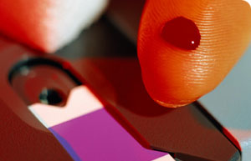 | 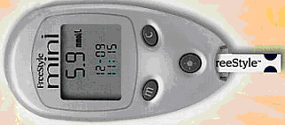

Glucose is an aldehyde (CHO)

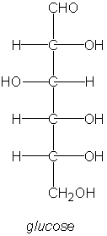 | Chemically glucose in its chain form can be thought of as an aldehyde [aldohexose]. It has the structural formula CH₂OH(CHOH)₄CHO. It is possible to oxidise the aldehyde group (CHO) into a carboxylic acid group (COOH) using Tollen’s reagent. Tollen’s reagent is essentially ammoniacal silver nitrate [Ag(NH₃)₂]⁺. Tollen’s reagent is reduced to elemental silver by the ‘reducing’ sugar glucose.

C. Thompson’s Silver Mirror  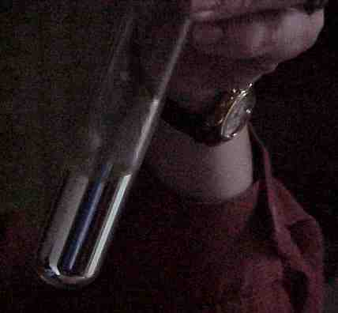  ppt = precipitate | Tollen’s Reagent Prep.  Put 2cm³ of AgNO₃ (aq) into a test tube. Add 1 drop of dil. NaOH (aq). A brown ppt of Ag₂O is observed. Add sufficient dil. NH₃ (aq) dropwise until all the ppt just dissolves. Often about 10 drops. CARE is needed to destroy all the Tollen’s reagent within 20 mins as explosions have been known to occur.

Sources of sugar

Table sugar is not glucose but the disaccharide sucrose formed from the condensation of the monosaccharide glucose and fructose. The reverse reaction, namely hydrolysis of sucrose, will yield both glucose and fructose. This chemical reaction is achieved by honeybees which use invertase enzymes.
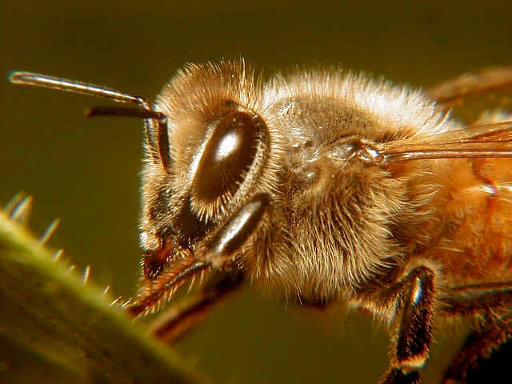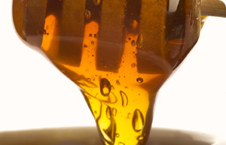

Sucrose has the molecular formula C₁₂H₂₂O₁₁

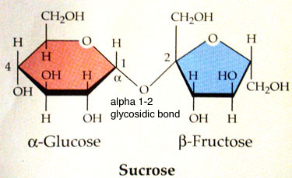

Sucrose is extracted from several plant sources, the most important being sugarcane and sugar beets. Sugar in these plants is often 12%–20% of the plant's dry weight. Sugar cane is one of the most efficient photosynthesisers in the plant kingdom, able to convert as much as 2% of incident solar energy into biomass. Average yield is 10 tons of sugar per hectare. The root of sugar beet contains a high concentration of sucrose.

Sugar Cane | Sugar Beet
 | 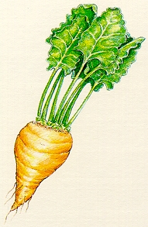

Energy tablets and drinks

Glucose is an immediate source of energy for the body. It is marketed as dextrose and is found in so called energy drinks and energy tablets. There are two ring forms of glucose and the natural form is the D form dextrose which is 70% as sweet as sucrose. | 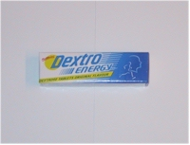

Fun Experiment with glucose

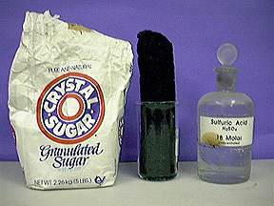
It is relatively straight forward to take away the water from glucose by dehydrating it with concentrated Sulphuric acid in a fume cupboard. This dehydration of glucose works best if a small amount of water is first added to the glucose and then the c. H₂SO₄ is quickly stirred in with a glass rod.

C₆H₁₂O₆ → 6C + 12 H₂O

Sugar in Songs

A spoonful of Sugar by R.M. & R.B. Sherman
That a …  Spoonful of sugar helps the medicine go down  The medicine go down-wown The medicine go down  made famous by Julie Andrews  in the musical Mary Poppins | 

Sugar in Nursery Rhymes

What are Little Boys made of?
What are little boys made of?  Snips and snails, and puppy dogs tails  That's what little boys are made of !"  What are little girls made of?  "Sugar and spice and all things nice  That's what little girls are made of!" | 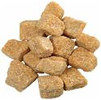  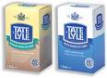

Glucose to help detect cancers

It is possible to use simple molecules like glucose use to detect cancers. The technique which allows this to be done is called PET which stands for Positron Emission Tomography. It is a medical imaging technique where radioactive glucose is injected into a vein. It is quite straightforward for synthetic chemists to replace oxygen atom(s) on glucose molecules with oxygen-18. Physicians can track glucose molecules in the body and see where they are being used up. Cancerous tissues have a higher metabolic rate than normal tissues so require more energy and therefore use up more glucose. A PET scan will highlight cancerous tissue as a bright area on a PET image.

Polymers of glucose

Starch and glycogen are polymers of glucose where alpha-glucose monomers are joined together. Their different structures give them different properties. Glucose is made from starch by hydrolysis with mineral acids, purification and crystallisation. Glucose obtained this way is widely used in confectionary and other food industries. Another glucose polymer is cellulose is the structural material of plant cell walls formed when beta-glucose monomers join together.

Glycogen [each hexagon represents a glucose monomer]

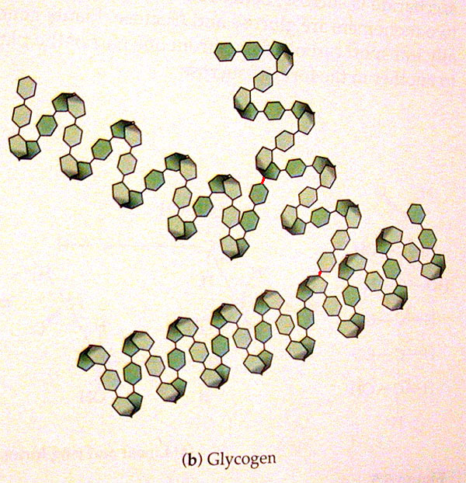

Cellulose
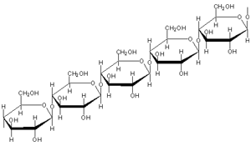 | 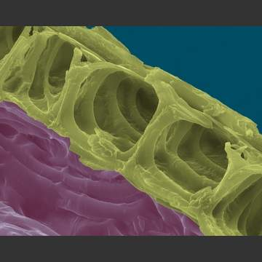cellulose cell wall

Fermentation

Fermentation is thought to be one of the oldest known chemical reactions. Zymase in yeast converts glucose in fruits into ethanol and carbon dioxide. This reaction has been exploited for millennia to make Western style bread and alcoholic beverages. Alcohol is an important source of energy in places where poor diets are common place.

Glucose → ethanol + carbon dioxide

C₆H₁₂O₆ → 2 C₂H₅OH + 2 CO₂

Chain and Ring forms of Glucose

The 1937 Nobel Prize in chemistry was awarded to the sugar chemist Haworth [Birmingham University] for his important work on carbohydrates. Howarth et al found that sugars have a ring-like [Howarth formulae], rather than just a straight-line, arrangement of their carbon atoms. Both forms shown below can exist in equilibrium.

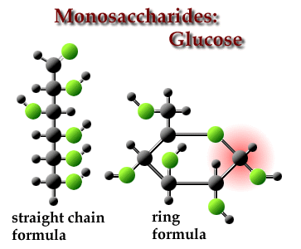 | 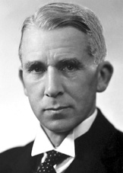  Haworth

In 1888 one of the world’s most important chemists, Emil Fischer discovered the three sugars, glucose, fructose and mannose. By 1890 he was the first chemist to synthesize all three sugars starting from glycerol. He was awarded the 1902 Nobel prize in Chemistry.

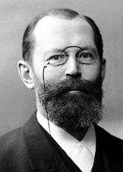  Fischer | Fischer confirmed the van’t Hoff theory, namely the theory of the asymmetric carbon atom. A-level students will be familiar with the concept of a chiral {asymmetric} carbon atom often indicated with an asterisk. Chiral carbons have four different groups bonded to them. It is quite remarkable that he also correctly predicted the 3D arrangements of glucose with its several chiral carbons.

