HYDROGEN PEROXIDE POSTERS

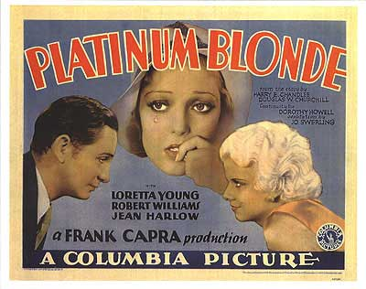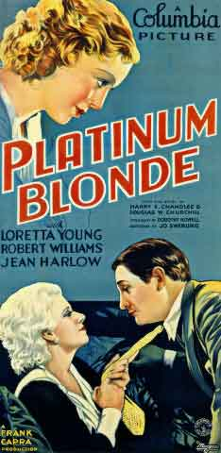

http://eu.movieposter.com/poster/MPW-15977/Platinum_Blonde.html

http://harlow.teamviola.com/

Jean Harlow
http://en.wikipedia.org/wiki/Jean_Harlow

http://en.wikipedia.org/wiki/Jean_Harlow

http://en.wikipedia.org/wiki/Marilyn_Monroe
http://en.wikipedia.org/wiki/Reese_Witherspoon

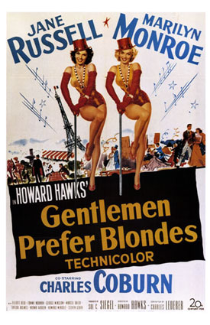
http://eu.movieposter.com/poster/b70-2965/Gentlemen_Prefer_Blondes.html

Reese Witherspoon Legally Blonde (2001)



http://www.impawards.com/2001/legally_blonde.html

