  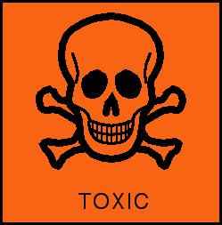 | Sulfuric ACID  Mike Thompson  Winchester College UK | 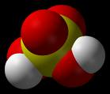

Spelling

If you wish this molecule of the month was on sulphuric acid rather than sulfuric acid then please click on the danger sign. It used to be known as ‘oil of vitriol’. In fact it might be even better to call it sulfur(VI) acid.

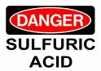

Contact Process

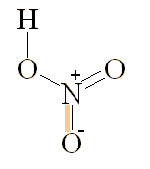
Sulfuric acid (H₂SO₄) is an extremely important chemical used in the manufacture of fertilisers and explosives. It is made from sulfur dioxide by the Contact Process. This process reacts together oxygen, O₂ and sulfur dioxide, SO₂ at 450°C and 2 atmospheres pressure, with the help of vanadium(V) oxide, to make sulfur trioxide, SO₃ gas in a 98% yield. This is then dissolved in water to make H₂SO₄.

Properties of sulfuric acid

At room temperature pure sulfuric acid (100%) is a covalent liquid. Concentrated sulphuric acid is 98% (36M) and is an oily liquid with a density of 1.83 g/cm³. It decomposes at its b.p. (330°C) and forms white fumes.

H₂SO₄ (l) → H₂O (g) + SO₃ (g) the reverse reaction is how to make sulfuric acid

Safety data click here

It has several important properties when concentrated; acid, oxidizing agent and dehydrating agent which makes it a very versatile reagent. It tastes sour not that you would taste it in a laboratory. It turns blue litmus red except when it is the covalent molecule, i.e. 100% H₂SO₄.

Concentrated sulfuric acid is very hygroscopic. It's affinity for water is so great that if you left a beaker half full with c.H₂SO₄ for three weeks it's volume would greatly increase and it would become more dilute because it would gave absorbed so much water vapour out of the air.

Test for sulfuric acid (and soluble sulfates)

Firstly, add dilute HNO₃. This is to prevent precipitation of other insoluble barium compounds such as BaCO₃ or BaSO₃. Secondly, add Ba(NO₃)₂ (aq). If sulphuric acid or a sulphate is present a white precipitate will be immediately observed.
Before After

Ba²⁺ (aq) + SO₄²⁻ (aq) → BaSO₄ (s) 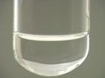 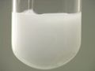
White

As an oxidising agent

Hot concentrated sulfuric acid is an oxidising agent when it accepts electrons. The electrons are supplied by the reducing agent in the reaction.

2 H₂SO₄ (aq) + 2e⁻ → SO₄²⁻ (aq) + 2 H₂O (l) + SO₂ (g)

Reactions with metals

Zn (s) + 2 H₂SO₄ (aq) → ZnSO₄ (aq) + H₂O (l) + SO₂ (g)
Fe (s) + 2 H₂SO₄ (aq) → FeSO₄ (aq) + H₂O (l) + SO₂ (g)
Mg (s) + 2 H₂SO₄ (aq) → MgSO₄ (aq) + H₂O (l) + SO₂ (g)
Cu (s) + 2 H₂SO₄ (conc) → CuSO₄ (aq) + H₂O (l) + SO₂ (g)

Reactions with non-metals

S (s) + 2 H₂SO₄ (aq) → 2 H₂O (l) + 3 SO₂ (g)
C (s) + 2 H₂SO₄ (aq) → 2 H₂O (l) + 2 SO₂ (g) + CO₂ (g)

Sulfur dioxide can be detected with a strip of filter paper moistened with potassium dichromate which turns from orange to green.

Halide salts with conc. sulphuric acid

Chlorides

Chlorides only react in one way no matter what the temperature.

NaCl (s) + H₂SO₄ (l) → HCl (g) + NaHSO₄ (s)

The misty fumes of hydrogen chloride gas are seen. The reason chlorine gas is not formed is because sulphuric acid is not powerful enough to oxidise chloride ions.

Bromides

Bromide ions are a stronger reducing agent than chloride ions. As bromide ions are larger than chloride ions their electrons are easier to remove. Bromide ions reduce sulphuric acid into sulfur dioxide in two steps.

NaBr (s) + H₂SO₄ (l) → HBr (g) + NaHSO₄ (s)
2 HBr (g) + H₂SO₄ (l) → Br₂ (l) + 2 H₂O (l) + SO₂ (g)

Iodides

Iodide ions are even larger than bromide ions and iodides electrons are even easier to remove. Iodide ions will reduce concentrated sulphuric acid into hydrogen iodide gas which will further reduce sulphuric acid in three ways at room temperature.

NaI (s) + H₂SO₄ (l) → HI (g) + NaHSO₄ (s)

Equation 1 8 HI (g) + H₂SO₄ (l) → 4 I₂ (s) + H₂S (g) + 4 H₂O (l)
Equation 2 6 HI (g) + H₂SO₄ (l) → 3 I₂ (s) + S (s) + 3 H₂O (l)
Equation 3 2 HI (g) + H₂SO₄ (l) → I₂ (s) + SO₂ (g) + H₂O (l)

What might you expect to observe if c. sulphuric acid was added to solid sodium iodide?
- Smell of bad eggs due to toxic H₂S (equation 1)
- purple iodine vapour (equations 1-3)
- brown due to iodate(V) formation (I₂ + I⁻ ↔ I₃⁻)
- dark grey iodine solid condensing on cold glassware

Uses of Sulfuric acid
• fertilizers such as ammonium sulphate (NH₄)₂SO₄ which is widely used as a nitrogenous fertilizer
2 NH₃ (aq) + H₂SO₄ (aq) (NH₄)₂SO₄ (aq)
• making hydrogen peroxide (H₂O₂) by reacting barium peroxide with sulphuric acid. The insoluble barium sulphate can be filtered off, leaving a solution of hydrogen peroxide.
BaO₂ (s) + H₂SO₄ (aq) BaSO₄ (s) + H₂O₂ (aq)
Before After
• ‘pickling’ to clean metal surfaces 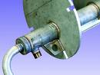
• extraction of metals
• HCl via the Mannheim process
2 NaCl + H₂SO₄  →  Na₂SO₄ + 2 HCl
• detergents and soaps
• drain cleaner
• drying gases (but not ammonia)
• superphosphate manufacture 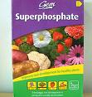
• paints and pigments
• natural and man-made fibre manufacture
• HF manufacture
Ca₅F(PO₄)₃ + 5H₂SO₄ + 10H₂O → 5CaSO₄.2H₂O + HF + 3H₃PO₄
• the electrolyte (33% H₂SO₄) in the lead-acid storage battery used in motor vehicles

As a dehydrating agent
Concentrated sulphuric acid is very good at removing the water from sugars. When the elements of water are removed from sucrose it leads to a black mass of carbon. This reaction has already been mentioned in the Molecule of the Month on Glucose. | 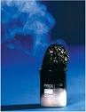
C₁₂H₂₂O₁₁ (s) + n H₂SO₄ (l) → 12 C (s) + 11 H₂O (l) + n H₂SO₄ (l)

Sulfuric acid can also be used to dehydrate sodium salts of some carboxylic acids. This use of sulphuric acid has already been mentioned in the Molecule of the Month on Carbon monoxide. The reactions involve protonation by the acid followed by subsequent dehydration.

Reactions of sulfuric acid

With bases

Dilute sulfuric acid neutralises basic oxides or hydroxides to form sulfate salts and water. Don’t forget sulfuric acid is a strong acid (completely ionizes in water).

CuO (s) + H₂SO₄ (aq) → CuSO₄ (aq) + H₂O (l)
ZnO (s) + H₂SO₄ (aq) → ZnSO₄ (aq) + H₂O (l)
Cu(OH)₂ (s) + H₂SO₄ (aq) → CuSO₄ (aq) + 2 H₂O (l)
Zn(OH)₂ (s) + H₂SO₄ (aq) → ZnSO₄ (aq) + 2 H₂O (l)

As sulfuric acid is dibasic (ionizes in two stages) when it reacts with sodium hydroxide it can form two possible sodium salts. To see which one is favoured you need to consider the stoichiometry (number of moles in the balanced equation) for the following two reactions.

2 NaOH (aq) + H₂SO₄ (aq) → Na₂SO₄ (aq) + 2 H₂O (l)
NaOH (aq) + H₂SO₄ (aq) → NaHSO₄ (aq) + H₂O (l)

With carbonates

Dilute sulfuric acid neutralises basic carbonates to form sulfate salts, water and carbon dioxide.

Na₂CO₃ (aq) + H₂SO₄ (aq) → Na₂SO₄ (aq) + H₂O (l) + CO₂ (g) | 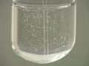  effervescence
MgCO₃ (aq) + H₂SO₄ (aq) → MgSO₄ (aq) + H₂O (l) + CO₂ (g)

The rate of reaction not only depends on the surface area of the carbonate and the concentration and temperature of the acid, but also on the solubility of the sulfate. When marble (CaCO₃) reacts with dilute H₂SO₄ it initially effervesces but because calcium sulfate is only sparingly soluble in water once it forms as a deposit on the marbles surface reaction soon slows.

With metals

Dilute sulfuric acid reacts with metals higher than hydrogen in the reactivity series to form sulfate salts and hydrogen gas. Note the metal reactions are different with concentrated sulfuric acid.

Mg (s) + H₂SO₄ (aq) → MgSO₄ (aq) + H₂ (g)
Zn (s) + H₂SO₄ (aq) → ZnSO₄ (aq) + H₂ (g)
Fe (s) + H₂SO₄ (aq) → FeSO₄ (aq) + H₂ (g)

Iron is cleaned free from rust prior to coating with tin to form tinplate and with zinc to form galvanized iron.

Sulfates
The biggest (80%) use of sulphuric acid in the manufacture of sulfates.
Gypsum is CaSO₄.2H₂O and is used to make plaster board as well as plaster casts 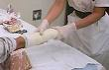, the laxative epsom salt is MgSO₄.7H₂O and green vitriol is FeSO₄.7H₂O. In 1648 Glauber made sulfuric acid by distilling crystals of this salt. Potassium sulfate is unusual in that it crystallizes without water of crystallization and has the formula K₂SO_{4.} As sulfuric acid is dibasic (diprotic) it is capable of forming two salts depending on the amount of alkali present in the reaction mixture;

2 NaOH (aq) + H₂SO₄ (aq) → Na₂SO₄ (aq) + H₂O (l)
NaOH (aq) + H₂SO₄ (aq) → NaHSO₄ (aq) + H₂O (l)

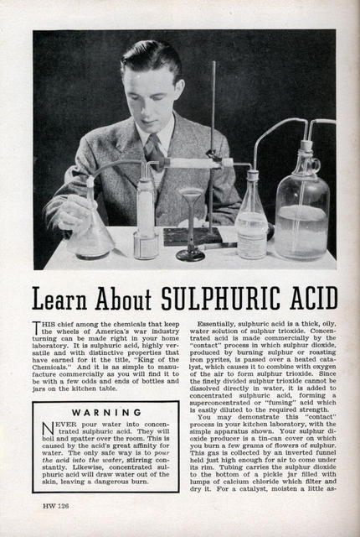

Sulfuric acid in Space

In 1999 solid (frozen) sulphuric acid was discovered on Europa’s moon of Jupiter. | 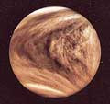
Scientists have even identified solid sulphuric acid hydrates such as hemitriskaidecahydrate (H₂SO₄.6½H₂O)

Sulfonation
Aromatic sulfonation is when an H is replaced by SO₃H (sulfonic acid group)
In the case of benzene it needs to be heated with c.H₂SO₄ for 8h to produce benzenesulfonic acid
This reaction is too slow and not to be attempted as benzene is implicated in childhood leukemia.

· 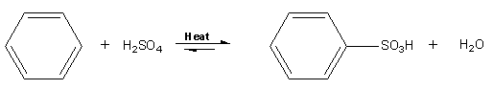

As the methyl (CH₃) group is electron releasing to 12 drops of
methylbenzene (toluene), add 30 drops of c.H₂SO₄ in a test
tube. Warm until the methylbenzene has dissolved into the acid
layer. Pour the mixture into 30cm³ of a cold saturated solution of
sodium chloride. White crystals of sodium methylbenzene
sulfonates are formed. The methyl group is ortho-para directing

and finally…..

Even Bart Simpson can spell sulfuric acid

