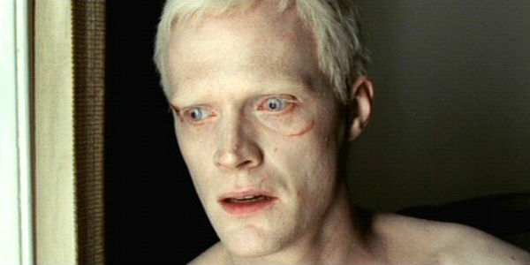

Silas – The Da Vinci Code (Paul Bettany)

Bosie – Cold Mountain (Charlie Hunnam)

http://whatculture.com/film/5-film-albinos-everything-thats-wrong.php

