MENTHOL

including the Mint Julep



Rhett Butler would not have been the man he was without his mint juleps.

http://www.doctormacro.com/Images/Leigh,%20Vivien/Annex/Annex%20-%20Leigh,%20Vivien%20(Gone%20With%20the%20Wind)_01.jpg

( also try http://www.allmoviephoto.com/c/1939_Gone_With_the_Wind_VivienLeigh.html )

c Warner Brothers



=
But what is a mint julep?

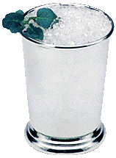

http://www.atasteofkentucky.com/images/mintjulep.gif

It is the classic Southern drink, made from bourbon, ice, sugar and mint, particularly associated with the Kentucky Derby, a classic event for 3 year old thoroughbreds, held over one and one-quarter miles at Churchill Downs racecourse on the first Saturday in May.

Great, so what does it have to do with menthol?
Menthol is a major component of mint. It is obtained by extracting mint by steam distillation, removing the water by drying, then chilling the resulting oil to crystallise the menthol. The best source is probably Mentha arvensis, Corn Mint, whose oil is up to 85% (-)-menthol.

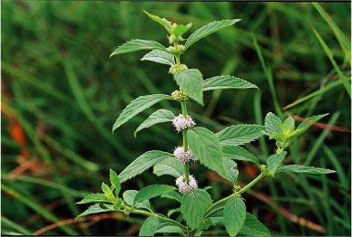.

You mean, the same mint used in mint sauce?
Yes, the stuff made from chopped-up mint leaves in vinegar, with a dash of sugar. Just the thing for roast lamb.

How is it made?
The Japanese chemist Ryoji Noyori, who shared in the Nobel Prize for Chemistry in 2001, developed rhodium-based catalysts for the synthesis of (-) menthol from myrcene. Such syntheses are now used commercially, with an enantiomeric excess of up to 100%.

How is it made in nature?
There is a complicated pathway, involving a series of enzyme-catalysed reactions.

What is menthol like?
It’s a colourless crystalline solid, m.p. 41 to 43 °C, soluble in ethanol but insoluble in water. In nature it only occurs as (-) menthol, and its formal name is (1R,2S,5R)-2-isopropyl-5-methylcyclohexanol.
Why is it called (-) menthol ?
The molecule can exist as a pair of optical isomers, though natural menthol is only the (-) form. In this form, all three bulky groups (OH, CH₃ and CH(CH₃)₂) are in equatorial positions, making it the more stable isomer.
Menthol has three asymmetric (chiral) carbon atoms in its cyclohexane ring; it therefore occurs as four pairs of optical isomers. The other isomers are known as isomenthol, neomenthol and neoisomenthol.

What difference does that make?
The two optical isomers (enantiomers) of menthol have identical chemical properties. They differ in those properties that depend upon the chiral carbon, like smell.

Why do they smell different?
Although the atoms are connected in the same sequence, the molecules look different to a receptor.

How do they differ?
(-) menthol can be described as “fresh, sweet, minty, cooling, refreshing”. The (+) isomer is similar, but less minty, more herby, with “musty, bitter, phenolic and herbaceous notes”, and is less refreshing. (-) menthol has also got about four times the cooling power of the (+) isomer.

Why is menthol cooling?
Drug molecules work by binding to receptor sites on sensory neurons, cells that send messages to the brain.
Capsaicin (link to MOTM for April 2001 ?), the key molecule in chilli peppers, acts on the TRPV1 receptor, which is also sensitive to temperatures above 43 °C, which is why chillis and curries are “hot”. Menthol binds to the TRPM8 receptor, which is also sensitive to temperatures in a range ca. 8-28 °C, hence the cooling effect of menthol.

How does the Cool Receptor work?
When menthol binds to the TRPM8 receptor, it has the same effect upon the receptor as exposing it to “cool” temperatures, it activates a surface pore which causes calcium ions to flow into the cell. This causes an electrical change in the cell, which sends a message to the brain. And because the message is the same as when cooling causes the pore to open, the brain registers “cool” when menthol binds too.

So how is menthol used?
Because of its “cooling” action, it is to be found in a wide range of medicines treating sore throats and mouth irritations. It is also used in treatments for minor aches and sprains, and in nasal decongestants. It is found in some oral hygiene products, including toothpaste and mouthwashes, and will combat “bad breath”. Of course, it is present in a number of chewing gums. It was first added to cigarettes in the 1920s and 1930s (e.g. “Spud” and “Kool” brands) for both its flavour and also to reduce irritation, especially to the throat.

And?
Don’t forget Crème de menthe.

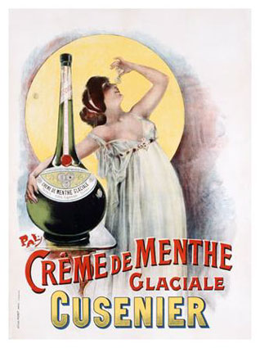

http://imagecache2.allposters.com/images/pic/VAS/0000-1019-4~Creme-de-Menthe-Posters.jpg

Bibliography

C. S. Sell, A Fragrant Introduction to Terpenoid Chemistry, Royal Society of Chemistry, 2003, pp 76-77 and 83-83.
E. Breitmaier, Terpenes: Flavors, Fragrances, Pharmaca, Pheromones, John Wiley, 2006
http://www.3dchem.com/molecules.asp?ID=202
http://en.wikipedia.org/wiki/Menthol
Science Creative Quarterly, Issue 2, Jan-Mar 2007 at http://www.scq.ubc.ca/?p=193

Isomers and Smell
Smell and flavour properties http://www.leffingwell.com/menthol1/menthol1.htm
R.Bentley, Chem. Rev., 2006, 106, 4099.

Synthesis
K. Tani, T. Yamagata, S. Akutagawa, H. Kumobayashi, T. Taketomi, H. Takaya, A. Miyashita, R. Noyori, and S. Otsuka, J. Am. Chem. Soc., 1984, 106, 5208.
K. C. Nicolaou and E. J. Sorensen, Classics in Total Synthesis, John Wiley, 1997, 343.
http://nobelprize.org/nobel_prizes/chemistry/laureates/2001/noyori-lecture.pdf
R. Noyori, Green Chem., 2003, 5, G37-G39

Biosynthesis
E.M.Davis, K.L.Ringer, M. E. McConkey and R. B. Croteau, Plant Physiology, 2005, 137, 883.
R. B. Croteau, E. M. Davis, K. L. Ringer and M. R.Wildung, Naturwissenschaften, 2005, 92, 562.

Mint
J. E. Landing, American Essence. A History of the Peppermint and Spearmint Industry in the United States, Kalmazoo Public Museum, 1969

Mint julep
J. Nickell, The Mint Julep, University Press of Kentucky, 2003.
http://en.wikipedia.org/wiki/Mint_julep
http://wiki.webtender.com/wiki/Mint_Julep

Crème de menthe
http://en.wikipedia.org/wiki/Creme_de_menthe

Kentucky Derby
http://www.kentuckyderby.info/
http://en.wikipedia.org/wiki/Kentucky_Derby

Menthol and the TRPM8 receptor.
D. D. McKemy, W. M. Neuhausser and D. Julius, “Identification of a cold receptor reveals a general role for TRP channels in thermosensation”, Nature, 2002, 416, 52
A. M. Peier, A. Moqrich, A. C. Hergarden, A. J. Reeve, D. A. Andersson, G. M. Story, T. J. Earley, I. Dragoni, P. McIntyre, S. Bevan, and A. Patapoutian, A TRP channel that senses cold stimuli and menthol. Cell. 2002, 108, 705.
S.-E. Jordt, D. D. McKemy and D. Julius, Lessons from peppers and peppermint: the molecular logic of thermosensation, Current Opinion in Neurobiology, 2003, 13, 487.
D. D. McKemy, "How cold is it? TRPM8 and TRPA1 in the molecular logic of cold sensation", Molecular Pain, 2005, 1, 16.

Tobacco and Menthol
G. F. Wayne and G. N. Connolly, Nicotine & Tobacco Research, 2004, 6, S 43 (Supplement 1)

