MOTM NYLON 2

NYLON
Why make nylon?
Until the first half of the 20th century, clothing was made of natural materials – wool, silk, leather, cotton, hemp, flax …. There was nothing else that could be used, and the properties of these materials were pretty fixed. At that time, structure and bonding in molecules were imperfectly understood. For one thing, it was generally believed that there was an upper limit to the size of molecules. Whilst studying the chemistry of rubber, the German chemist Hermann Staudinger (1881 –1965) measured very high molecular masses and in 1920 he proposed the idea of small molecules joining to form very long chains, in other words, the concept of polymerisation, though this was a very unpopular opinion. By the 1930s, more and more experimental data supported this view, though it was not until 1953 that Staudinger was awarded the Nobel Prize for Chemistry "for his discoveries in the field of macromolecular chemistry".

Picture of Staudinger hereabouts

So who made nylon first?
In early 1928, Wallace Carothers (1896-1937) went from an academic career at Harvard to be in charge of organic chemistry at the new Du Pont laboratory for fundamental research at Wilmington, Delaware. His main project was to create polymers; his salary went up from $267 to $500 a month, and “as for funds, the sky is the limit”. If a molecule has just the one functional group, at one end, it can only react at that end, and reaction stops there. Carothers had the idea of using monomers with a reactive functional group at each end, so each end of the monomer could react and thus form part of a chain. Despite succeeding in polymerising chloroethene and also making the first polyesters, his initial work was not commercially successful, but the research continued.

Picture of Carothers hereabouts

And how was nylon made?
On February 28th 1935, Dr. Gerard Berchet, a member of Carothers’ team, heated together hexamethylene diamine (1,6-diaminohexane, H₂N-(CH₂)₆-NH₂ ) with adipic acid (Hexane-1,6-dioic acid, HOOC-(CH₂)₄-COOH) and meta-cresol at 215 °C; water distilled off, then the temperature was raised to 255-260 °C to distil off the cresol in vacuo. He had made Nylon 6,6 ( this means that it is a copolymer of a 6C diamine and a 6C diacid). By that autumn, the first nylon threads had been spun. With synthetic fibres, chemists could tailor substances with particular properties.

Nylon is made from two monomers, each containing six carbon atoms, so the product is known as Nylon 6,6. On reaction, an OH group is lost from the acid molecule and one hydrogen from the amine molecule, so a molecule of water is eliminated, and an amide link is formed between the two monomers.

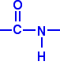

The loss of a small molecule in the condensation process, during the formation of Nylon and Terylene, is known as condensation polymerisation, in contrast to polymerisation of alkenes like ethane, when no atoms are gained or lost, in the process called addition polymerisation.

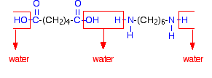
When this is repeated at both ends of each monomer, a chain results:-

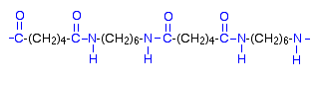
(This shows two repeat units of the polymer).

Overall, (n+1) H₂N-(CH₂)₆-NH₂ + (n+1) HOOC-(CH₂)₄-COOH

→ H₂N-(CH₂)₆-NH[CO(CH₂)₄-COHN-(CH₂)₆-NH]_{n}OC-(CH₂)₄-COOH + (n+1)H₂O

Despite this success, and his election to the National Academy of Sciences, Carothers was unable to shake off the depression and mental instability that had dogged him for years. The death of his favourite sister may have been the last straw. He committed suicide by drinking potassium cyanide dissolved in lemon juice on April 29th 1937, shortly after applying for a patent on Nylon. U.S. Patent 2,130,948 'Synthetic fibers' was issued on September 20th 1938.

Another approach to making a nylon used just the one monomer, which effectively had two different functional groups, an amine at one end and a carboxylic acid at the other. “Effectively”, as this molecule 6-aminohexanoic acid actually exists as a cyclic lactam (caprolactam), but this can be polymerised to form nylon-6. When this molecule polymerises, the ring opens, and the monomers link up forming a single chain of Nylon-6.

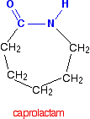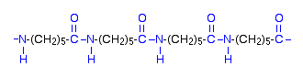

Though investigated by the Carothers team, Nylon-6 was largely the work of Paul Schlack at IG Farben in Germany, who achieved this synthesis on January 29th 1938; it went under the name of Perlon.

Picture of Paul Schlack

EQUATION

And Du Pont commercialised the discovery ?
With Nylon, Du Pont had an amazing material. Corrosion-free; easy to colour (unlike bakelite or natural materials); flexible; low density; non biodegradeable (which we may view as a mixed blessing today). It was resistant to many chemicals, though acid tends to hydrolyse it.

The invention of nylon was made public by Charles Stine (a vice president of Du Pont) on October 27th 1938, at a meeting of womens’ club members in New York; Du Pont would be targeting women for sales of the product that came to be associated with the name of their new polymer. However, the first application of nylon was in toothbrushes. Nylon bristles replaced boar’s bristles, which had been hard to obtain since the Japanese invasion of Manchuria in 1937. Now Dr West’s Miracle-Tuft brushes (1938) were touted as a toothbrush without bristles, which it would not shed, and which could not get soggy.

Picture – First Nylon toothbrush

Nylon stockings weren’t far behind. First offered on 24th October 1939 just to Du Pont's employees at their Wilmington, Delaware, factory, a nationwide campaign was behind their launch. May 15th 1940 was "N-Day", when nylon stockings went on sale right across America; huge queues formed and Du Pont sold 5 million pairs on that day alone, at $1.15 a pair. Expensive silk stockings quickly became a thing of the past.

Pictures – Du Pont stocking advert (s) – which advertise more than that.
invention.smithsonian.org/.../act1/nd13.jpg
http://www.adclassix.com/images/48dupontnylon.jpg

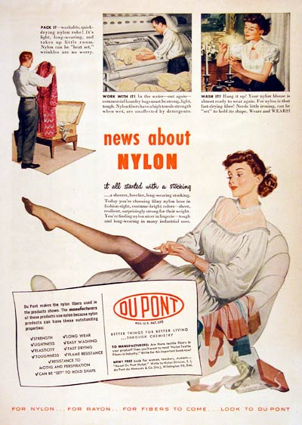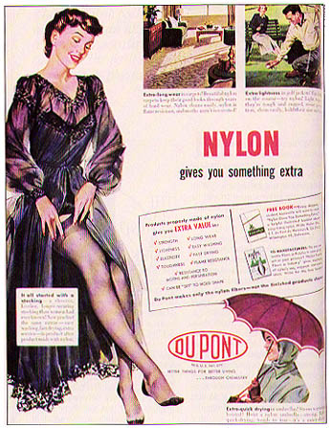

America entered World War II on December 7th 1941, and nylon rapidly became indispensable to the war effort. Parachutes were formerly made of silk, from Japan. Forthwith they were made of nylon. So were ropes, tyre cords, machinery parts like gears, life rafts …….

WWII Parachute picture
There is lots out there - Maybe something like this, photo #4 . Arnhem photos would give a good idea of how many people could be parachuting at once.
http://www.funonthenet.in/forums/index.php?topic=148687.0
failing all else http://www.chemheritage.org/EducationalServices/NYLON/photo/prod/prod99.jpg

And stockings?
The switch of production to military uses meant that there was no nylon to spare for civilian uses. No nylon stockings for American women; black market prices were astronomical. It was not until after the end of the war in the summer of 1945 that nylon was available for civilian use. Du Pont released a limited supply of stockings at just a few stores to huge queues; these stockings sold out quickly, and women rioted, the so-called “Nylon Riots”. As you can see, one lady could not wait to get them home before trying them on.
It was not until spring 1946 that Du Pont was making enough for supply to catch up with demand.

Picture of queues ?
See e.g. http://invention.smithsonian.org/centerpieces/whole_cloth/u7sf/u7materials/nylondrama.html

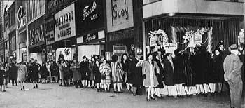

Picture
Post WWII woman sitting on kerb, trying on her new nylons.
Very well known picture… at http://www.chm.bris.ac.uk/webprojects2001/esser/images/nylon.jpg
Or maybe http://invention.smithsonian.org/centerpieces/whole_cloth/u7sf/u7materials/nylondrama.html

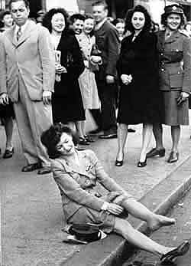
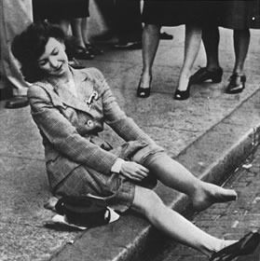

And since then??
As it became an everyday material, Nylon ceased to be so novel. Increasingly, its position was usurped by polyesters, marketed under names like Dacron (US) and Terylene (UK), and celebrated in that testament to the age of plastics, The Man in the White Suit, played by Alec Guinness (1951). PVC came of age in the 1960s. World consumption of polymers amounted to nearly 250,000 thousand metric tons in 2006, and is increasing; much of that is still Nylon.

Picture here of Alec Guinness poster

How does the Nylon Rope Trick work?
To make nylon 6, 10, we would use 1,6-diaminohexane and sebacic acid (decane-1,10-dioic acid). In fact, this reaction uses the diacyl chloride, not the diacid, as the former is more reactive, so that the reaction can be carried out at room temperature; the sebacoyl chloride is dissolved in a hydrocarbon solvent, such as heptane [less toxic than the often-used hexane]. The amine is dissolved in water, usually containing a little alkali.
The amine solution (which is the denser of the two) is poured into a beaker or crystallising dish, then the acyl chloride solution is very carefully poured on top of it, so that the solutions do not get agitated and mix [pouring down a glass rod is a good way of achieving this].
A nylon film forms at the interface between the solutions – use a pair of forceps and grasp the film, pulling it carefully out of the beaker, it will come as a thread. This can be wrapped round a windlass resting upon the beaker and the polymer wound up.
Reaction happens where two reactants come into contact; as the nylon is removed, more molecules can meet, so nylon is formed continually as the nylon thread is wound away, and reaction continues until one of the reactants becomes exhausted.
The product can be washed with water (to remove HCl etc) and left to dry.

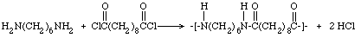

If adipoyl chloride (hexane-1, 6-dioyl chloride) is used, the product is nylon 6,6. The starting material does not keep as well as sebacoyl chloride, though.

Bibliography:-

Nylon and Polymers
Herbert F. Mark, Giant Molecules, Time-International Nederland, 1968, pp 105 -109.
Stephen Fenichell, Plastic. The Making of a Synthetic Century, HarperCollins, 1996, pp134 -174.
Susannah Handley, Nylon: the Manmade Fashion Revolution, Bloomsbury Publishing 1999.
Sharon B. McGrayne, Prometheans in the Lab: Chemistry and the Making of the Modern World, McGraw-Hill, New York, 2001, pp 106 -147.
Peter Atkins, Atkins' Molecules, Cambridge University Press, 2nd edition, 2003, pp 93 -97.
Penny Le Couteur and Jay Burreson, Napoleon's Buttons: How 17 Molecules Changed History, Tarcher/Putnam, 2003, pp 105 -123.
Mireille Defranceschi, La chimie au quotidien, Ellipses, Paris, 2006, pp 48 - 49.
Walter Gratzer, Giant Molecules: From nylon to nanotubes, Oxford, 2009, pp 126 -127, 157 -158.
Audra J. Wolfe, “Nylon, a revolution in textiles”, Chemical Heritage Newsmagazine, 2008, 26 (3). Online at http://www.chemheritage.org/pubs/magazine/feature_nylon_p1.html
http://www.pslc.ws/mactest/nysyn.htm (making Nylon 6, and Nylon 6,6)
http://invention.smithsonian.org/centerpieces/whole_cloth/u7sf/u7materials/nylondrama.html

Wartime nylon
“Stocking Panic”, Business Week, August 9 1941, p.24.
Online at http://invention.smithsonian.org/centerpieces/whole_cloth/u7sf/u7materials/act4_5.html
“Nylon in Tires”, Scientific American, August 1943, p.78.
Online at http://invention.smithsonian.org/centerpieces/whole_cloth/u7sf/u7images/act4/tires.html
“Bootleg Nylons”, Readers Digest, Feb. 1945, pp 66-68.
Online at http://invention.smithsonian.org/centerpieces/whole_cloth/u7sf/u7materials/act4_12.html

Wallace Carothers:-
Matthew Hermes, Enough for One Lifetime, Wallace Carothers the Inventor of Nylon, Chemical Heritage Foundation, 1996.
Roger Adams, Biographical Memoir of Wallace Hume Carothers 1896-1937, National Academy of Sciences of the USA, 1939, Vol XX.
online at http://books.nap.edu/html/biomems/wcarothers.pdf
http://en.wikipedia.org/wiki/Wallace_Carothers

Paul Schlack and Nylon-6 (Perlon)
http://en.wikipedia.org/wiki/Paul_Schlack
http://www.german-hosiery-museum.de/technik/garne/perlon/perlon.htm
http://www.chf.de/benzolring/archiv/sc-1297.html (in German)

Hermann Staudinger
http://en.wikipedia.org/wiki/Hermann_Staudinger
http://nobelprize.org/nobel_prizes/chemistry/laureates/1953/staudinger-bio.html (Nobel biography)
http://acswebcontent.acs.org/landmarks/polymer/staudinger.html

Nylon Rope Trick
Ted Lister, Classic Chemistry Demonstrations, Royal Society of Chemistry, 1995, Demonstartion 64, pp 159 – 161.

Instructions for nylon rope trick and demonstration.
http://chemed.chem.purdue.edu/demos/main_pages/25.1.htm

Synthesis of Nylon- 6, 10 (includes videoclip)
http://www.uni-regensburg.de/Fakultaeten/nat_Fak_IV/Organische_Chemie/Didaktik/Keusch/D-Nylon-e.htm

http://www.umanitoba.ca/outreach/crystal/resources%20for%20teachers/Polymerization%20Synthesis%20of%20Nylon%206,10%20C11-5-22.doc

http://www.youtube.com/watch?v=y479OXBzCBQ&mode=related&search=

Nylon-6 synthesis
http://www.chemheritage.org/EducationalServices/FACES/teacher/poly/activity/nylon6a.htm
http://www.pslc.ws/macrog/lab/lab01.htm (background too)

