MOTM OCTANE

Picture of space-filling MOLYMOD octane molecule
(example at http://www.wikiwand.com/en/Space-filling_model )
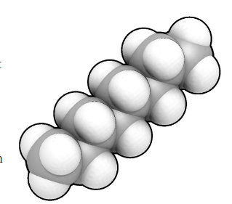

Is that Mister Wiggly? (Caterpillar picture?)
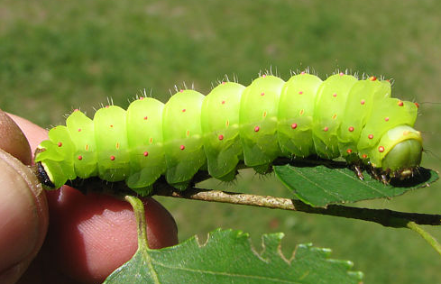
e.g. ‘a fully grown Luna caterpillar from http://www.naturenorth.com/spring/classrm/skclass/Fskclass.html
No, it is a molecule of octane.
Is that anything to do with the 95 and 97 or 98 on petrol pumps?
Yes, although there is more to it than octane ratings.
How?
Well, octane is a hydrocarbon, a molecule made up of just carbon and hydrogen atoms bonded together. It’s got 8 carbon atoms; that is why the name begins with oct-.
What about the –ane ending?
Octane belongs to a family of molecules called alkanes. These are hydrocarbon molecules with just single, two-electron, bonds connecting the atoms. If there was a double bond in the molecule it would be an ‘alkene’ and the name would end in –ene.
Where does octane come from?
It is one of thousands of different molecules found in crude oil. Another name for crude oil is petroleum, which is not the same as petrol. Crude oil originated in marine organic matter like plankton, present millions of years ago in warm seas. Organic deposits formed on the seabed, and these deposits gradually got buried. As the deposits were forced deeper and deeper, the pressure (and temperature) on them increased, causing the molecules to split into a mixture of lots of smaller ones. This mixture is crude oil, which impregnates porous rock, and is trapped between layers of impermeable rock. This ‘source rock’ is what oil companies search for, so that they can drill for the crude oil, which pressure then forces to the surface.
Picture of gusher e.g.
https://commons.wikimedia.org/wiki/File:MEDI_D099_The_gusher_of_the_Cerro_Azul_oil_well.jpg https://commons.wikimedia.org/wiki/File:Gusher,_Oil_City,_Pennsylvania_1899_cph.3b14492.jpg
How do they get octane from the crude oil?
They refine the petroleum. This involves boiling the crude oil and passing the vapour up a ‘fractionating tower’ that is hot at the bottom and cold at the top. Because the different-sized molecules have different boiling points, they condense out from the vapour at different points. There are trays at different levels of the tower that collect ‘fractions’, molecules with similar boiling points.
Picture of fractionating tower cross-section.
Something like
https://en.wikipedia.org/wiki/Continuous_distillation#/media/File:Continuous_Fractional_Distillation.PNG
Why do molecules have different boiling points?
When you boil a liquid and convert it to a gas, the molecules are separated from each other and move much further apart. For this to happen, you have to overcome the attractive forces between the molecules. These ‘intermolecular forces’ are weaker than the chemical bonding forces that hold molecules together; think of them as ‘Molecular Velcro’ if you like. The bigger the molecule, the stronger the intermolecular forces. So molecules of roughly similar size collect in the same ‘fraction’, though a fraction still contains lots of different molecules.
How do you get pure octane from its fraction?
Further careful fractional distillations are needed. You can also get octane by the process known as cracking.
Cracking, sounds like something Wallace would say?
[picture of Wallace with a speech bubble “Cracking reaction, Gromit”.]
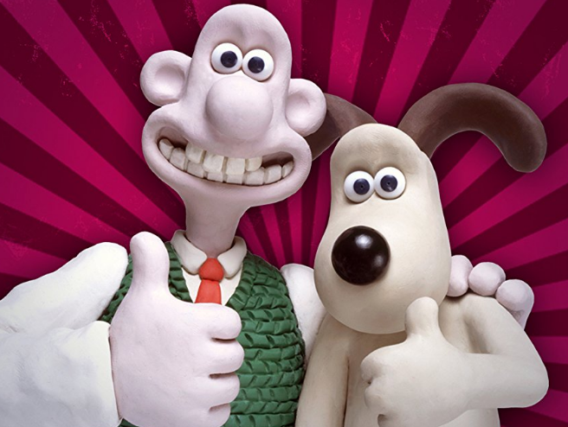
Cracking involves passing the vapour of big molecules over a hot catalyst, which splits them into smaller molecules. One product produced by cracking will be an alkene such as ethene (MOTM December 2006); these reactive molecules are very useful to the chemical industry.
In essence, cracking means reactions like:
Big alkane → Smaller alkane + Alkene
So you can get octane (amongst other molecules) by cracking decane, for example.
C₁₀H₂₂ → C₈H₁₈ + C₂H₄

You can also make other alkanes by ‘isomerisation’ reactions using appropriate catalysts.
Picture of a cracker, from Baton Rouge (straight out of the Johnny Cash songbook)
https://en.wikipedia.org/wiki/Baton_Rouge_Refinery#/media/File:Exxon_Mobil_oil_refinery_-_Baton_Rouge,_Louisiana.jpg
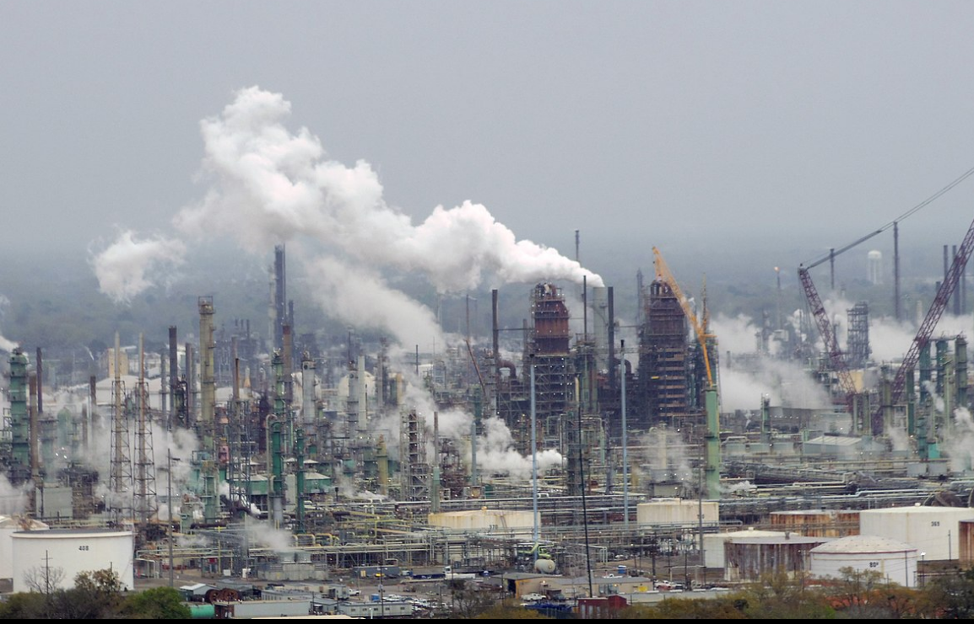
What’s isomerisation?
Well, isomers are compounds with the same molecular formula but different structures. For example, octane has lots of isomers, like these three, all variants on C₈H₁₈:-

Picture of structures of octane, 2-methylheptane, 2,2,4-trimethylpentane
So isomerisation means converting one isomer into another one. In the chemical industry this usually means converting a straight chain octane into an isomer with more branches; these are valuable on account of their higher octane ratings.
But you’ve still not explained octane ratings
First, you have to understand the engines in petrol-fuelled cars. Petrol engines are driven by the combustion of a mixture of a gaseous mixture of air and hydrocarbon fuel. This mixture is injected into the cylinder as the piston is on its downstroke, then gets compressed as the piston moves up. At a particular point, a sparking plug fires a spark that ignites the mixture, forming a very hot mixture of carbon dioxide and steam, creating the power that forces the piston down, driving the engine and powering the wheels. As time went on, manufacturers developed engines where the fuel-air mixture was compressed more before it was ignited – with higher ‘compression ratios’. This gave more power, but it was also likely that the fuel-air mixture would pre-ignite, before it was sparked. This caused the engine to misfire, known as ‘knocking’ which would result in less power, not more.
So how did they solve that problem?
This was the work of an American chemist called Russell Marker; he was employed by the Ethyl Corporation, who played a leading role in developing tetraethyllead (MOTM Jan 2001) as an antiknock agent. Marker examined a number of alkanes that found in the ‘petrol’ fraction from refining, looking at their ‘knocking’ characteristics. He started with heptane, a seven-carbon molecule that was very similar to octane. Both heptane and octane are known as ‘straight’ chain alkanes; in this context ‘straight’ means that the chain of carbon atoms in the molecule is unbranched, as the chains are anything but straight, with a zig-zag chain of carbon atoms. Heptane caused really bad knocking, so next he tried 2,2,4-trimethylpentane, traditionally known as isooctane; it also has the formula C₈H₁₈ so is an isomer of octane. This has a branched chain containing eight carbon atoms, but does not cause any knocking. Like heptane, octane, with its ‘straight’ chain of eight carbons, was bad too.

Best Marker picture is at http://science.psu.edu/news-and-events/2011-news/Wartik2-2011-2
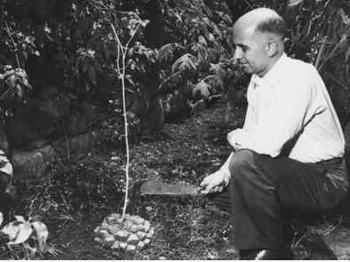
So?
Mixtures were made with varying amounts of heptane and isooctane, so that their knocking characteristics could be studied. A fuel described as 95 octane has the same knocking characteristics as a mixture containing 95% isooctane and 5% heptane. The higher the octane rating, the more the gas-air mixture can be compressed before it is ignited, and the more power you get when it burns.
And that is why it is important to motorists.
If you go back to the last century, high-octane fuel helped shape history. Back in 1927-1931, British seaplane aircraft won the high-speed Schneider trophy for Britain three times, with the help of high-octane fuels developed by Air Commodore Rod Banks and his colleagues. The designer R. J. Mitchell developed these Supermarine seaplanes into the Supermarine Spitfire fighter aircraft. 100 octane fuel originating in the refineries in Aruba, off the Venezuelan coast, found its way into squadron use with the RAF’s Hurricanes and Spitfires in 1939-40, just in time for the Battle of Britain. At the same time, the Luftwaffe’s Me(Bf) 109 aircraft were also running on 100-octane fuel, so without it the RAF’s fighers would have been at a considerable disadvantage in the Battle of Britain.
Picture of Supermarine seaplane (S6A)
https://en.wikipedia.org/wiki/Supermarine_S.6#/media/File:Supermarine_S.6A_N248.JPG
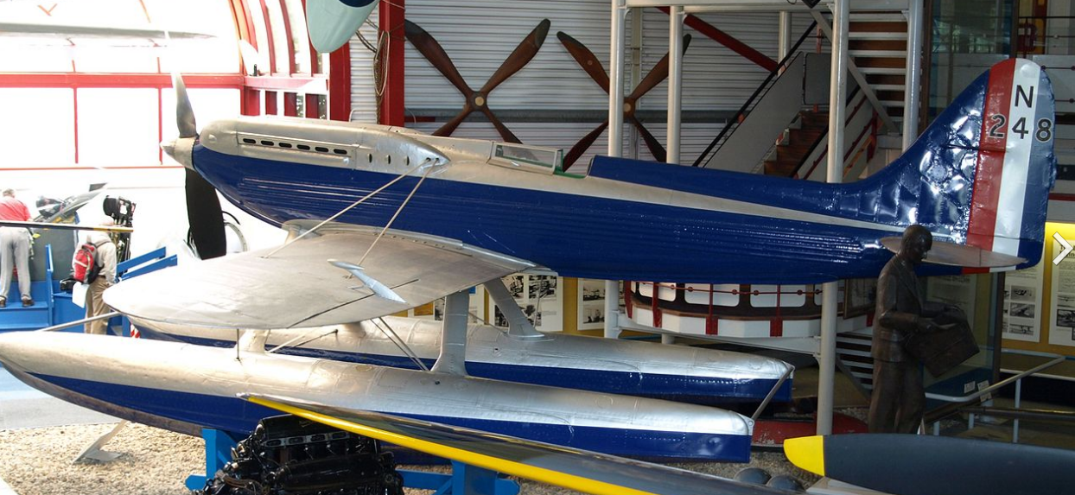

and Spitfire.
https://commons.wikimedia.org/wiki/File:Supermarine_Spitfire_Vb_%E2%80%98R9649_-_LC%E2%80%99_(G-CISV_-_EP122)_(35522161724).jpg

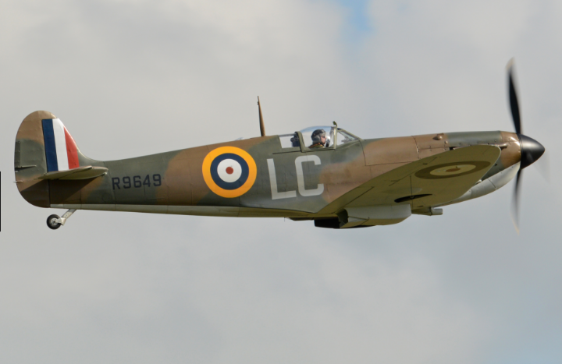

And Russell Marker you ask? Well, he became one of the few university professors not to have a PhD. Just over 10 years after his work on octane ratings, he found a way of degrading diosgenin, found in Mexican yams, into progesterone, which became known as the Marker degradation, an example of semisynthesis at work. This ultimately led to oral contraceptives. People have won Nobel prizes for less valuable work.
How do you make alkanes in the lab?
These days no one takes the trouble, as they can be bought cheaply from chemical suppliers.
Several methods are due to famous chemists of the past. Herman Kolbe (1818-1884) found that alkanes can be made by electrolysis of salts of carboxylic acids. So using sodium pentanoate results in butane (and carbon dioxide) at the anode – and sodium hydroxide and hydrogen at the cathode. Two butyl groups get coupled together to make the octane molecule in this reaction.
Overall: - 2 C₄H₉COONa + 2 H₂O → C₈H₁₈ + 2 CO₂ + 2 NaOH + H₂
In a different type of ‘coupling reaction’, due to Adolphe Wurtz (1817-1884), 1-iodobutane reacts with sodium metal.
2 C₄H₉I + 2 Na → C₈H₁₈ + 2 NaI

Victor Grignard (1871-1935) devised the synthesis of ‘Grignard reagents’, by reaction of clean magnesium metal with halogenoalkanes in an ethereal solvent, so 1-iodooctane reacts with magnesium forming C₈H₁₇MgI; if this is hydrolysed, octane is the product.
C₈H₁₇I + Mg → C₈H₁₇MgI
C₈H₁₇MgI + H₂O → C₈H₁₈ + Mg(OH)I
But all these reactions are more expensive (and time consuming) than buying ready-made octane!

Bibliography
Chapman and Hall Combined Chemical Dictionary code number: BGV37-P (octane); DDN93-Q (2-methylheptane); BGT79-T (2,2,4-trimethylpentane).
P. W. Atkins, Molecules, Scientific American Library, 1987, pp 37-38.
For octane ratings
http://www.eesi.org/papers/view/fact-sheet-a-brief-history-of-octane
Derek Splitter 1 *, Alexander Pawlowski 1,2 and Robert Wagner, ‘A Historical Analysis of the Co-evolution of Gasoline Octane Number and Spark-Ignition Engines’, Frontiers in Mechanical Engineering, January 2016, Vol 1. doi: 10.3389/fmech.2015.00016

Pictures of Kolbe
https://cs.wikipedia.org/wiki/Hermann_Kolbe
Wurtz.
https://en.wikipedia.org/wiki/Charles_Adolphe_Wurtz#/media/File:Charles-Adolphe_Wurtz.jpg
Grignard
https://en.wikipedia.org/wiki/Victor_Grignard#/media/File:Viktor-grignard.jpg

