Bibliography for Quinine

Quinine and Malaria
F.Rocco, The Miraculous Fever-tree: Malaria, Medicine and the Cure That Changed the World, HarperCollins, 2003
M.Honigsbaum, The Fever Trail: In Search of the Cure for Malaria, Macmillan, 2001
R.S.Desowitz, The Malaria Capers, W.W.Norton, 1991.
H.Hobhouse, Seeds of Change: Six Plants That Transformed Mankind, Sidgwick and Jackson, 1985.
P.Le Couteur and J.Burreson, Napoleon's Buttons: How 17 Molecules Changed History, Tarcher, 2003.

http://www.organische-chemie.ch/OC/Artikel/Malaria/Quinine.pdf (review of quinine)

Malaria
http://www.malaria.org/
http://www.who.int/mediacentre/factsheets/fs094/en/
Science, 2000, 290, 428-441 (strategies)

Two classic Syntheses of Quinine
P.Ball, Chem.Brit, October 2001, 26
R.B.Woodward and W.E.Doering, J.Amer.Chem.Soc., 1945, 67, 860
G.Stork, D.Niu, A.Fujimoto, E.R.Koft, J.M.Balkovec, J.R.Tata, and G.R.Dake, J.Amer.Chem.Soc., 2001, 123, 3239
http://www.nap.edu/readingroom/books/biomems/rwoodward.pdf (biography of R.B.Woodward)

The Mosquito and malaria cycle
A.Spielman and M.D'Antonio, Mosquito: The Story of Man's Deadliest Foe, Faber and Faber, 2001
Malaria parasite cycle http://www.travelhealth.co.uk/diseases/malaria_lifcycle.htm
http://www.malariasite.com/malaria/LifeCycle.htm
Animated cycle of malaria parasite http://www-ermm.cbcu.cam.ac.uk/dcn/swf001dcn.htm

Antimalarial drugs in general
A.R.Butler and T.Hensman, Education in Chemistry, 2000, 37, 151.
A. Robert, F. Benoit-Vical, O. Dechy-Cabaret, and B. Meunier, Pure Appl.Chem., 2001, 73, 1173.
P.Wilairatana, S.Krudsood, S.Treeprasertsuk, S.Chalermrut and S.Looareesuwan, Arch.Med.Res., 2002, 33, 416.

J.Wiesner, R.Ortmann, H.Jomaa and M.Schlitzer, Angew.Chem.Int.Ed.Engl., 2003, 42, 5274.

Drug Resistance
D.C.Warhurst, Infection, 1999, 27, S 55
P.A.Winstanley, S.A.Ward and R.W.Snow, Microbes Infect., 2002, 4, 157
D.A.Fidock, T.Nomura, A.K.Talley, R.A.Cooper, .M.Dzekunov, M.T.Ferdig, L.M.B.Ursos, A.bir Singh Sidhu, B.Naudé, K.W.Deitsch, X.-Z.Su, J.C.Wootton, P.D.Roepe and T.E.Wellems, Molecular Cell, 2000, 6, 861. (chloroquine resistant gene)

Artemisinin
D.L.Klayman, Science, 1985, 228, 1049
A.R.Butler and Y.L.Wu, Chem.Soc.Rev., 1992, 21, 85.
M.A.Avery, K.M.Muraleedharan, P.V.Desai, A.K.Bandyopadhyaya, M.M.Furtado, and B.L.Tekwani, J.Med.Chem., 2003, 46, 4244
U.Eckstein-Ludwig, R.J.Webb, I.D.A.Van Goethem, J.M.East, A.G.Lee, M.Kimura, P.M.O'Neill, P.G.Bray, S.A.Ward and S.Krishna, Nature, 2003, 424, 957.
G.H.Posner and P.M.O’Neill, Acc.Chem.Res., 2004, 37, 397
P.M.O’Neill and G.H.Posner, J.Med.Chem., 2004, 47, 2945

Fosmidomycin
M.A Missinou, S.Borrmann, A.Schindler, S.Issifou, A.A.Adegnika, P.-B.Matsiegui, R.Binder, B.Lel, J.Wiesner, T.Baranek, H. Jomaa and P.G.Kremsner, The Lancet, 2002, 360, 1941.
T.Murakawa, H Sakamoto, S Fukada, T Konishi, and M Nishida, Antimicrob Agents Chemother. 1982, 21, 224

OZ 277
J.L.Vennerstrom, S.Arbe-Barnes, R.Brun, S.A.Charman, F.C.K.Chiu, J.Chollet, Y.Dong, A.Dorn, D.Hunziker, H.Matile, K.McIntosh, M.Padmanilayam, J.S.Tomas, C.Schuerer, B.Scorneaux, Y.Tang, H.Urwyler, S.Wittlin and W.N.Charman, Nature, 2004, 430, 900 ; A.Yarnell, Chem.Eng.News., August 23 2004, 82, 4.

Malaria vaccines
P.Van de Perre and J.-P.Dedet, The Lancet, 2004, 364, 1380; P.L.Alonso, J.Sacarlal, J.J.Aponte, A.Leach, E.Macete, J.Milman, I.Mandomando, B.Spiessens, C. Guinovart, M.Espasa, Q.Bassat, P.Aide, O.Ofori-Anyinam, M.M.Navia, S.Corachan, M. Ceuppens, M.-C.Dubois, M.-A.Demoitié, F.Dubovsky, C.Menéndez, N.Tornieporth, W.R.Ballou, R.Thompson, and J. Cohen, The Lancet, 2004, 364, 1411.
R.Ménard, Nature, 2005, 433, 113 ; A.-K.Mueller, M.Labaied, S.H.I.Kappe and K.Matuschewski, Nature, 2005, 433, 164.

Bob Dylan lyrics

The Mighty Quinn (Quinn The Eskimo)
Everybody's building the big ships and boats
Some are building monuments, others jotting down notes
Everybody's in despair, every girl and boy
But when Quinn the Eskimo gets here everybody's gonna jump for joy
Oh come all without, come all within
You'll not see nothing like the mighty Quinn
Come all without, come all within
You'll not see nothing like the mighty Quinn.
Oh you know I like to do just like the rest
You know I like my sugar sweet but guarding fumes and making haste
You know it ain't my cup of meat
Everybody's out the trees, feeding pigeons all under the limb
But when Quinn the Eskimo gets here the pigeons gonna run to him
Oh come all without, come all within
You'll not see nothing like the mighty Quinn
Come all without, come all within
You'll not see nothing like the mighty Quinn.
A cat's meow and a cow's moo to you know I, I could recite them all
Just tell me where it hurts you, honey, and I'll tell you who to call
Nobody can get asleep, there's someone on everybody's toes
When Quinn the Eskimo gets here everybody's gonna want to doze
Oh come all without, come all within
You'll not see nothing like the mighty Quinn
Come all without, come all within
You'll not see nothing like the mighty Quinn.

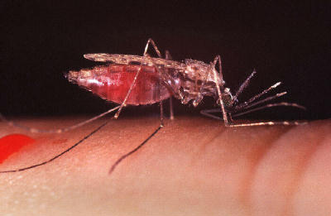
Photo courtesy Centers for Disease Control & Prevention, photographer Jim Gathany
This female Anopheles gambiae mosquito is feeding. You can see the blood swelling her abdomen.

Picture in http://science.howstuffworks.com/mosquito3.htm

http://en.wikipedia.org/wiki/Mosquito

Anopheles Mosquitoes
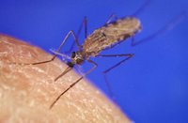
Anopheles gambiae

http://www.wellcome.ac.uk/doc_WTD002919.html

for following copyright-free images

http://www.wellcome.ac.uk/en/pressimages/orange/mal7_hi.jpg (cartoon, Images from the 1943 US War Department booklet "This Is Ann", produced for US troops during World War II as a warning against contracting malaria.)
See http://www.sel.barc.usda.gov/Diptera/ann1.htm for more of these WWII images.
http://www.sel.barc.usda.gov/Diptera/ann_text.html for text-only version.

Another picture from http://www.scripps.edu/newsandviews/e_20021007/#

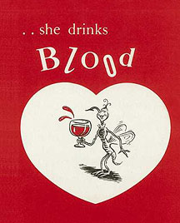

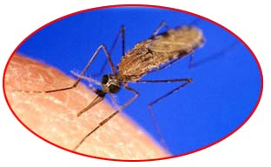

A female Anopheles gambiae mosquito feeding on a person. Anopheles transmit the malaria parasite. Photo courtesy of CDC, viewed at National Institute of Allergy and Infectious Diseases.

From… http://whyfiles.org/016skeeter/3.html

Biography of Sir Ronald Ross (1857-1932), who won the Nobel Prize for Medicine in 1902 for his work on malaria… with picture.

http://nobelprize.org/medicine/laureates/1902/ross-bio.html

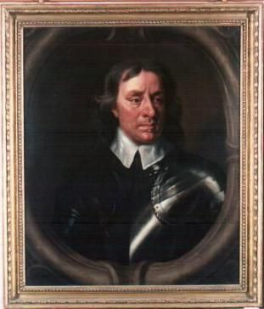

http://edweb.camcnty.gov.uk/heritage/cromwell-museum/images/large/h0077z2.jpg

Picture of a G+T ??
http://www.dpchallenge.com/image.php?IMAGE_ID=52057 or somesuch.

Cinchona tree pictures…
http://images.google.co.uk/images?q=cinchona&hl=en&lr=&sa=N&tab=wi&sourceid=tipimg

such as www.agridept.gov.lk/ NBG/H_cinco.htm

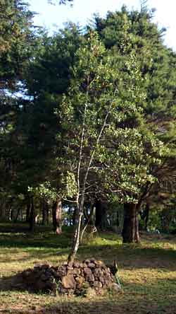

Bark ?? at www.cocura.de/P328.html

