**Thallium Sulfate**

***Rat poison used for Murder***

Mike Thompson, Matty Coe and Thomas Sloan

Rugby School, UK

**Isn’t it just another typical white powder?**

Well, yes, but it’s a lot more interesting than that. Thallium sulfate is an ionic compound with a giant lattice structure. Sulfates are typically made from the reactions of metals with [sulfuric acid](http://www.chm.bris.ac.uk/motm/h2so4/h2so4h.htm) (MOTM May 2008). The thallium, in thallium sulfate, is found in the +1 oxidation state, so there are two Tl+ ions for every sulfate molecule, giving it an overall formula of Ti2SO4. Thallium(I) sulfate is a more accurate name. Thallium also forms a +3 oxidation state like the other elements in Group 13 (boron, aluminium, gallium and indium). The name thallium, like many other elements, comes from a Greek word, *Thallos*, which means ‘green shoot/twig’, because thallium produces a green flame when heated in a flame test, due to the single green spectral line in its [emission spectrum](https://uvachemistry.com/tag/emission-spectrum/).

 The green flame test for thallium. [http://labphoto.tumblr.com/post/107916866002/something-really-awesome-the-pure-green-color.]

Thalium’s electron configuration is [Xe] 4f14 5d10 6s2 6p1. The ‘inert pair’ effect is the reason why thallium prefers the +1 oxidation state. This tendency towards univalency is due to the reluctance of its 6s2 electrons to be lost in reactions.

**Structure of Thallium sulfate**

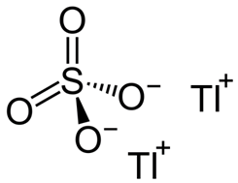

**How heavy is Thallium?**

Thallium is classified as a heavy metal…

**You mean like *Motorhead* and *Iron Maiden*?**

No, like lead and mercury. Thallium has a density of 11.8 g/cm3 which makes it one of the densest metals known, even denser than the more familiar heavy metal, lead, with its density of 11.35 g/cm3.

|  |  |
| --- | --- |
| Thallium sulfate powder, a heavy metal compound | Lemmy Kilmister 28/12/15 RIP – a heavy metal legend |

**I’ve heard that many heavy metals are quite toxic…?**

Indeed. Thallium and its compounds are most widely known for their high toxicity and it has made the news around the world when it was used in numerous homicide (murder) cases. As a white solid it has a very similar appearance to granulated sugar. As a substance it is apparently tasteless, and we are happy to take others’ word for that. Fortunately, nowadays this substance is difficult to get hold of. To give an idea of the toxicity of thallium sulfate, a single teaspoon of Ti2SO4 (about 34 g) would be capable of killing 34 people - reason enough for chemists to be banned from eating or drinking in their laboratories. Thallium sulfate has a solubility of 4.87 g in 100 mL of water at 20oC. So in a mug of tea with about 200 mL water at around 60oC quite a lot of thallium sulfate (10 times the lethal dose in fact) would dissolve unnoticed.

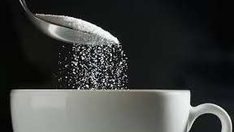

**So has it been used for murder?**

Of course, but we’ll come onto that later. From the 1700s to the 1900s it was actually used as a rather poor medical treatment for ringworm – a fungal infection of the skin which results in an itchy, round rash. Ringworm is transmitted by physical contact with an infected individual and is said to affect 20% of the population at any given time. Thallium sulfate often proved too toxic for the patient, but at least it did kill the ringworm before it killed the patient!

The itchy, round rash associated with ringworm

[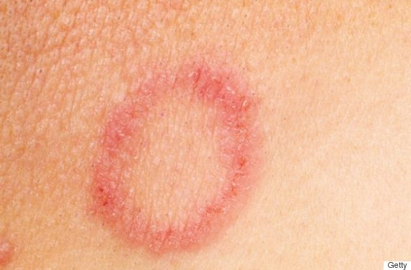](http://www.huffingtonpost.co.uk/2016/08/31/ringworm-in-babies-and-children-treatment-and-prevention_n_7355350.html)

In the 1920s thallium sulfate found widespread use as a pesticide. But this was not without its controversies; in the South American country of Guyana, more than 40 people died from its (mis)use. The reason was that the pesticide, which was left lying around in an attempt to kill rats, was absorbed by plants, and then entered the food chain, increasing in concentration (‘bioaccumulation’, see MOTM November 2014 about triclosan [http://www.chm.bris.ac.uk/motm/triclosan/triclosanh.htm]), until it was eventually ingested by humans in meat or vegetable foods. It was also found that thallium sulfate had the unfortunate side effect of inhibiting the growth of plants by stopping germination, which reduced crop yields.

And in Israel its use as a rodenticide is blamed for wiping out the brown fish owl – a local bird of prey that used to eat fish. The thallium compound had seeped into the rivers and lakes and poisoned the fish, which were then eaten by the owls.

|  |  |
| --- | --- |
|  | Brown fish owl – allegedly poisoned in Israel by widespread misuse of thallium sulface rat killer.  [Photo: Hedayeat CC BY-SA 4.0, https://commons.wikimedia.org/w/index.php?curid=59733595] |

**So I suppose they stopped using it as a pesticide…?**

Not immediately…despite thallium sulfate’s known toxicity its use was not discontinued in Guyana until 1987. Another problem is that the only way to identify patients with thallium poisoning was through blood and urine testing, and this was done only in Guyana’s Hospital in its capital Georgetown. Of the 2,400 people who had either their blood or urine tested, a shocking 77% tested positive for thallium poisoning, showing just how widespread the thallium poisoning had become in the environment.

**What are the symptoms of poisoning?**

Thallium sulfate poisoning, much like the deceptive appearance of the compound itself, has initial symptoms typical of a winter virus. This generally means that poisoning is mistaken for a common cold or flu. The symptoms are generally seen in the hours immediately after exposure and can include severe stomach aches as well as diarrhoea. 2-5 days after exposure to thallium the body’s response takes a more neurological turn with numbness and tingling, felt especially on the palms and soles of the feet. This is followed in the weeks after exposure with the growth of a dark pigment at the root of hair leading to baldness. There is also an increase in neurological symptoms such as comas and blindness. These symptoms can sometimes also appear in the days immediately after exposure dependent on the quantity ingested. The compound also affects the heart; initially increasing heart rate and later possibly causing circulatory disturbances that can lead to death. The time that the compound will take to kill you depends on many factors and ranges from as little as 6 days or up to 8 weeks.

**Why does thallium kill you?**

TI+ behaves chemically in a very similar manner to Na+ and K+ ions, and when present in the body it can replace these ions within cells. Since these ions are essential for nerve function, it is therefore no surprise that victims of thallium poisoning often suffer neurological symptoms. The presence of thallium impairs the ability of your cells to produce nerve impulses, and will likely kill you through either respiratory paralysis or circulatory disruption. And it takes very little to be fatal; the lethal dose of thallium sulfate for an adult is thought to range from 500 mg to 1 g.

**Is there an antidote?**

Yes, the antidote, rather surprisingly, is to take tablets of a cyanide-based molecule called Prussian Blue Fe7(CN)18 [see the MOTM Nov 2011 http://www.chm.bris.ac.uk/motm/HCN/HCN.htm], three times a day for 2 weeks.

|  |  |
| --- | --- |
| Prussian Blue pigment | Vicent van Gogh’s Starry Night  Which used Prussian Blue |

Prussian Blue is more commonly known as a pigment with a dark blue colour and was the first modern synthetic pigment. It is insoluble in water, but can still be used in paint as it has a very fine colloidal dispersion.

**The antidote for Thallium****poisoning is Prussian Blue Fe7(CN)18**

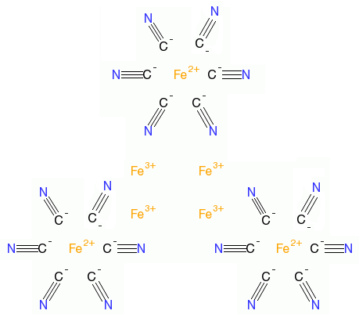

**How does it work?**

Prussian blue is an ‘ion exchange material’, which means it can swap its central Fe2+ ion for another suitable ion in its surroundings, in this case Tl+. So the Prussian Blue acts as a sponge, soaking up the poisonous Tl+ ions in the body and replacing them with harmless Fe2+ ions. The new complex containing Tl+ renders the metal unavailable for absorption in the stomach and it can safely pass through the intestines and then be excreted.

**Ok, now can we get to the murders?**

Sure – in fact thallium has been called ‘Inheritance powder’ and the ‘poisoner's poison’ because thallium is colourless, odourless and tasteless. Its symptoms are often similar to those of a host of other illnesses and conditions, including innocuous ones such as colds or flus, so the victim often doesn’t realise they’ve been poisoned. And its symptoms are so slow-acting they allow the poisoner to be long gone before the victim falls sick.

One of the first notable cases was that of Graham Young, who was born in 1947 in Neasden, London. From an early age, Young was obsessed with poisons. This led him to begin testing different toxic substances on his relatives when he was only 14.

Suspicion was aroused when Young’s family became violently ill, with his sister once hallucinating on the train to work. After she was taken to hospital it was concluded that she had been exposed to he plant Deadly Nightshade (*atropa belladonna*)*,* but the source was not known.

Eventually his ‘experiments’ killed his stepmother Molly. To destroy evidence of his murder he convinced his father to have her cremated, so that her body couldn’t be tested for the presence of his poisonous chemicals. Next came another mysterious illness of his sister, which led his aunt to become suspicious. Knowing of his love of poisons she suggested taking Young to a psychiatrist. Soon after this consultation he was in the hands of the police.

After being found to possess psychopathic tendencies, by pre-trial psychiatrists, he was sent to Broadmoor Hospital; a high security hospital in Crowthorne in Berkshire. He was their youngest inmate since 1885.

Broadmoor Psychiatric Hospital

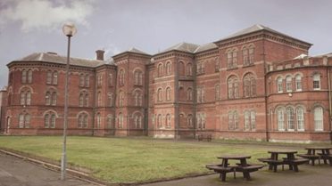

Young was later released from Broadmoor in 1971 because authorities thought that they had ‘cured’ him of psychopathy. He then went to work as a laboratory technician at a chemical factory in Bovingdon, near Hemel Hempstead. Here he is thought to have been the cause of the “Bovingdon Bug” which affected more than 70 people and killed three. This cause of the ‘bug’ Young who was poisoning his co-workers’ tea with thallium sulfate.

|  |  |
| --- | --- |
| Graham Young at his first trial aged 15 | Young at his second trial aged 25 |

**Any more?**

In Australia in the 1950s there were several thallium poisonings, so much so that they became known as Australia's "Thallium Craze". This is partly because at that time thallium sulfate was readily available over the counter as a rat poison.

In one case,Yvonne Fletcher from Sydney killed two husbands using thallium. She nearly got away with the first murder, but suspicions were raised after it became obvious to friends that her second husband was dying and exhibiting the same symptoms that had killed her first husband. A police investigation found clear evidence of thallium in the remains of the first husband’s body, and this led to Yvonne’s being convicted for murder.

Soon after, grandmother Ruby Norton was tried, but later acquitted, for the murder of her daughter's fiancė Allen Williams, who had died of thallium poisoning.

In a sensational trial in1952, Veronica Monty was tried for the attempted murder using thallium of her son-in-law, well-known Australian rugby-league player Bob Lulham. The trial revealed that Lulham and Monty had had an "intimate relationship" while Lulham's wife was at Sunday mass. Neverthless, Monty was found not guilty, but she later Monty killed herself, ironically using thallium, in 1955.

In 1953 Sydney woman Beryl Hague was tried for "maliciously administering thallium and endangering her husband's life". She confessed to buying thallium sulfate rat poison (under the brand name of ‘Thall rat’) and putting it in her husband's tea. She said she wanted to "give him a headache to repay the many headaches he had given me" in past domestic violence.

And in the saem year, Caroline Gills poisoned three members of her family and a friend. Once again the poison was difficult to detect because the thallium sulfate had been added to tea. She spent the rest of her life in jail, where the inmates dubbed her "Aunt Thally”.

 Aunt Thally

**What about outside Australia?**

The leader of Cameroon, [Félix-Roland Moumié](https://en.wikipedia.org/wiki/F%C3%A9lix-Roland_Moumi%C3%A9) was assassinated with thallium in Geneva in 1960 French secret service ([SDECE](https://en.wikipedia.org/wiki/SDECE)). And in Kiev in1987 [Tamara Ivanutina](https://ru.wikipedia.org/wiki/%D0%98%D0%B2%D0%B0%D0%BD%D1%8E%D1%82%D0%B8%D0%BD%D0%B0,_%D0%A2%D0%B0%D0%BC%D0%B0%D1%80%D0%B0_%D0%90%D0%BD%D1%82%D0%BE%D0%BD%D0%BE%D0%B2%D0%BD%D0%B0) and several members of her family found guilty of 40 cases of poisoning (13 of them fatal) with [Clerici solution](https://en.wikipedia.org/wiki/Clerici_solution) (a dense thallium-based solution used to test minerals). In 1988, in Florida, members of the Carr family fell ill from thallium poisoning. The mother died slowly and painfully, while her son and stepson were critically ill but eventually recovered. Their neighbour, George J. Trepal, who was a chemist, was convicted of murder and attempted murder and sentenced to death. In this case, he had placed the thallium into bottles of [Coca-Cola](https://en.wikipedia.org/wiki/Coca-Cola)! There are many other cases, but one of the strangest was in 2004, when 25 Russian soldiers earned Honorable Mentions in the [Darwin Awards](https://en.wikipedia.org/wiki/Darwin_Awards). They all became ill from thallium exposure after finding white powder in a rubbish dump on their base in the far east of Russia. Despite this being an unidentified white powder from a military dump, the soldiers added it to tobacco, and used it as a substitute for talcum powder on their feet!



Moumie

**I’m sure I’ve heard of thallium in TV programs and books…**

Crime writers are always looking for ways for their characters to commit crimes. The world-renowned whodunnit author Agatha Christie knew about the symptoms of thallium poisoning (hair loss) when she wrote her book ‘*The Pale Horse*’ in 1961. In fact This novel is unusual in that it probably saved at least two lives after readers recognised the symptoms of thallium poisoning described in the book. In contrast, the same book was found amongst the belngings of two notorious poisoners (George Trepal and his wife Dr Diana Carr), with the implication being that they got their nefarious ideas from the book.

Another author Ngaid Marsh also gave thallium a mention in the form of thallium acetate in her book *Final Curtain* published in 1947. It’s also appeared in numerous movies (such as *Big Nothing* (2006),  *The Young Poisoner's Handbook* (1955), *Edge of Darkness* (2010), and the James Bond movie *Spectre* (2015)) and TV shows (*House*, *NCIS*, *CSI:NY*, *Royal Pains* to name but a few).

|  |  |
| --- | --- |
|  |  |

**Are there any legitimate uses for thallium sulfate?**

Perhaps the only ethical use of thallium sulfate today is for scientific research. It is currently being used as a source of Tl+ to make thallium sulfide (Tl2S).by the reduction of thallium sulfate.

Tl2SO4 + 4C 🡪 Tl2S + 4CO

Thallium sulfide has many interesting uses such as in early cinematic projectors which enabled the synchronization between sound and picture, as well as its use in the development of long wave infra-red detectors in WW2.

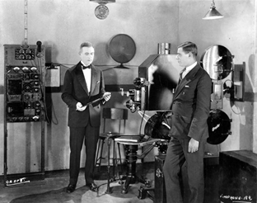

Refs

Wikipedia

Prussian Blue [https://en.wikipedia.org/wiki/Prussian_blue];

Thallium poisoning [https://en.wikipedia.org/wiki/Thallium_poisoning];

Thallium sulfate [https://en.wikipedia.org/wiki/Thallium(I)_sulfate];

Prusian blue antidote [https://en.wikipedia.org/wiki/Prussian_blue_(medical_use)];

Thallium poisoning [https://en.wikipedia.org/wiki/Thallium_poisoning];

Clerici solution [https://en.wikipedia.org/wiki/Clerici_solution];

Félix-Roland-Moumié [https://en.wikipedia.org/wiki/F%C3%A9lix-Roland_Moumi%C3%A9];

Thallium sulphide [https://en.wikipedia.org/wiki/Thallium(I)_sulfide]

**Bio/Chemistry**

Douglas, K. T.; Bunni, M. A.; Baindur, S. R. (1990). "Thallium in biochemistry". *International Journal of Biochemistry*. **22** (5): 429–438.  (Poisoning and antidotes)

[*What is thallium?*](http://news.bbc.co.uk/1/hi/uk/6163520.stm), BBC, November 19, 2006.

**Ecological effects**

Voous, K.H. 1988. *Owls of the Northern Hemisphere*. The MIT Press, 0262220350 (Israeli brown fish owls being wiped out by Tl poisoning)

Mendelssohn, H. [Ecological effects of chemical control of rodents and jackals in Israel](http://rapaces.lpo.fr/sites/default/files/vautour-percnoptere/143/controle_chimique_israel.pdf) (Owls)

**Poisonings**

Michael Farrel, Poisons and Posioners, Bantam, London, 1992

**John Emsley, The Elements of Murder: A History of Poison (**OUP, Oxford, 2005**)**

Amy Ellis Nutt & Sue Epstein, [A 15-year-old case yields a timely clue in deadly thallium poisoning](http://www.nj.com/news/index.ssf/2011/02/thallium_is_favored_method_of.html), The Star-Ledger, February 13, 2011 [http://www.nj.com/news/index.ssf/2011/02/thallium_is_favored_method_of.html] (poisoning)

G. Zhao, M. Ding, Meiping, B. Zhang, W. Lv, H. Yin, L. Zhang, Z. Ying, Q. Zhang, "Clinical Manifestations and Management of Acute Thallium Poisoning". *European Neurology*. **60** (2008): 292–7.

Australian TV documentary [*Recipe for Murder*](https://en.wikipedia.org/wiki/Recipe_for_Murder_(film)), (2011) (Australia’s thallium craze)