# **Trinitrotoluene (TNT)**

The explosive that won WWI & WWII

[Mike Thompson](mailto:mat@rugbyschool.net) & George Innes

[Rugby School](http://www.rugbyschool.net/)

# What is TNT?

The acronym TNT short for 2,4,6 trinitrotoluene. It is an aromatic organic molecule with three nitro groups attached on the 2,4,6 positions of toluene (methyl benzene). TNT was first made in 1863 by Joseph Wilbrand, a German chemist, who was working on the production of dyes. Yellow TNT’s early use was not as an explosive, and this ‘hidden’ property was not discovered for another 20 years. From the mid 19th century until the end of WWII Germany was the world’s leading country in chemical research. [TNT](http://www.ch.ic.ac.uk/vchemlib/mim/bristol/tnt/tnt_text.htm) is a yellow solid at room temperature (mp 80⁰C) and called Trolite in France and Trotyl in Germany. TNT has a detonation velocity of 6900 m/s, and in the early days of its use as an explosive it needed a primary explosive such as fulminate to detonate it.

# How is TNT made?

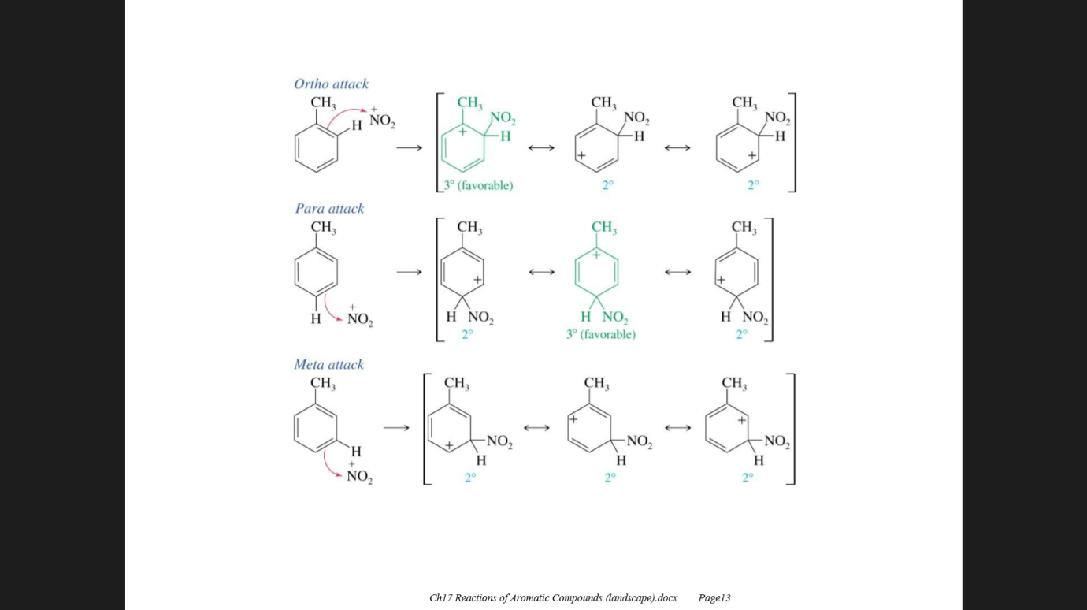TNT is made from toluene using a nitrating mixture (c. sulfuric & c. nitric acid). The methyl group has a positive inductive effect (electron releasing) making the nitration of toluene faster than benzene. The methyl group is also [ortho-para directing](http://www.chemguide.co.uk/organicprops/arenes/nitration.html) stabilising the carbocation intermediates in the 2 and 4 positions on the arene ring.

Generation of the electrophile, nitryl cation (NO2+) is from the reaction between H2SO4 and HNO3.

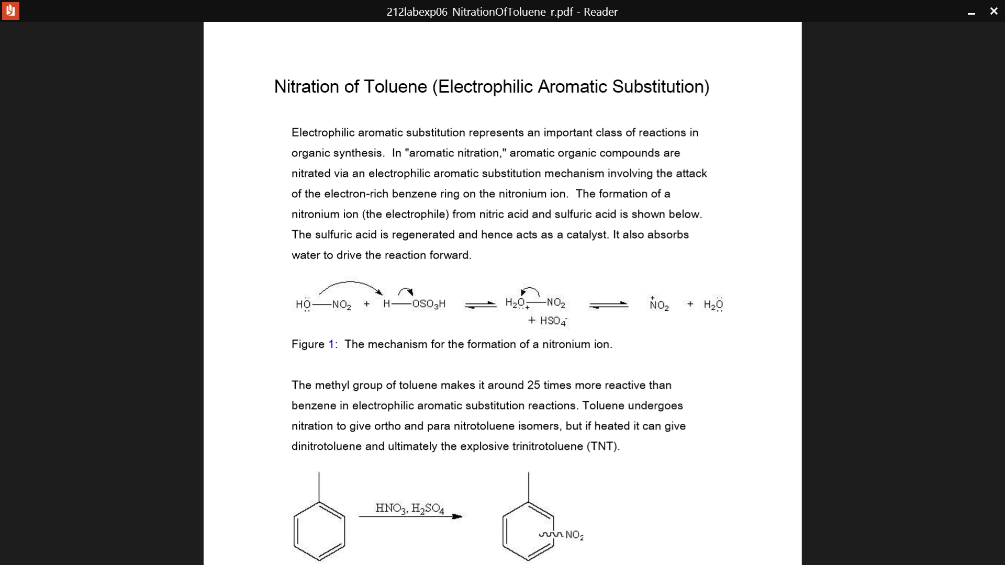

Nitration goes *via* mononitrotoluene (MNT), dintrotoluene (DNT) and then trinitrotoluene (TNT). A [laboratory method](http://web.mit.edu/semenko/Public/Military%20Manuals/RogueSci-Mirror/explo/trinitrotoluene.html) is not to be recommended as a license is needed to make explosives which are highly regulated and require specialist training and equipment. The [dangers](http://www.princeton.edu/~achaney/tmve/wiki100k/docs/Trinitrotoluene.html) of TNT are well documented.

# WWI

During WWI the 8th Viscount Chetwynd was commissioned by the government to set up the National Shell filling factory at Chilwell in Nottinghamshire. During the course of the ‘Great War’ they produced 19 million shells at this site. Due to the great expense of TNT it was mixed with ammonium nitrate to make an explosive called AMATOL which helped make the TNT, which was in short supply, go further. Ammonium nitrate is an oxygen rich molecule so provides extra oxygen to TNT during combustion ensuring a complete and more exothermic combustion. TNT is not shock sensitive which gives it an advantage over other explosives being used at the time like [picric acid](http://oag.ca.gov/sites/all/files/agweb/pdfs/cci/safety/picric.pdf). However, the inevitable happened on the 1st July 1918, when the factory exploded injuring 250 and killing 134. The blast was so loud it was hear over 20 miles away from the site. A memorial to these brave factory workers is found in [St Mary’s Church Attenborough](http://southwellchurches.nottingham.ac.uk/attenborough/hwarmem.php). One side effect of working with TNT was skin of the worker’s (mainly women) turned yellow. These ‘girls’ were known as the ‘[Canary girls](http://www.dailymail.co.uk/news/article-2561630/The-war-children-born-YELLOW-How-women-working-explosives-factories-sparked-clutch-Canary-Babies-WW1.html)’. It is believed that over [400 women died](http://www.striking-women.org/module/women-and-work/world-war-i-1914-1918) from exposure to TNT during the course of WWI.

TNT’s superiority to other explosives was demonstrated at the naval battle of [Jutland](http://www.firstworldwar.com/battles/jutland.htm) (1916) where the German TNT filled shells penetrated the British ships before exploding. This led to more damage than the British shells which detonated on initial impact. Other advantages of TNT is that its relatively low melting point (80oC) allowed it to be poured into shells more easily.

# WWII

In 1941 a brilliant aircraft scientist, [Sir Barnes Wallis](http://www.sirbarneswallis.com/), was working on an experimental bomb to destroy Dams in the heart of the Industrial heartland for the then third Reich. The [bouncing bomb](http://www.youtube.com/watch?v=bOGRTlrYCIE) contained the ubiquitous TNT. In the final attack the bomber had to fly at 220 mph at a height of 60 feet and release the bomb exactly 425 yards from the [Mohne dam’s](http://www.youtube.com/watch?v=i0sRsXjgAyU) wall. Channel 4 produced a television programme Dambusters: Building the Bouncing Bomb which was first shown on 2nd May 2011.

# TNT in Music

The movie [Iron Man 2](http://www.youtube.com/watch?v=huOQWNApKmA) features a lot tracks by the heavy rock band ACDC. One of their iconic songs is [TNT](http://www.youtube.com/watch?v=u09WlvBrneo) which contains these lyrics –

'Cause I'm T.N.T., I'm dynamite  
(T.N.T.) and I'll win the fight  
(T.N.T.) I'm a power load  
(T.N.T.) watch me explode

Whilst ACDC are undoubtedly one of the world’s greatest rock bands their chemistry leads something to be desired as dynamite is based on the explosive nitroglycerine. Perhaps the band were using the word dynamite as a *slang term* for *something very dangerous*? This [link](http://www.youtube.com/watch?v=ZJezWRo4V2w) shows the power of TNT an explosive which the younger generation will have heard of through the game Minecraft.

# How does TNT work?

The equation for the combustion of TNT is shown.

2CH3C6H2(NO2)3 (s) 3N2 (g) + 5H2O (g) + 7CO (g) + 7C (s)

For every 2 moles of TNT we can see that 15 moles of gas is produced giving a large increase in volume of gas which usually amounts to 1 gram of TNT producing 1 litre of gas. From the stoichiometric ratio in the balanced equation there is a very high increase in entropy change. On explosion TNT creates a high velocity shockwave because a large volume of gas is produced in a very hort space of time.

We can also see that TNT is a self-oxidising molecule as there is enough oxygen in the molecule for it to combust without the need for extra oxygen from other sources. Although not all the carbon has been oxidised as there is not enough oxygen in TNT for total oxidation to occur. To get around this problem and maximise the power of a TNT explosion it can be mixed with an oxygen rich explosive to ensure total combustion of the carbon.

# Other explosives containing TNT?

Amatol a 1:1 to 1:4 mixture of TNT and ammonium nitrate used to [demolish](http://www.youtube.com/watch?v=FZ4S0fnKmYw&list=PL5523B0650508D1EC) buildings

Torpex a mixture of TNT & RDX ([cyclonite](http://www.cdc.gov/niosh/npg/npgd0169.html)) and Aluminium used to create large underwater shockwaves when [torpedoes](http://www.youtube.com/watch?v=6PKQaWAFo1k) hit their target.

[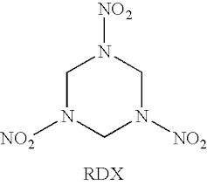](http://www.google.co.uk/imgres?imgurl=http://patentimages.storage.googleapis.com/US8323956B2/US08323956-20121204-C00003.png&imgrefurl=http://www.google.nl/patents/US8323956&h=286&w=320&tbnid=vglLjd8Km5ewGM:&zoom=1&q=rdx%20explosive&docid=X42jwhnKMY3VCM&ei=pg_pU_P6IsGj0QXA0YHwCg&tbm=isch&ved=0CCsQMygMMAw&iact=rc&uact=3&dur=2375&page=1&start=0&ndsp=15)

**References**

1. Birmingham Universities Simon Cotton’s podcast for the RSC on TNT

<http://www.rsc.org/chemistryworld/podcast/CIIEcompounds/transcripts/TNT.asp>

1. Dambusters: Dimensional Analysis worksheet by Dr Andy Davies, Head of Physics, Rugby School.
2. Every Molecule Tells a Story by Simon Cotton, Publisher Chapman & Hall, ISBN-10: 1439807736

<http://www.youtube.com/watch?v=GnRbeknpMoI>