**Tropane**

**The bicyclic amine that is the precursor to ~ $4 billion pharmaceutical industries**

[**Quazi Hasibul Hasan**](mailto:sunny@lab-q.net)

[**Shahjalal University of Science & Technology**](http://www.sust.edu)**, Bangladesh.**

**Molecule of the Month – June 2012**

**What is tropane?**

Tropane is a bicyclic amine that has a pyrrolidine and a piperidine ring sharing a common nitrogen atom and 2 carbon atoms. It is the common structural element of all tropane alkaloids (Lounasmaa and Tamminen, 1993).

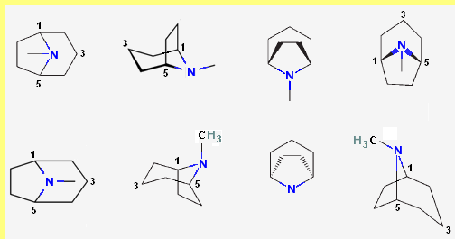

Fig. 1 Tropane; (1R, 5S)-8-methyl-8-azabicyclo [3.2.1] octane

**In what form is it found in nature or used as?**

Tropane does not occur naturally in free form rather it is found as part of esters in plant species. Esters of tropane are generally secondary metabolites of these plants.

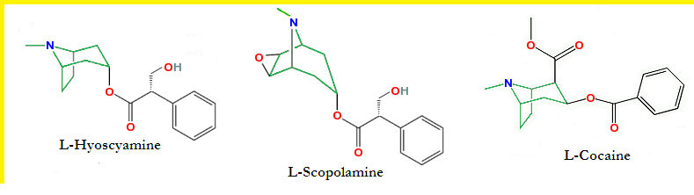

Fig. 2 Some natural esters of tropane

Almost all of the tropane based pharmaceuticals are natural or semi-synthetic esters. There are also alkylated or arylated tropane-compounds known as phenyltropanes.

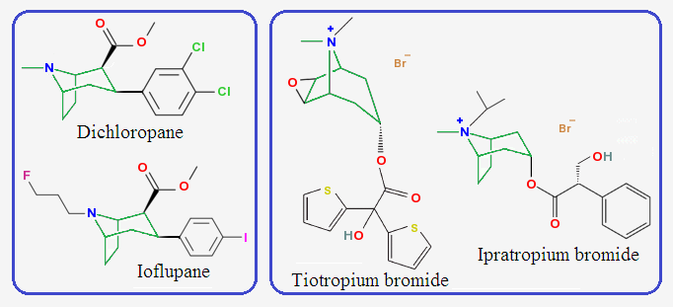

Fig. 3 Arylated or alkylated tropane (left) and semi-synthetic esters (right)

**Why is tropane important?**

Tropane derivatives are among the economically most important pharmaceuticals (Rates 2001; Raskin 2002). Various pharmaceutical industries are manufacturing over 20 active pharmaceutical ingredients (APIs) containing the tropane moiety in their structures; they are applied as mydriatics, antiemetics, antispasmodics, anesthetics, and bronchodilators (Grynkiewicz and Gadzikowska, 2008).

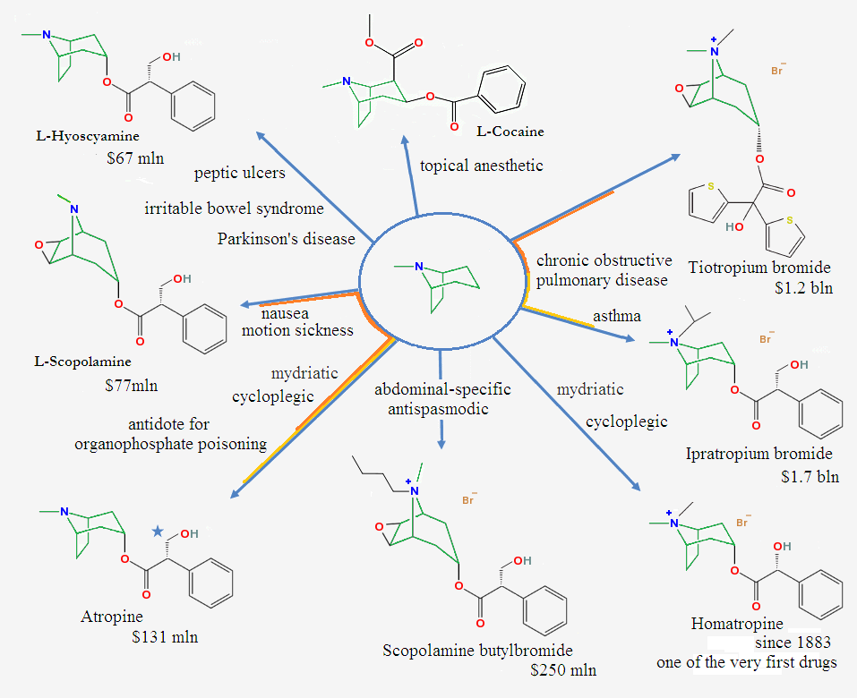

Fig. 4 Tropane in APIs, their major applications, and annual global revenue

**When was its chemistry developed?**

Although alkaloids with the tropane moiety are the oldest medicines known to man, only recently they have been isolated, purified and studied.

|  |  |
| --- | --- |
| **K. Mein** First to isolate atropine in 1831  **P. L. Geiger** First to isolate hyoscyamine in 1833  **Friedrich Gaedcke** First to isolate cocaine in 1855  **K. Kraut and W. Lossen** Discovered how the alkaloid substance can be split, by action of simple chemical agents, into two components: tropine base and tropic acid in 1880  **John Stith Pemberton** (1831–1888) Introduced Coca-Cola in 1886 | Willstar.png  **Albert Ladenburg** (1842-1911) First to isolate scopolamine in 1881. He also discovered the esterification process to synthesis esters with the tropane moiety. |
| Willstar.png  **Richard Martin Willstätter** (**1872–1942**) Established the structures of the tropane alkaloids and cocaine. His tropine synthesis of 1903 was an outstanding milestone in the history of organic chemistry. He won the Nobel prize for chemistry of 1915 largely for solving the structure of chlorophyll and other plant pigments. | Willstar.png  **Sir Robert Robinson** (**1886–1975**) Carried out an elegant biomimetic synthesis of the tropane ring system in 1917 and highlighted the tropic acid biosynthesis problem in 1955. He won the Nobel Prize for chemistry in 1947 for his investigations on plant products of biological importance, especially the alkaloids. |
| Willstar.png  **Edward Leete** (**1928–1992**) Made seminal contributions to the understanding of the tropane alkaloid ring system and cocaine biosynthesis. |  |

**What are the natural sources?**

Esters of tropane have been found in different plant families like Proteaceae, Rhizophoraceae, Euphorbiaceae, Convolvulaceae, Erythroxylaceae, but they are best known for their occurrence in the family Solanaceae. Solanaceaecomprises about 100 genera and 300 species; among them *Datura*, *Brugmansia*, *Hyoscyamus*, *Atropa*, *Scopolia*, *Anisodus*, *Przewalskia*, *Atropanthe*, *Physochlaina*, *Mandragora*, *Anthotroche*, *Cyphantera*, and *Duboisia* are known as being rich in alkaloids with the tropane moiety (Griffin and Lin, 2000).

Commercial cultivation of *Duboisia spp.* inAustralia*, Erythroxylum spp.* inSouth America*, and Hyoscyamus* *muticus* inEgypt*,* constitutes the basis for supply of the global demand for alkaloids with the tropane moiety. Also to a limited extent, *Hyoscyamus niger* is cultivated in USA, UK and India; *Atropa* *belladonna is* cultivated in UK, Germany, former USSR, USA and India; and *Duboisia spp.* are cultivated in India and Ecuador*.* While the *Scopolia spp.* arecollected from wild sources, and used in commercial isolation of tropane alkaloids, in China and Romania.

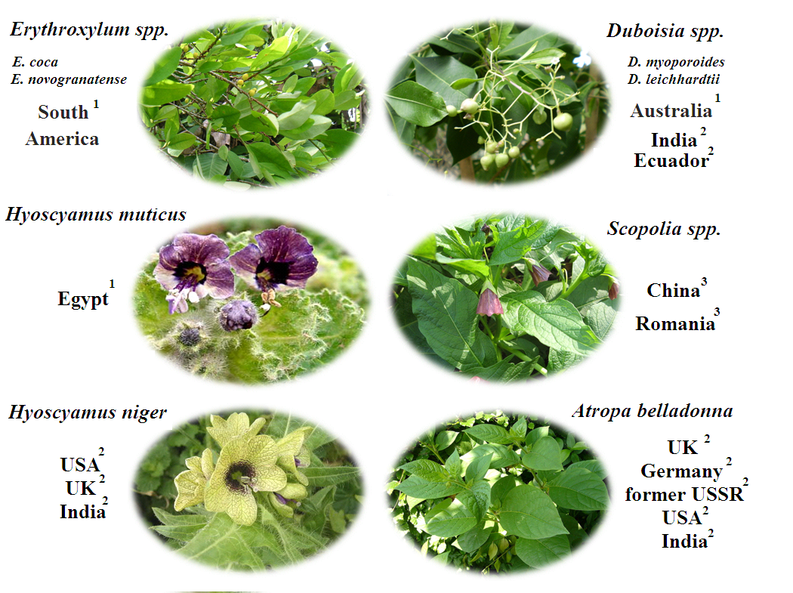

Fig. 5 Commercial cultivation1, Semi-commercial cultivation2, and wild sources3

Hairy root culture, a Biotechnological approach towards efficient alkaloid production, is also in progress for commercialization (along with some technical limitation), e.g. *Agrobacterium rhizogenes* induced hairy root culture of *Hyoscyamus muticus.*

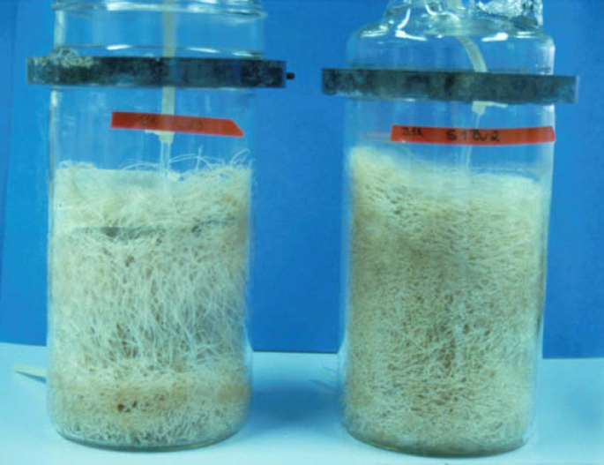

Fig. 6 Hairy root culture of *Hyoscyamus muticus* (Courtesy of Annika Wilhelmson)

**Synthesis routes:**

Although there are many synthesis routes E. L. [1](http://www.lab-q.net/synthesis/syn_tropine)[2](http://www.lab-q.net/synthesis/syn_scopine)[3](http://www.lab-q.net/synthesis/syn_ecgonine), Robinson’s one pot synthesis (1917) is the still the best choice for synthesis of tropane and its derivatives. The original parameters have changed from time to time in order to synthesis a specific derivative or to increase yield.

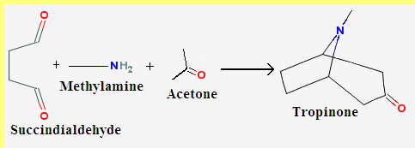

Fig. 7 Robinson’s one pot synthesis of tropinone

**Facts about tropane**

* CAS registry number 529 – 17 – 9 is tropane
* Around 522 compounds with tropane moiety have CAS number.
* In CAS database, 50 - 36 - 2 (cocaine) is the first registered tropane derivative, and 402856 - 42 – 2 (tesofensine) is the last
* Most of the natural tropane derivatives are naturally occurring deliriants
* “Bella dona” which means beautiful lady in Italian, was coined during the Renaissance, because women used the juice (atropine) of the berries of *Atropa belladonna* to enlarge the pupils of their eyes.
* Between 1910’s to 1960’s, doses of scopolamine along with morphine were used to produce twilight sleep in mothers during childbirth. It is a temporary condition where the expectant mother would remain semi-conscious during childbirth but forget the process.
* One of the world’s first synthetic drugs is homatropine, which is a semi-synthetic ester, synthesized by Ladenburg and introduced by E. Merck Company as a mydriatic in 1883.
* The most famous tropane derivative is certainly cocaine, which has been used as both medicine and narcotic since 3000 BC. Some famous products that used to contain cocaine are:

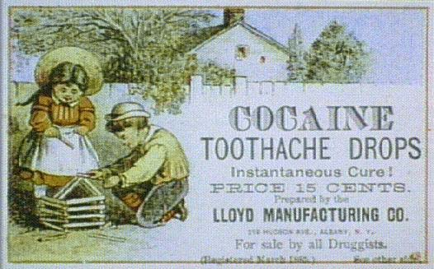 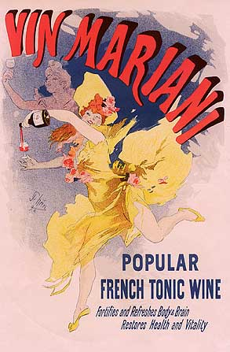

* Coca-Cola is another famous beverage that contains decocanized coca syrup. In the beginning, Cola-Cola used to contain cocaine; and the decocanized formula was introduced after the pass of Pure Food & Drug (USA) act in 1906.

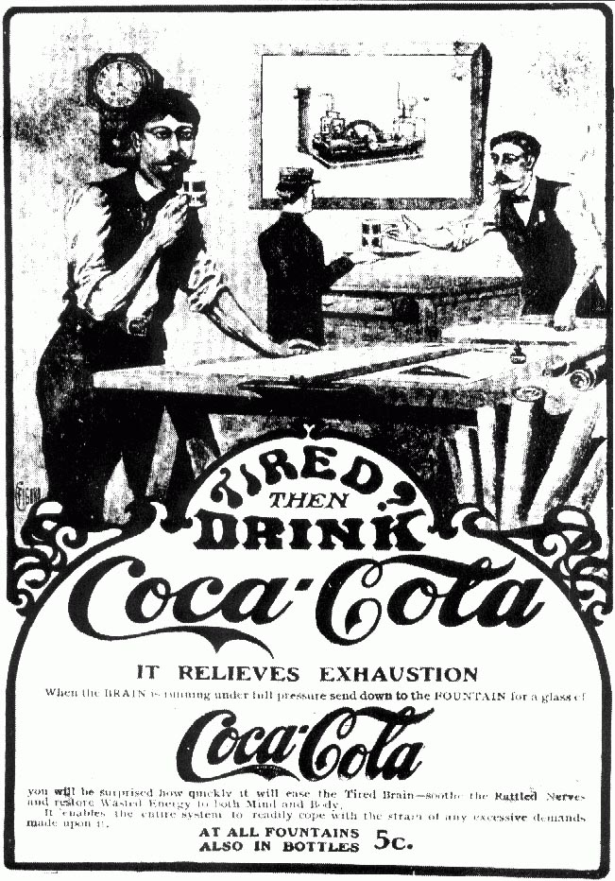 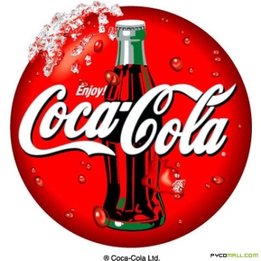

Fig.8. Coca-Cola advertisement in 1902 (left), Coca-Cola today (right)

**Bibliography**

Griffin, W.J. and Lin, G.D. 2000. Chemotaxomic and geographical relationship of tropane alkaloid producing plants. Phytochemistry 53: 623-637

Grynkiewicz, G. and Gadzikowska, M. 2008. Tropane alkaloids as medicinally useful natural products and their synthetic derivatives as new drugs. Acta Pol Pharm – Drug Res, 2008, 60, 439-463

Humphrey AJ, O’Hagan D: Tropane alkaloid biosynthesis. A century old problem unresolved. Nat Prod Rep, 2001, 18, 494–502

Lounasmaa, M. and Tamminen, T. 1993. The tropane alkaloids: Chemistry and Biology. In: The Alkaloids (Ed: G.A. Cordell), Academic Press, New York, Vol. 44, pp. 1-114.

Wilhelmson, Annika. The importance of oxygen availability in two plant-based bioprocesses: hairy root cultivation and malting. Espoo 2007. VTT Publications 652. 66 p. + app. 56 p.

Zarate R, Jaber-Vazdekis NE, Medina B, Ravelo AG: Tailoring tropane alkaloid accumulation in transgenic hairy roots with gene encoding hyoscyamine 6-*β*-hydroxylase. Biotechnol Lett, 2006, 28, 1271–1277

**External Links**

**1.** [**Synthesis procedures of tropine and its derivatives**](http://www.lab-q.net/synthesis/syn_tropine)

**2.** [**Synthesis procedures of scopine and its derivatives**](http://www.lab-q.net/synthesis/syn_scopine)

**3.** [**Synthesis procedures of ecgonine and its derivatives**](http://www.lab-q.net/synthesis/syn_ecgonine)

____________________________________________________________________

**Return to the** [**Molecule of the Month Page**](http://www.chm.bris.ac.uk/motm/motm.htm)

**[DOI:** [**10.6084/m9.figshare.5414788**](http://dx.doi.org/10.6084/m9.figshare.5414788)**]**