URANIUM HEXAFLUORIDE, UF₆
You mean the stuff put in the bombs?

No, that is usually uranium metal.
So you can’t just dig uranium out of the earth?
No, first you have remove impurities from the uranium compound in the ground (uranium is too reactive to occur as lumps of metal, like gold does). Then when you have pure uranium oxide, this then has to be turned into uranium metal. When you have done that, you need to separate the two sorts of uranium atom; it has been estimated that starting from 50 000 tons of uranium ore you can get less than a ton of the kind of uranium atom needed to make a bomb.

So where does the energy come from? What’s an atom bomb?
Atoms bombs (and nuclear power stations get their energy from fission of uranium-235 atoms. Neutrons can split uranium-235 atoms up (fission) into two smaller atoms and release more neutrons. So one reaction that can occur when a neutron of the right energy splits a uranium-235 atom is:
¹n + ²³⁵U → ¹⁴⁰Ba + ⁹³Kr + 3 ¹n
These three neutrons can go on to split three more uranium atoms, producing nine more neutrons; this can continue to produce a self-sustaining chain reaction.
(if you want a static diagram, something like this…?)

There are animations at http://www.npp.hu/mukodes/lancreakcio-e.htm
(in Hungarian!)- covering fission and a chain reaction
An alternative, in English, is at http://www.newcastle-schools.org.uk/chemistry/Radioactivity/Nuclear%20Fission%20Page.htm
Or at http://www.pplweb.com/community/seic/seic_fission.htm
Another at
http://www.pbs.org/wgbh/pages/frontline/shows/reaction/interact/fiss1.html

Why does this nuclear reaction produce energy?
Einstein was the first scientist to talk about mass and energy being interconvertible.
His famous equation is :
E = m c²
(where E is the energy, m is the mass, and c is the velocity of light)

The total mass of all the particles produced in the fission reaction is a little less than that of a ²³⁵U plus a neutron; the difference is released as energy.
So each time a uranium-235 is split, a chunk of energy is released. The more atoms split, the more energy is released. If the chain reaction gets out of control, so much energy is produced that a nuclear explosion would occur, and this is how an atom bomb works.

I’ve found a video of the Trinity explosion (July 16th 1945) at http://www.danshistory.com/ww2/atombomb.html
I don’t know if there is a better one, it takes time to unload.
or
http://gk12.rice.edu/trs/science/Atom/man.htm
has a video including clips from Grolier claimed to be picture of the first atom bombs being dropped on Japan.

Does this work with all uranium atoms?
No. Natural uranium is 99.28% ²³⁸U and 0.72% ²³⁵U. Only the ²³⁵U atoms undergo this kind of fission.

What’s the difference?
Both uranium atoms have 92 protons; ²³⁸U atoms have 146 neutrons and ²³⁵U atoms have 3 less.
So why don’t nuclear power stations explode, just like atom bombs?
Nuclear power stations have to have effective control devices that regulate how many neutrons are flying round the reactor, by absorbing any excess when the fission process is getting too fast.

How do power stations use the energy produced by fission?
Heat is removed from the nuclear reactor by a circulating coolant; the hot coolant is used to boil water, making steam. This drives a turbogenerator to make electricity.

For animations:-

http://www.pbs.org/wgbh/amex/three/sfeature/tmihow.html
http://www.nei.org/scienceclub/nuclearworld/nw_nuclearenergy.html

What is all the fuss about nuclear waste?
The atoms formed when uranium atoms are split up are usually very radioactive. The "used" fuel rods from a reactor [discarded when about 25% of the uranium has undergone fission] are kept in a cooling pond for months for the more intensely radioactive atoms to decay and release most of their energy. Then they have to be processed to separate "unused" uranium atoms from the remaining fission products that have to be stored safely.

All nuclear reactors are man-made, right?
In 1972, it was discovered that the uranium content in a mine at Oklo in Gabon (Africa) was very low in ²³⁵U. The only acceptable explanation is that some time in the past millions of years ago pockets of ore were formed that contained enough ²³⁵U for natural nuclear reactors to be formed (²³⁵U made up 3% of natural uranium at that time). Isotopes of fission products of ²³⁵U have been found in the ore, in just the exact amounts expected to confirm this theory.

So where does UF₆ fit into all this?
Its main use lies in the separation of the two main isotopes of uranium; you may remember that the most abundant isotope, ²³⁸U, does not readily undergo nuclear fission, but the 0.71% of ²³⁵U readily undergoes fission with slow neutrons.

What’s its structure?

That’s a lot of fluorines!
If you want a compound of an element in a high oxidation state, fluorine is the most likely element to help you achieve it; partly favoured by the low F-F bond energy, partly because fluorine forms strong bonds with almost any other element. So uranium isn’t the only element to form a hexafluoride. Other actinides like Np and Pu do it; several of the platinum metals like Pt, Ru, Os, Rh and Ir form them, so do Tc, Re, Mo and W; and of course there are the famous noble-gas compound XeF₆ and the unreactive gas SF₆ (important in the electrical industry as an insulating gas and recently the subject of concern for its potential in global warming) as well as SeF₆ and TeF₆ . But UF₆ is the most important, as we shall see.
What is UF₆ like?
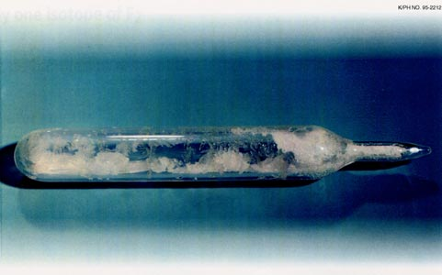
UF6 crystals in a glass vial. (from http://www.npp.hu/uran/2hex-e.htm )
It is a white crystalline solid at room temperature (its triple point is 64°C (147.3°F) and sublimes at 56.5°C (133.8°F) at atmospheric pressure). The liquid phase only exists under pressures greater than about 1.5 atmospheres and at temperatures above 64 ˚C (see the phase diagram)
http://web.ead.anl.gov/uranium/guide/prodhand/sld022.cfm
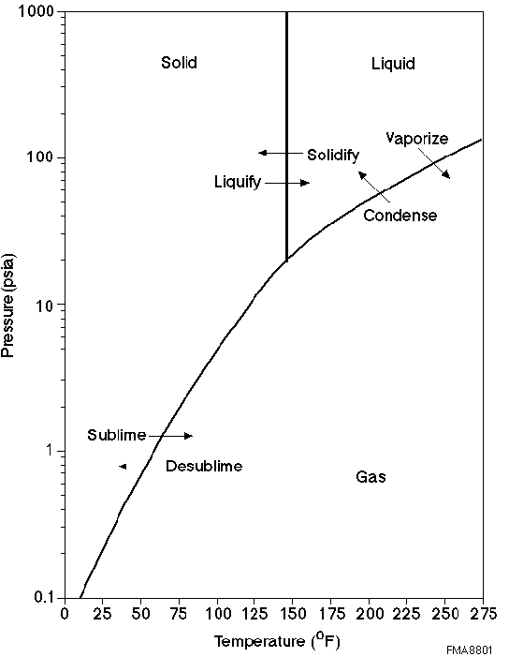
Phase diagram, showing relationship between pressure, temperature, and physical form.

Like all the other hexafluorides (except XeF₆) it has an octahedral structure (U-F = 1.994 Å), with strong covalent bonds within the molecules but only weak Van der Waals' forces between neighbours, so that it has a low boiling point and melting point. Vibrational frequencies are ν₁ (R) 667 cm⁻¹; ν₂ (R) 535 cm⁻¹; ν₃ (IR) 624 cm⁻¹; ν₄ (IR) 186 cm⁻¹; ν₅ (R) 201 cm⁻¹; ν₆ (inactive) 140 cm⁻¹

Is it reactive?
It does not react with dry air, oxygen, nitrogen or carbon dioxide. However, when it comes in contact with water, even traces, it undergoes hydrolysis to uranyl fluoride (UO₂F₂) and the corrosive and toxic gas HF.
UF₆ + 2 H₂O → UO₂F₂ + 4 HF
For this reason, it attacks glass unless absolutely free of either water or HF. It reacts with many elements (e.g. Group I and II metals; B, Al, Ga, In, C. Si-Pb etc) forming their fluorides. Most hydrogen-containing compounds react forming HF, so that hydrocarbons (including arenas) form a mixture of carbon fluorides, carbonaceous material and HF, but there is no reaction with fluorocarbons such as Teflon. It attacks many metals, except Ni (owing to the formation of a surface coating of fluoride) and Al that bears a surface oxide layer.

How is it made?
There are many ways of making UF₆. Although reaction of uranium and fluorine was first noted by Henri Moissan, first isolator of fluorine, c.1900, UF₆ was originally reported by Ruff (pioneer of syntheses of many metal fluorides) and Heinzelmann in 1911. They made it by fluorination of uranium, and also by fluorination of UC₂; fluorine needs to be heated to react with uranium, unless it is finely divided.
U (s) + 3 F₂ (g) → UF₆ (g)
UC₂ (s) + 7 F₂ (g) → UF₆ (g) + 2 CF₄ (g) (at 350°C)
An unusual reaction which does not use fluorine (but which has not been employed commercially) is:-
2UF₄ (g) + O₂ (g) → UF₆ (g) + UO₂F₂ (g)
The main process used industrially employs fluorination of UF₄ at around 500°C. It is a very exothermic process; temperatures can reach 1100°C in reactors with capacities of up to 380 kg per hour.
UF₄ (g) + F₂ (g) → UF₆ (g)

Presumably UF₄ has to be made first
Indeed, and its synthesis from the uranium ore is quite a complicated process. The uranium is usually present in the ore as an oxide, approximating to U₃O₈. This is dissolved in nitric acid forming UO₂(NO₃)₂.6H₂O (In some places, carbonate leaching, affording [UO₂(CO₃)₃]⁴⁻ is used). This is purified by extraction using a solvent such as tributylphosphate in kerosene; after evaporation of the solution, the resulting solid is roasted to form UO₃.
The resulting UO₃ is then converted into UF₆ in a three-stage process.
- UO₃ (s) + H₂(g) → UO₂(s) + H₂O(g)
- UO₂ (s) + 4HF(g) → UF₄(s) + 2 H₂O(g)
- UF₄ (g) + F₂ (g) → UF₆ (g)

How is UF₆ used?
It is extremely volatile (it has a vapour pressure of around 120 mm Hg at room temperature) so can be handled as a gas for the isotope separation.

How is the separation achieved?
Several methods have been used:-
- Gaseous diffusion
- Electromagnetic isotope separation
- Gas centrifugation
- Laser isotope separation
Electromagnetic isotope separation, using UCl₄, was the original method used in the Manhattan project in a plant at Oak Ridge Tennessee. Laser isotope separation has been little used, the best known version being the Australian Silex process. Of the other two processes, something over 90% of the world’s enriched uranium is obtained this way.
In gaseous diffusion, UF₆ gas is forced to diffuse under pressure through porous membranes. The lighter ²³⁵UF₆ molecules diffuse slightly faster than the ²³⁸UF₆ molecules though over 1000 stages are required to produce a UF₆ product with even 3-4% enrichment. As the most volatile uranium compound, UF₆ was an obvious choice for use, but because of its high reactivity and problems associated with its handling, many alternatives were investigated, such as alkoxides, whilst unsuccessful attempts were made by Gilman to obtain simple alkyls. Ultimately the technology was improved to enable full advantage to be taken of its volatility.

Hazards
As an α-emitter, uranium is not especially hazardous unless ingested by the body. However, the ready reaction of UF₆ with water makes it a potentially hazardous substance, owing to the toxicity of the HF produced.
In a 1944 accident when a cylinder containing UF₆ was being heated by steam, a weld ruptured, releasing some 400 lb of UF₆; the reaction of UF₆ with steam released sufficient HF to cause two fatalities. Another person was killed by inhaled HF in 1986 following rupture of a heated cylinder; some 31 other people were exposed to the fumes but no one else appears to have suffered long-term ill effects.

Bibliography

General material on uranium
S.A.Cotton, Lanthanides and Actinides, Macmillan, London, 1991.
J.J.Katz, G.T.Seaborg and L.R.Morss, The Chemistry of the Actinides, 2nd edn., Chapman and Hall, London, 1986.
http://www.chem.ox.ac.uk/icl/heyes/LanthAct/lanthact.html
http://www.uic.com.au/

Background to uranium

L.Bickel, The Deadly Element. The Story of Uranium, London, Macmillan, 1980.
Primo Levi, The Periodic Table, New York: Schocken Books, 1984; Everyman’s Library, 1997.

A brief history of the Manhattan project
http://gk12.rice.edu/trs/science/Atom/man.htm

UF₆

Properties
J.E. Macintyre (ed), Dictionary of Inorganic Compounds, Chapman and Hall, London, 1992, entries IC-018690

Synthesis:-
N.P.Freestone and J.H.Holloway, in G.Meyer and L.R.Morss (eds), Synthesis of Lanthanide and Actinide Compounds, Kluwer, Dordrecht, 1991, pp80-87.
O.Ruff and A.Heinzelmann, Ber., 1909, 42. 495; Z.,Anorg.Allgem.Chem., 1911, 72, 63.

Vibrational spectrum
E.L.Grasner and B.Frlec, J.Chem.Phys., 1968, 49, 5135
H.H.Claassen, G.L.Goodman, J.H.Holloway and H.Selig, J. Chem. Phys.,1970, 53, 341

Extraction
http://www.uilondon.org/education_resources/chemistry_of_uranium/index2.htm
http://www.ne.doe.gov/uranium/facts.html

Isotope separation

Diffusion
http://www.fas.org/nuke/intro/nuke/uranium.htm
http://www.uic.com.au/nip33.htm
http://www.fas.org/irp/imint/doe_paducah_01.htm

Centrifuge
http://www.schneider.fr/html/kiosque2/old_parutions/references7/eurodif.htm
http://www.cogema.fr/cogema/fr/connaitre/sites/fiche_eurodif.htm
Silex
http://www.silex.com.au/

Overall process
http://www.ne.doe.gov/uranium/facts.html

Portsmouth Gaseous diffusion site
http://web.ead.anl.gov/uranium/guide/prodhand/sld025.cfm

Toxicity
http://web.ead.anl.gov/uranium/guide/health/accident/index.cfm
http://fast.antenna.nl/wise/uranium/rup.html#UF6
http://www.ilo.org/public/english/protection/safework/cis/products/icsc/dtasht/_icsc12/icsc1250.pdf

Picture
http://web.ead.anl.gov/uranium/guide/uf6/index.cfm
http://www.npp.hu/uran/2hex-e.htm

