VANILLIN

http://www.cottoninc.com/CottonCandyPress/CottonCandyPressIssue2/images/ICE-CREAM.jpg
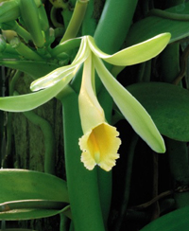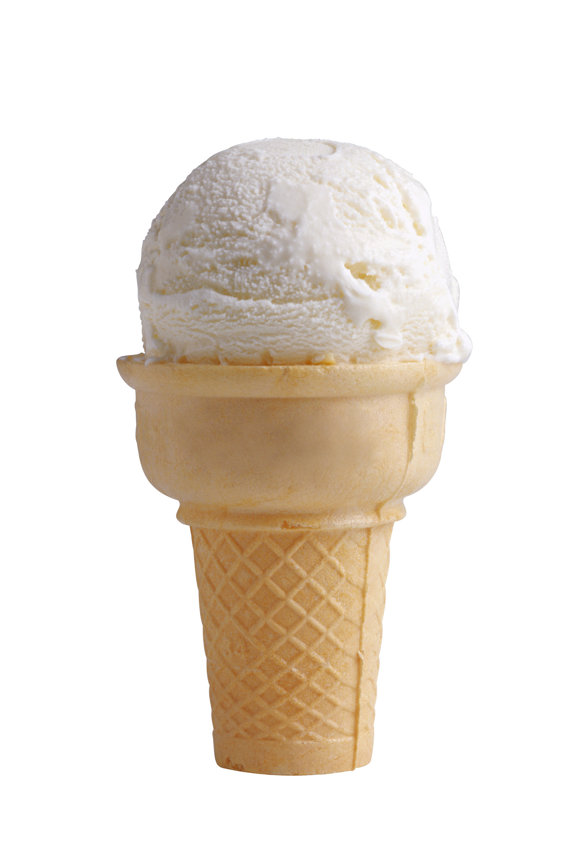

http://www.orchidsaustralia.com/images/vanilla.jpg

Is this it the same as Vanilla?
No: Vanillin is a single molecule, 4-hydroxy-3-methoxybenzaldehyde (much easier to call it Vanillin). It’s a white crystalline solid, which melts at 81ºC. Vanilla planifola is an orchid which produces seed pods from which vanilla extracts are obtained; these extracts contain nearly 200 different molecules, of which vanillin is the most important, and most abundant, making up 98% of the eventual vanilla extract. Vanillin itself was first isolated from vanilla pods by Nicholas-Theodore Gobley in 1858 (though he thought that its formula was C₁₀H₆O₂, not C₈H₈O₂). The biosynthetic pathway starts with phenylalanine.

So you just pick it off the trees.
Not so simple, and not just because vanilla grows on vines, not trees. The freshly harvested green vanilla pods do not smell “vanilla” as the vanillin is locked up inside them as a β-D-glycoside.

The pods have to be cured, during which time they become deep brown, and enzymes release the vanillin from the glycoside, along with over a hundred other molecules, all of which contribute to the authentic vanilla aroma. Vanillin itself makes up about 2% of the final mass of the “cured” beans.

http://www.huahuafarm.com/imgVanillaBeans.jpg

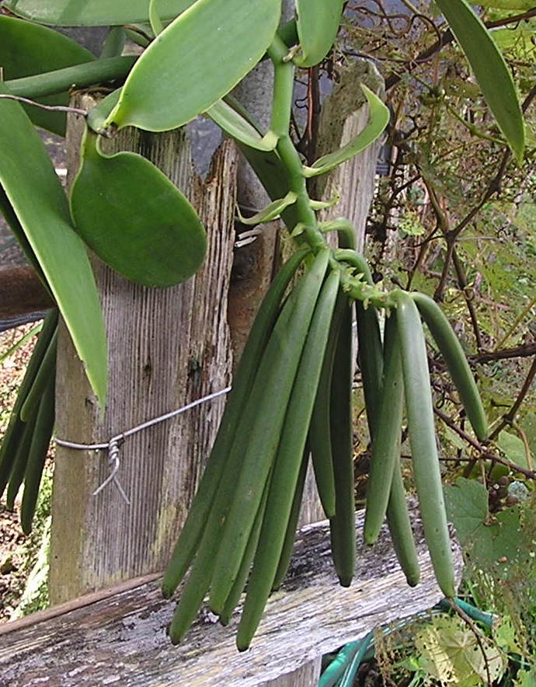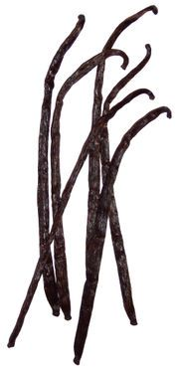
http://asimpleyarn.net/wp-content/uploads/2007/04/vanilla-pods.jpg

And it is a modern flavouring
Not so. The vanilla plant, Vanilla planifola, originates in subtropical forests in Mexico and parts of Central America, and it was the Mayan and Aztec civilisations which first realised the potential of vanilla, using it to lighten up the flavour of the chocolate that they drank. The Aztec leader Moctezuma hinted to Hernán Cortés (who led the Spanish invaders) that the Aztecs’ vanilla flavoured chocolatl drinks were a very useful aphrodisiac. After their conquest of these areas, the Spaniards brought vanilla to Western Europe in the early 16th century.

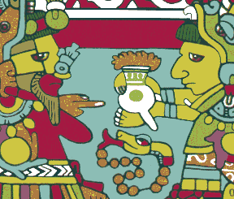

http://www.athenapub.com/nuttal1x.GIF

But there wasn’t any ice cream around then.
People discovered lots of other uses, as a sweetener and flavour enhancer, in food flavourings and confectionary, not just chocolate, in medicines and cleaning products (including soap), not to mention to mask flavours in animal feed. Eventually it found its way into Coca-Cola, and into some great perfumes and fragrances. Nowadays it is widely used in chemical synthesis, for example in the manufacture of L-dopa, for treatment of Parkinson’s disease, of the antibacterial compound trimethoprin, and of the heart drug papaverin
In research laboratories, acidic solutions of vanillin in ethanol are used as a developing (visualising) agent for tlc plates as it gives coloured spots with a range of different compounds.

Why does the distinction between vanilla and vanillin matter?
Production of vanilla spread well beyond Central America, once it was discovered that vanilla orchids could be fertilised manually. It has been grown in tropical regions as diverse as the Caribbean islands, Tahiti, Réunion, Madagascar (the world leader) and the Indonesian archipelago. Despite this, since the 19th century, demand has vastly outstripped production of natural vanilla, so that synthetic routes to vanillin had to be found. Nowadays less than 5% on vanilla flavouring comes from natural sources; many people are so conditioned to the use of synthetic “vanilla” flavour that they prefer it to the real thing, and may wonder about the tiny flakes of vanilla beans they find in an up-market ice cream.

Does it really matter if the vanillin is natural or synthetic?
Because genuine vanilla extract from pods is 200 times more expensive than counterfeit vanilla essence using synthetic vanillin, detection of fake vanilla is important. Some fakes can be detected using chromatography, but the goalposts keep moving. One of the first detection methods relied on the fact that vanillin obtained from fresh vanilla pods had higher radiocarbon (¹⁴C) levels than vanillin from petrochemical sources (though it did not distinguish it from material obtained from fresh lignin); in response, the fakers added extra ¹⁴C to their vanillin. Analysts then examined the ¹³C/¹²C ratios in the samples by mass spectroscopy. A distinction is possible because the vanilla orchid has an unusual biosynthetic pathway for vanillin so that more ¹³C than usual is incorporated; “fake” vanilla extract will originate in material with a lower ¹³C/¹²C ratio; in their turn, the fakers added ¹³C to their molecules, usually just at one site – analysts have hit back by using site-sensitive NMR techniques (SNIF-NMR). On some levels, this problem is somewhat semantic, since the two products are identical by taste.

So, how can you make vanillin?
If you just want to make a few grams, a very convenient laboratory synthesis has recently been described, involving electrophilic bromination of 4-hydroxybenzaldehyde, followed by copper-catalysed methoxylation

As far as large-scale industrial syntheses go, a classic early method starts from eugenol, which occurs naturally in cloves, nutmeg and cinnamon. This isomerises to isoeugenol in alkaline solution, and this in turn can be oxidised (by nitrobenzene) to vanillin.

Other oxidising agents like acidified potassium dichromate can be used, but then the OH group has to be protected by acetylation prior to oxidation.

More dramatic is the Reimer-Tiemann method (1876). Here another natural product, guaiacol, obtained from sources like pine tar, gains an aldehyde group when refluxed with an alkaline solution of chloroform. The mechanism is now known to involve the carbene species :CCl₂.

A more modern method reacts guaiacol, itself obtained from catechol, with glyoxylic acid, and that is how a lot of vanillin is produced today.

Early in the 20th century, chemists found out that lignin was a source of vanillin; lignin makes up around 5% of the sulphite waste waters from paper mills. Lignin is a polymer with a strengthening role in woods and in the cell walls of plants (simplified structure below). On combustion of wood at relatively low temperatures, the polymeric structure breaks down into small units, and small molecules such as vanillin and guiaicol are formed; these are responsible for the smell and taste of smoked food. Wine stored in oak casks similarly gains some of its flavour from leached vanillin. From the 1920s, much of the world’s vanillin was extracted from lignin waste.

Not only did this process make vanillin, it also cut down on organic discharges, but at present this is out of favour in North America, owing to environmental concerns, as over 160 tons of “caustic waste” are produced per ton of vanillin.

Ferulic acid, found in many plants, is another source of vanillin, via microbial routes.
A new lignin route to vanillin is a possibility, ever since Dr Mayu Yamamoto, of the International Medical Centre of Japan, realised that cow dung contained a lot of lignin, from the animal’s feed. She found a way of extracting the lignin, then converting this to vanillin. In fact, many herbivores’ excrements yield vanillin. Her achievement saw her win the Ig Nobel prize of Chemistry for 2007, the award – a send-up of the “real” Nobel prize - being presented at a ceremony at Harvard University on October 4th 2007. At the time, a leading ice cream parlour in Cambridge, Massachusetts (home of Harvard) created a new ice cream flavour, “Yum-A-Moto Vanilla Twist”, offering free public tastings. This was created from genuine vanilla beans; since food labelling laws will require the origin of vanillin to be disclosed, such vanillin of animal origin would only find non-food outlets.

[Picture of Mayu Yamamoto at the Ig Nobel ceremony].
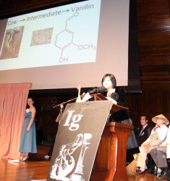

http://mdn.mainichi.jp/national/news/20071005p2a00m0et025000c.html

The Shroud of Turin
Vanillin came into the picture in the debate over the dating of the Shroud of Turin, which many believe to be the burial cloth of Jesus Christ. Radiocarbon datings made in 1988 suggested that the age of the Shroud was 1260-1390 AD, at odds with chemical evidence. Recent examination of vanillin levels in the Shroud showed vanillin to be present in cloth added following a fire in 1532, but absent from the older parts of the Shroud. Vanillin levels in material containing lignin fall with time, thus it cannot be detected on the 2000-year-old Dead Sea Scrolls linen too. Examining of the kinetics of vanillin loss indicated the main part of the Shroud to be between 1300 and 3000 years old, suggesting that the radiocarbon dating sample may have been taken from a newer piece of material.

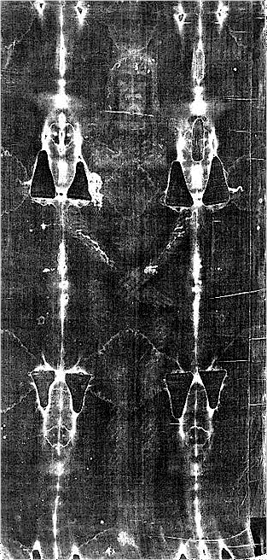

http://www.21c-online.com/ShroudTurin-4.JPG

http://www.nachtkabarett.com/ihvh/img/shroud4.gif

And the Perfumes?
Two classic Guerlain perfumes use vanillin molecules as key elements. In 1889, Aimé Guerlain created Jicky, which over a century later remains amazingly contemporary. It is often said to be the first “modern” perfume, utilising synthetic ingredients. The initial impact is provided by top notes of lavender, lemon and bergamot, followed by a similarly cold and rosy middle, supported by a warm base of amber, musk and, above all, vanilla (“un ballet olfactif”).

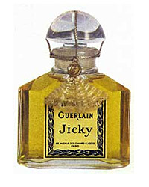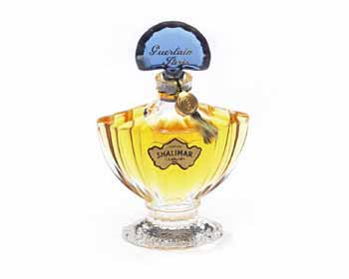

Aimé Guerlain’s nephew Jacques was responsible for Shalimar in 1925 (named after the garden that the Mughal emperor Shah Jahan created for his wife). It is said that he added synthetic ethyl vanillin to a sample of Jicky. Ethyl vanillin, which does not occur naturally, has a much stronger vanilla smell than its methyl analogue, vanillin itself. The odour threshold of ethyl vanillin is given as 0.000007 mg/m³ of air, in comparison for a value for vanillin itself in the range 0.005 – 0.000001 mg/m³ of air. In Shalimar, the lemon and bergamot impact again presages the floral middle passage (rose, jasmin) against a warm vanilla base. The result is quite sensual. Just think of Mireille Darc in Les Coeurs Brûlés.



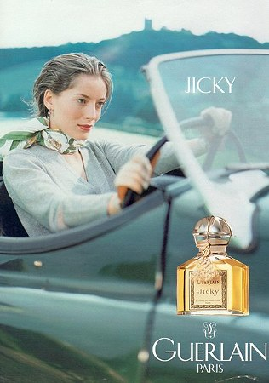

http://www.escentual.com/isroot/Escentual/SiteImages/ProductImages/Guerlain/Jicky/edp.jpg

http://www.thestylegroup.com/TSG_Optimized/top10/perf_lrg_shalimar.jpg

http://news.xinhuanet.com/fashion/2005-12/12/xin_41212021209525152781132.jpg

www.librarising.com

Bibliography

Vanilla
Patricia Rain, Vanilla: The Cultural History of the World's Favorite Flavor and Fragrance, Jeremy P.Tarcher, 2004.
Tim Ecott, Vanilla: Travels in Search of the Ice Cream Orchid, Grove/Atlantic, 2004.
A. S. Ranadive, in G. Charalambous (ed), Spices, Herbs and Edible Fungi (Developments in Food Science), Elsevier, 1994. pp 517-577.
H. McGee, McGee on Food and Cooking: An Encyclopedia of Kitchen Science, History and Culture, Hodder & Stoughton, 2004, 448-449, 699, 731, 738.
P. Le Couteur and J. Burreson, Napoleon's Buttons: How 17 Molecules Changed History, J.P.Tarcher, 2003, pp 129-130, 138-139.
Andrew Dalby, Dangerous Tastes: The Story of Spices, British Museum Press, 2000, pp 147-148, 158.
Robert L. Wolke, What Einstein Told His Cook: Kitchen Science Explained, W.W.Norton, 2002, pp 105-106
Robert L. Wolke, What Einstein Told His Cook 2: The Sequel - Further Adventures in Kitchen Science: The Sequel v. 2, W.W.Norton, 2005, pp. 363-366, 425
http://en.wikipedia.org/wiki/Vanilla

Vanillin
Dictionary of Organic Compounds, J.Buckingham and F. McDonald, eds., Chapman and Hall, London, 6th edition, 1995, Compound D-0-06926.
L. J. Esposito, K. Formanek, G. Kientz, F. Mauger, V. Maureaux, G. Robert, and F. Truchet, "Vanillin", Kirk-Othmer Encyclopedia of Chemical Technology, 4th edition , 1997, John Wiley & Sons, Vol 24, pp 812–825 (see also vol. 11, pp 20-21 for odour thresholds)
Ullman’s Encyclopedia of Industrial Chemistry, Wiley-VCH, 6th edition, 2003, Vol 14, pp 137-139.
N. J Walton, M. J. Mayer, and A. Narbad, "Vanillin". Phytochemistry, 2003, 63, 505–515 (rev, esp. biosynth).
S. Budavari, M. J. O'Neil, A. Smith, P. E. Heckelman, J. F. Kinneary, The Merck Index, 12th. ed., 1996, Merck & Co., Inc., p. 1693.
http://en.wikipedia.org/wiki/Vanillin

Syntheses
N-T. Gobley, Journal de Pharmacie et de Chimie, 1859, 34, 401 (original isolation).
D. F. Taber, S. Patel, T. M. Hambleton, and E. E. Winkel, J. Chem. Educ. 2007, 84, 1158. (lab. scale)
O. Snow, Love Drugs, Thoth Press, 2005, p.38 (electrochemical synthesis from isoeugenol)

The Reimer-Tiemann reaction
I. L. Finar, Chemistry. Volume 1. The Fundamental Principles, Longman, 6th edition, 1973, pp 743, 747.
R. A. Mackie, D. M. Smith and R. A. Aitken, Guidebook to Organic Synthesis, Longman, 1990, p.103

Synthesis from lignin
Kirk-Othmer Encyclopedia of Chemical Technology, 4th edition , 1997, John Wiley & Sons, Vol 15, pp 280-281.
Ullman’s Encyclopedia of Industrial Chemistry, Wiley-VCH, 6th edition, 2003, Vol 19, pp 515-516.
M. B. Hocking, J. Chem. Ed., 1997, 74, 1055–1059 (review).
O. Snow, Love Drugs, Thoth Press, 2005, p.143 (synthesis from peat)

Extraction from cow dung

M. Yamamoto, Aroma Res., 2006, 7, 258
http://pubs.acs.org/cen/newscripts/85/8541newscripts.html
http://www.forbes.com/home/feeds/afx/2006/03/06/afx2571739.html

Synthesis through microorganisms.
L. Lesage-Messen, M.Delattre, M.Haon, J.-F.Thibault, C. Ceccaldi, P.Brunerie and M. Asther, J. Biotechnol., 1996, 50, 107.
A. Muheim and K.Lerch, Appl. Microbiol. Biotechnol., 1999, 51, 456.
H. Priefert, J.Rabenhorst and A. Steinbüchel, Appl Microbiol Biotechnol., 2001, 56, 296. (rev)

Detecting genuine vanilla extract
http://www.greener-industry.org/pages/vanillin/3Vanillin_Issues.htm
R. Hoffmann, “Fraudulent Molecules”, American Scientist, 1997, 85, 314.
Available online at http://www.roaldhoffmann.com/pn/modules/Downloads/docs/Fraudulent_Molecules.pdf
G. S. Remaud, Y.-L. Martin, G. G. Martin, and G. J. Martin, J. Agric. Food Chem., 1997, 45, 859. (SNIF-NMR)
D. A. Krueger and H. W. Krueger, J. Agric. Food Chem., 1983, 31, 1265. (carbon isotopes)
D. A. Krueger and H. W. Krueger, J. Agric. Food Chem., 1985, 33, 323 (fraudulent C-13 labelling)
G. Lamprecht, F. Pichlmayer, and E. R. Schmid, J. Agric. Food Chem., 1994, 42, 1722. (isotope analysis)
G. E. Martin, M. W. Ethridge and F. E. Kaiser, J. Food Science, 1977, 42, 1580.

Perfumes
J. Emsley, The Consumer’s Good Chemical Guide, W. H. Freeman, 1994, pp 1-23.
L.Turin, The Secret of Scent, Faber and Faber, 2006, pp 46-48.
C. Sell (ed), The Chemistry of Fragrances: From Perfumer to Consumer, Royal Society of Chemistry, 2nd edition, 2006, pp 44-45, 116-118.
S. Girard-Lagorge, 100 Parfums de légende, Solar, 2000, pp 78, 80-81.
D. Veuillet-Gallot, Le Guide du Parfum, Éditions Hors Collection, 1996, pp 82-84, 87-88.

Ice Cream
C. Clarke, The Science of Ice Cream, Royal Society of Chemistry, 2004, pp 54-55.
M. Powell, Ice Cream, the delicious history, Overlook Press, 2006.

Shroud of Turin
R. N. Rogers, “Studies on the Radiocarbon Sample from the Shroud of Turin”, Thermochimica Acta, 2005, 425, 189-194.
R. N. Rogers, and A. Arnoldi, “Scientific Method applied to the Shroud of Turin”; http://www.shroud.com/pdfs/rogers2.pdf

