Photochemical Reactors

Within our group we use three routine experimental methods to carry out our organic photochemistry. Firstly irradiation via mercury discharge lamps, these can be coupled with (1) a fixed volume batch reactor or as part of (2) a continuous flow reactor system. The third method of irradiation is (3) the use of Nd:YAG and dye lasers. Each method has its pros and cons and what follows is a basic description of each method tailored to a level for new users. We hope it is hopeful.

(1) Photochemical Batch Reactors

Generally synthetic organic photochemistry is usually performed in solution using immersion well batch reactors. These are fixed volume batch reactors irradiated from within using single mercury vapour discharge lamps (Figure 1).

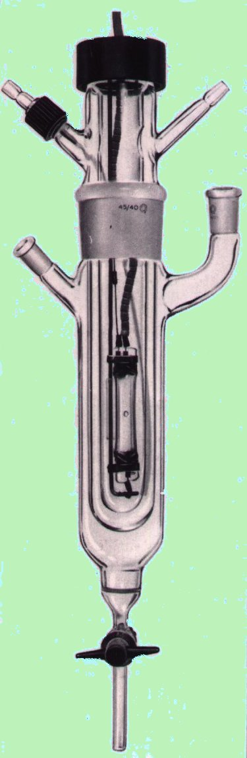

Figure 1. Immersion well batch photochemical reactor,

Mercury vapour lamps are the most commonly used light source. There are three main types of mercury lamp; low pressure, medium pressure, and high-pressure lamps, each having a different output spectrum. Low-pressure lamps (10⁻⁵ atm), operate at temperatures ranging from 40-50°C and emit two wavelengths of radiation at 253.7 nm and 184.9 nm. The 185 nm emission is of no use to photochemists because it is absorbed by the quartz that surrounds the lamp; therefore the only interesting line is the weak 253.7 nm emission and for this reason these lamps are thought of as monochromatic.

More useful for synthetic photochemistry are the medium-pressure (1-10 atm) lamps. Since these lamps have an operational temperature of 600-800°C, they are utilised in cold-water cooled immersion jackets (as shown in Figure 1) to prevent thermal excitation of the photochemical substrate.

Medium-pressure lamps have a broad spectral output that allows targeting of many more chromophores and therefore a more diverse range of photochemical applications are possible compared to the low-pressure lamps.
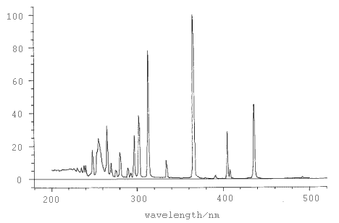
Figure 2. Emission spectrum for a medium pressure mercury lamp
As you can see from the above spectrum wavelengths as low as 200 nm are emitted by medium pressure lamps so various glassware filters such as Quartz, Vycor or Pyrex are commonly used to prevent high-energy short wavelength radiation from reaching the photochemical substrate and allow transmission of only specific regions of the mercury emission spectrum. This can allow greater control over which chromophores of the substrate are excited.
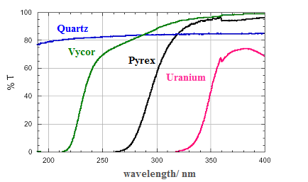
Figure 3. Wavelength transmissions in glass

Advantages
- Simple and quick to set up, reactions controlled by a flick of a switch
- Allows for reactions on a scale up to approx. 1mmol/100mL
- Variety of immersion well volumes available 100mL-1L
- Varying degrees of power available, we use 6W, 125W, 400W, 600W.

Disadvantages
- Lamps can very hot, you need to make sure there is continuous flow of cold water to cool them, we have a trip switch which automatically turns of the lamp if the water pressure drops.
- Because medium pressure lamps are broadband emitters irradiation can excite more than just the desired chromophore, often leading to unwanted secondary photoproducts and polymerisation, lowering yields and complicating purification.
- Batch reactors have limited application for large-scale photochemical synthesis as most of the photochemistry occurs within a short radius of the lamp.

To alleviate the limitation of scale associated with batch photochemistry our group has designed, constructed and implements a practical flow reactor for continuous organic photochemistry.

(2) Continuous Photochemical Flow Reactor

We have developed a novel flow reactor consisting of coils of UV-transparent fluorinated ethylenepropylene (FEP) tubing wound round a traditional water-cooled immersion well. The reaction solution is driven around the reactor via a common HPLC pump and irradiation time is defined by the flow rate (Figure 4).
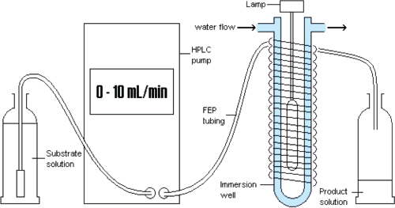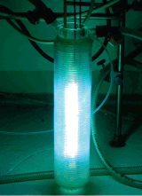

Figure 4. Schematic and photo of FEP continuous flow reaction

By tailoring the flow rate and the number of layers of coils wrapped around the immersion well, conditions can be optimised for each photoreaction. (For greater detail see Ref 4). We have demonstrated that large scale (~500 g) organic photochemical synthesis can be performed easily within a standard fumehood and hope this will stimulate chemists in industry and academe to consider continuous photochemistry as a viable method for the synthesis of complex organic molecules on scale.

Our flow reactor has proven to be an extremely useful tool in the total synthesis of a number of natural products, and we think that the simplicity of the reactor design should enable others to customise their own versions to best suit the UV source they utilise.

(3) Nd:YAG and Dye LASERS in Organic Photochemistry

Monochromatic irradiations are obtained using laser sources. In our group we use two different laser systems, both involving the coupling of Nd:YAG with Dye Lasers. These two different systems and their relative variable setups allow selective irradiations with a significant number of wavelengths.

Laser System 1 consists in a Nd:YAG Surelite laser which pumps a dye laser. Different setups can be used according to the experimental requests. Third (355 nm) and fourth (266 nm) armonic generation frequencies (setup 1a, Figure 5) can be used directly from the Nd:YAG laser using doubler or tripler frequency crystals. This setup does not require the use of the dye laser and higher power can be achieved (up to 700 mW). Different wavelengths can be obtained by pumping the dye laser (setup 1b, Figure 5) using the second armonic generation (532 nm). The efficiency of the frequency transformation using the dye is 25-30 % at the peak of emission of each dye. The dye used are generally Rhodamine B (emission peak at 596 nm), Rhodamine 6G (560 nm), DCM (630 nm), Styryl 8 (740 nm). A range of 30 nm around the peak of each dye can be used but the dye efficiency decreases significantly when a wavelength different from the main peak is selected. Wavelength selection for a specific dye is possible using manual or electronic tuning (Sirah Control software) of the grating system. The resultant emitted frequencies are doubled up using a KDP crystal which generate the corresponding UV frequencies (298, 280, 315, 370 nm respectively). Because the doubling and tripling crystals are not 100% efficient, generally the use of a Pellin-Broca prism follows, splitting in two different directions the non-transformed from the transformed beams. The UV beam is sent to the sample cuvette. Power obtained using this setup is strongly depending on which dye is used. Operative powers are in the range of 50-250 mW.

PMH
PM
CV
PBP
KDP
Dye Laser
PBP
Optics
Nd:YAG Laser (Surelite)
PC
Path 1
266 nm/355 nm (300-500 mW)
600 nm
532 nm
PMH
P
BD
Nd:YAG Laser power supply
532 nm
600 nm
Path 2

Figure 5. Schematic of Surelite Nd:YAG laser coupled with dye laser

Laser System 2 (Figure 6) consists in a Nd:YAG Powerlite II pumping a dye laser. The second (532 nm) and the third (355 nm) armonic generation frequencies are obtained from the Nd:YAG laser with a power of 20 W and 4.5 W respectively. The 532 nm beam is sent to the dye laser containing Rhodamine B, (output at 598 nm). The 598 nm beam is mixed with the 355 beam through a mixing frequencies BBO crystal, from which there is an output of 222 nm with a power of 80-130 mW.

Figure 6. Schematic of Powerlite II Nd:YAG laser coupled with dye laser
Dye Laser
Nd:YAG Laser power supply
BBO
Nd:YAG Laser
(Powerlite II)
1064 nm
CV
PMH
355 nm
(4 W)
532 nm
(20 W)
596 nm
222 nm
(80-130 mW)
PC
PM
optics
355 crystal

In both systems, beam power is measured before, during (transmittance) and after the reaction. Test reactions are usually performed in 3 mL quartz cuvettes (10-20 mM). Reaction solvents tend to be acetonitrile and dichloromethane, but also methanol, ethanol, water and hexane can be used. Big scale reactions are performed using 1-2 mmol of starting material dissolved in 25 mL of solvent in a 25 mL quartz cuvette. Reactions are followed by TLC and products are isolated with the standard methods of purification.
Monochromaticity also allows the possibility of carrying quantum yield studies without the use of actinometry. Laser irradiations are performed in 3 mL cuvettes using deuterated solvents. After an appropriate irradiation time, the reaction is stopped and the mixture is analyses by ¹H-NMR. From the mmols of product obtained and the mmols of photons used it is possible to determine the quantum yield at a specific wavelength.
Scattered light experiments are sometimes required. In this case a diffuser is put in front of the same cuvette.

Advantages
Monochromaticity: irradiation are performed using one wavelength at time;
High power: very high intensity in the area unit;
Tuneability: possibility to use a significant number of different wavelength in the range 222-532 nm;
Useful for mechanistic investigations.

Disadvantages
Small scale reactions: not applicable for synthetic approaches.

Experimental Organic Chemistry, Standard and Microscale, 2nd ed.; Harwood, L. M., Moody, C. J., Percy, J. M., Eds.; Blackwell Science Ltd.: Cambridge, MA, 1999; p 61.
www.alibaba.com/.../Photochemical_Reactor.html
<http://www.uv-light.co.uk/images/applications/disinfection/figure8.gif>
Booker-Milburn, K. I. et. al. J. Org. Chem. 2005, 70, 7558.

