**Electrostatic spray deposition apparatus:**

Standard Operating Procedure

School of Chemistry, University of Bristol

Last changed: 6/06/2019

1. **Summary of technique and equipment**

This document outlines the procedure for spraying colloidal suspensions of nanoparticles and other solids onto a range of substrates. The setup consists of a sealed/insulating box in which is located an Earthed substrate-mount with the option of spinning the substrate on a motor for better coverage of large areas. Adjacent to the substrate, a syringe with a metal needle enters the box as it turns through 90°. The tip of the metal syringe is connected to a high-voltage power supply. The high voltage pulls the colloid through the syringe and ionizes the droplets as they emerge from the tip. The ionized droplets repel each other and the solvent evaporates in flight depositing a fine layer of particles onto the substrate. The properties of the colloidal suspension are important to allow complete evaporation of the dispersion medium between the nozzle and the substrate surface.

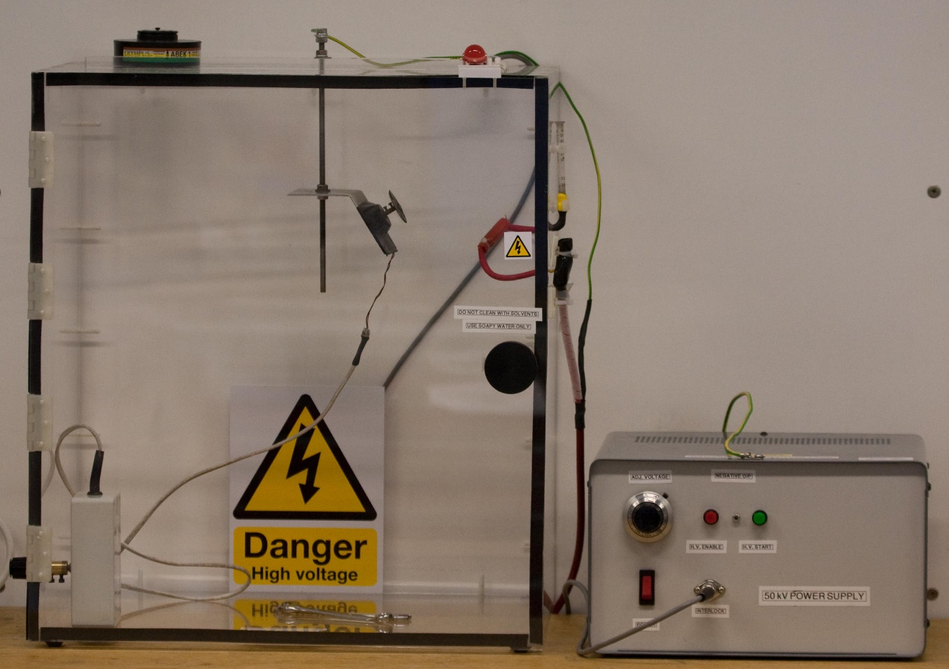

1. **Detailed procedure for safe use**
2. Ensure substrate is well cleaned and de-greased in acetone/acid wash.
3. Check voltage supply is off and apparatus is Earthed (this can be done by filling the syringe with methanol and observing the solvent dripping down the syringe needle inside the box: indicating that no voltage is applied).
4. Clean syringe and needle with methanol (if necessary flush through by removing from position).
5. Stick the substrate onto the mount using conductive carbon sticking pads, making sure that the pads are strong enough to hold the sample depending on its weight. Ensure large substrates are located centrally.
6. Clamp mount into optimized position within box (optimization is crucial for homogeneous application onto large substrates and involves adjusting:
   1. mount position up/down on threaded bar within box
   2. mount position left/right on clamp within box
   3. mount position by changing to one of three positions on top of box
   4. syringe needle angle (depends mainly on viscosity of colloid).
7. Start substrate rotation on control box.
8. Fill syringe with colloid solution (generally in methanol).
9. Apply high voltage (between 35 and 50 kV) by switching on power supply, dialling in the required voltage (the dial reads “double” the real value, *i.e*. 70 = 35 kV, 20 = 10 kV), and pressing the red and green switches to apply the voltage.
10. The suspension should now be pulled through the syringe and some arcing may be observed inside the box. While the voltage is applied the syringe, wiring and entire box should not be touched due to the build up of charge.
11. Once all the suspension has been pulled through, leave for another minute to allow any residue in the syringe to evaporate.
12. Turn off voltage supply by pressing the green and red switches. Return dial to zero and switch off power.
13. Check voltage is off by placing methanol in syringe and allowing solvent to drip down inside box (this will also clean the needle).
14. Open box and remove mount and substrate.
15. Clean syringe, mount and box thoroughly after use.
16. **Risk assessment: High Voltages & airborne solvents/nanoparticles**

The full official Risk Assessment form for this apparatus is available as a separate document on the Diamond group website. Below are just some procedures to minimise risk.

By far the largest risk with this apparatus comes from the very high voltages placed on the syringe needle resulting in a risk of electrical shock from the entire experiment once the voltage is applied. Risks have been minimised by ensuring that the box is insulating (made from wood) and Earthed. But build up of static can still occur on the surface of the box when the high voltage is switched on. Therefore, it is recommended that the box (or any surrounding area) should not be touched after the voltage is switched on. It has been observed that possible arcing could occur if anything comes within ~5 cm of the syringe. So this should be avoided. Other apparatus should be kept at a safe distance from the electrospray box to reduce the risk of arcing.

If unsure about the applied voltage, filling the syringe with methanol should show if the potential is present – it is safe to touch if the solvent drips out of the syringe nozzle under gravity.

A secondary risk comes from formation of aerosols containing colloidal particles or solvent droplets. The possible inhalation of these airborne nanoparticles as well as the evaporated solvent may be harmful to the lungs and respiratory system – although the exact biological effects of diamond nanoparticles are not fully known. These risks can be minimised by running the apparatus in a fume hood to extract the air from the box when in use. This is mandatory for more harmful liquids such as THF and chloroform. It is recommended that, after use, the box be left for 10 mins in the fume cupboard with the door open to allow any aerosol particles to be extracted safely, before the sample is removed. When removing the substrate, care should be taken to avoid directly inhaling the air inside the box.

All power supplies should be switched off from the mains plug when not in use.

*PWM June 2019*