Standard Operating Procedure

## Edwards Evaporator (E306A)

**This equipment must only be used by trained personnel.** If you need training to use this equipment, please contact James Smith (james.smith@bristol.ac.uk). This document should be read and used in conjunction with the system Risk Assessment, with this page providing a simple SOP and the full SOP on the later pages for additional details. Note: due to the slight risk of implosion with the glass bell-jar, safety glasses must be worn at all times when the evaporator is under reduced pressure.

## Switching samples

(The reactor should have been left clean and under high vacuum, with all filaments and samples removed, and the power supply must be OFF and read zero before starting.)

1. Return chamber to atmospheric pressure:
   1. Turn off Penning gauge on the gauge controller – gauge 1, labelled “AIMX”, button as shown in figure 1.
   2. Rotate exhaust handle anti-clockwise 225°, then push handle in and rotate another 45°, so handle points straight down to isolate pumps.
   3. Depress white “Air Admit” button to bring up to atmospheric pressure.
2. Remove plastic shield and bell jar – wear “rigger” gloves when doing this. Twist the bell jar slightly to help loosen the seal.
   1. Once removed, rest the bell jar on its side on the rack.
   2. Check for damage to the bell jar – report any damage to James Smith before use.
   3. The bell jar can now be cleaned with paper towels and ethanol. If this is insufficient to clean the bell-jar, contact James Smith for alternative methods.
   4. When bell-jar is clean and dry, spray the inside with Bell-Brite.
3. Load filaments/boats/other sources onto the holder posts – disposable gloves should be worn.
   1. If evaporating two metals, the aluminium barrier should be fitted to prevent contamination.
4. Place samples on the stage – where possible, avoid placing samples directly under filaments, and ensure the samples are the same distance from the filament as the thickness monitor is.
5. Replace bell jar, ensuring the rubber seal remains attached, then replace plastic shield.
6. Reduce pressure in the chamber to operating pressure (10-6 mbar):
   1. Press white “Air Admit” button (lifts to “up” position and light should go off).
   2. Rotate exhaust handle anti-clockwise 90° to “roughing”.
   3. Once low vacuum gauge – gauge 2 – reads 6.0 × 10-2 mbar or below, rotate exhaust handle clockwise 135°, press the handle in and rotate a further 225°.
   4. Turn on Penning gauge – see step 1a. for method. Base pressure should be on the order of 10-6 mbar and should be reached after approx. 2 hours.

## Running evaporator

1. Turn on the thickness monitor, set the density of metal being evaporated on the thickness monitor, and then press “Zero” on the monitor to zero it.
2. If using the heated stage, turn on, set to desired temperature and allow it to stabilise to that temperature. For desorption of water, set to 250°C for one hour before evaporation coating.
3. Select which holder you want to power (LT selector: 1 for left hand holder, 2 for right hand).
4. Press “reset” then “LT” buttons on the power control panel.
5. Slowly increase the power using the power control knob to increase the current, allowing time for the source to heat before increasing the current further. The rate and quantity of metal deposited on the samples can be seen on the thickness monitor.
6. Once the desired metal thickness is reached, press “trip” button, then reduce power to zero and press “LT” button. Return to step 1.

# Full SOP

1 – The chamber needs to be brought up to atmospheric pressure. Firstly, turn off the Penning (High vacuum) gauge by pressing the on/off button (figure 1) on the gauge controller. The gauge must be left OFF until the system is back under high vacuum. Next, rotate the main control valve anti-clockwise. While rotating the valve you should be able to see the vacuum baffle located under the sample stage close (about ½ turn), at this point the valve will click and require another ¼ turn so the valve position points straight down (6 o’clock). At this point the chamber is isolated from the vacuum system. To quickly bring the chamber up to atmospheric pressure press the white “Air Admit” button on the top of the control panel. The chamber will quickly rise to atmospheric pressure. To carefully increase the pressure in the chamber slowly turn the gas admit valve just below the front of the chamber. This is particularly useful if the samples are small or are thin films.

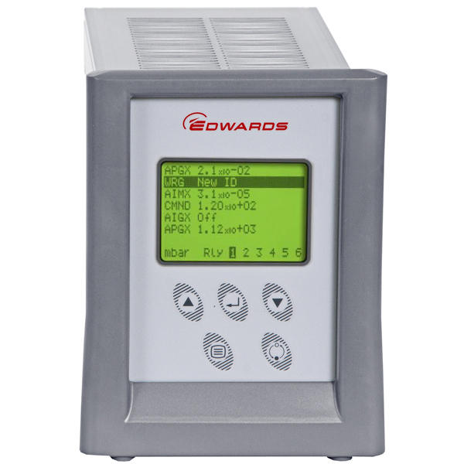

Figure 1: On/off button for the gauge controller.

2 – Once the chamber is at atmospheric pressure the Bell Jar can be removed. First remove the clear plastic shield from the chamber. This must be in place whenever the chamber is under vacuum (low or high vacuum). Wearing protective “Rigger” gloves, carefully remove the glass Bell Jar. The dome can sometimes be difficult to remove as the rubber seal can stick onto the metal baseplate. Do not tap or try to force the dome as once the dome becomes free it may hit one of the internal posts and shatter. The easiest way to free the dome seems to be by carefully twisting the chamber until it is free then lifting it straight up avoiding the internal posts. The dome is heavy, if you need help lifting ask someone in the lab. The dome should be rested on its side on the rack. The dome should be cleaned and inspected for damage every time it is removed. If any damage is found, the dome must not be used. Report any damage. The dome can be cleaned with a dry paper towel, small amounts of ethanol may be used if the evaporated metal is not easily removed. Bell-Brite or other approved evaporation spray films must be applied to the inside of the dome prior to replacing the dome back onto the system. Care should be taken not to inhale the mist from the spray.

3 – Filaments, boats or other evaporation sources can now be fitted onto the system. Wearing disposable gloves locate and tighten the source onto the holder posts. If using a filament, the evaporation source metal wire should be cut into small sections and wound onto the filament. If using a boat, the evaporation metal pellets should now be loaded in. The samples that require coating can now be loaded onto the sample stage. If possible, it is best to avoid placing samples directly under the filament as some evaporation source material may melt and fall onto the sample. Also ensure that the samples are placed approximately the same distance from the filaments as the thickness monitor is, as this will allow more a more accurate thickness reading. If evaporating two metals, then fit the aluminium barrier to prevent cross-contamination of the filaments.

4 – The thickness monitor should now be checked. Switch on the thickness monitor, it will take a few seconds to run a test sequence. If the display then reads a number (typically 0.0) the monitor is working OK, proceed to step 5. If, the monitor displays FAIL the thickness monitor head will need be checked.

5 – When the samples and evaporation sources have been loaded the Bell Jar can now be returned to the system. Carefully lift the dome onto the system, making sure that the rubber seal stays attached and no wires are trapped under the dome. Replace the plastic shield.

6 – Ensure the “Air Admit” button is not depressed and the gas admit valve is fully closed. Turn the main vacuum valve from closed (6 o’clock) anticlockwise to point at “Roughing”. The chamber is then exposed to the roughing (Rotary) pump. On the gauge control panel, the pressure of the chamber should gradually reduced until it reads below 6.0 × 10-2 Bar. If the chamber does not reach this level of vacuum, rotate the vacuum valve clockwise back to the 6 o’clock position and go back to step one to remove and replace the dome. Check the rubber seal on the dome. If problems persist very small amounts of Fomblin vacuum grease can be used on the rubber seal. Once the vacuum is below 6.0 × 10-2 Bar the main vacuum valve can be rotated clockwise from its 3 o’clock “Roughing” position approx. 360° to the backing position. When going past the 9 o’clock position the valve will click outwards, do not force the handle. Between the 9 o’clock and 2 o’clock position the baffle under the sample plate will rise. The chamber is now open to the complete vacuum system and will now go down to high vacuum. The Penning high vacuum gauge can now be turned back on. The chamber should eventually reach 10-6 Bar within 2 hours, if it doesn’t reach this level of vacuum after 3 hours, report this and do not continue until this is resolved.

7 – Once the chamber has reached base pressure set the density on thickness monitor for the metal to be evaporated. Press the density button to display the set value and adjust with the up and down key while holding the density button. Lists of the densities of various metals are displayed in the front of the logbook or on the evaporation sources poster near the equipment. Zero the thickness monitor, the display should read a stable 0.0 value. Press the “Reset” button on the main control panel and then the “LT” button. This switches on the filament power supply. Slowly turn the “Power Control” knob from zero clockwise to increase the current. Increase the power in small steps and allow the evaporation source to heat up before increasing the current further. The required current input will depend on the temperature required to evaporate the metal. The metal should start evaporating as it reaches temperature, the thickness monitor will register the metal layer thickness and, as the metal evaporates onto the bell-jar, the dome will become coated in the metal and appear opaque.

8 – Once the required metal thickness is achieved reduce the power down to zero and press the “Trip” button. Note it is best to have the rate of evaporation slow if you wish to deposit a well-defined thickness layer. Turn off the Penning gauge. Turn the main valve anti-clockwise from 2 o’clock all the way to 6 o’clock, the baffle should close, the final position will isolate the chamber from the pumping system. Depending on the sample you can either depress the “Air Admit” button, which will introduce air into the chamber quickly, or slowly open the gas inlet valve on the front of the chamber until the dome is returned to atmospheric pressure. The former is a slower but much more controlled way to introduce air into the system and should be used if the samples are thin and fragile. Once the chamber is at atmospheric pressure the protective shield and the glass dome may be removed. The samples and evaporation sources can now also be removed, gloves should be worn. This should be done with care as all parts into the system will remain hot for some time.

9 – After use the inside of the chamber and bell jar should be wiped clean of any evaporated metal. The inside of the ball jar can be cleaned with small amounts of acetone if required, care must be taken to not allow the rubber seal to get in contact with any organic solvent. The system should be left under high vacuum when not in use and should not contain any samples or evaporation sources.

Notes:

1. For desorption of water vapour from the sample surface, the heated stage should be turned to 250°C for 1 hour. Do not leave unattended for extended periods. Cooling after evaporation takes a long time under vacuum, so it is recommended to be cautious removing samples after using the heated stage; when possible, leave the system overnight to cool before returning to atmosphere and removing samples. When cooling, set the Eurotherm to room temperature, as this ensures a temperature reading is always visible.
2. If using a mask, shadowing can occur if the angle of incidence from the filament is too large. To avoid this, position the filaments as high up and central as possible – this may require changing the arms and arm heights.
3. If it looks like a piece of metal may fall from the filaments, try to only increase the temperature gently. This allows for more wetting to occur and, when done correctly, will draw the metal back onto the filament. Faster rate of increase increases the likelihood of the metal falling off.
4. Tungsten filaments alloy with several metals, most notably aluminium. As such, over time, the filament will become brittle. Checking the filament carefully for cracks before loading can help avoid having the filament snap during deposition.