**Terminator SOP**



**Inserting Samples**

* Close ‘gas inlet’ pneumatic valve;
* Press trip/reset, check that voltage is set to 0, HV button is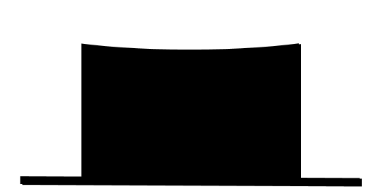, not ;
* Close the large pump valve and open the air inlet;
* Once the chamber is at atmospheric (hissing has stopped), gently open the lid, taking care with the glass disc;
* Place the samples in the middle of the anode, gently close the lid, close the air inlet, and open the large pump valve completely;
* Wait for pressure to drop below 1x10-2 torr;

**Generating Plasma**

* Open the ‘gas inlet’ pneumatic valve and wait for pressure to stabilise (<1x10-2 torr);
* Switch to the correct MFC, value should be close to 0, open the wall valve for the relevant gas, the MFC should stabilise at 10 after a few seconds;

**DO NOT OPEN OXYGEN AND HYDROGEN TOGETHER**

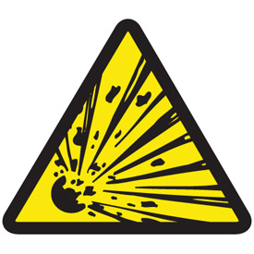**EXPLOSIVE DANGER!!!**

* Close pneumatic valves for gases not being used;
* If using the heater, set temperature by holding * and using the arrows;
* Press the heater button to start the heater;
* Let gas flow through the chamber for 10 minutes;
* Using the small pump valve, adjust the pressure to 1 torr;
* Set the timer to the appropriate value (7 seconds for oxygen termination);
* Set voltage to desired level (usually 7), press the HV and the green start button;
* To start the plasma, press start on the timer, the plasma will automatically switch off at the end of the timer;

**Retrieving Samples**

* Press HV, press the red trip/reset button, and ensure voltage is set to 0;
* If heater was used, press heater button to switch off, wait for sample to cool down;
* Close the wall valve of the gas you were using, close the ‘gas inlet’ pneumatic valve, open the small pump valve completely;
* Wait for pressure to drop below 1x10-2 torr;
* Close the large pump valve and open the air inlet;
* Once the chamber is at atmospheric (hissing has stopped), gently open the lid, taking care with the glass disc;
* Retrieve your samples, gently close the lid, close the air inlet, and open the large pump valve completely;
* Open all pneumatic valves;

