**Standard Operating procedure for the Thomas Swan machine**

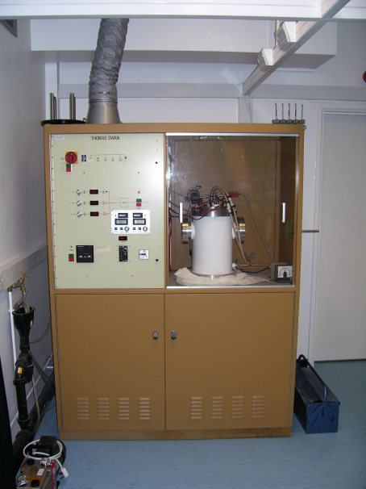

PWM, JNH 21/09/2010

The Thomas Swan hot filament Chemical Vapour Deposition (HF-CVD) reactor can deposit diamond onto either diamond fibres or tungsten carbide cutting tools, depending on which type of carousel is loaded. Typical growing conditions are as follows:

Figure 1

The Thomas Swan reactor

* 1% CH4 in H2
* 20 Torr
* 65 – 70 hours
* 500 W on each filament

The Thomas Swan reactor houses two carousels, each consisting of a central filament (0.5 mm diameter tungsten wire) which held under tension by a spring.

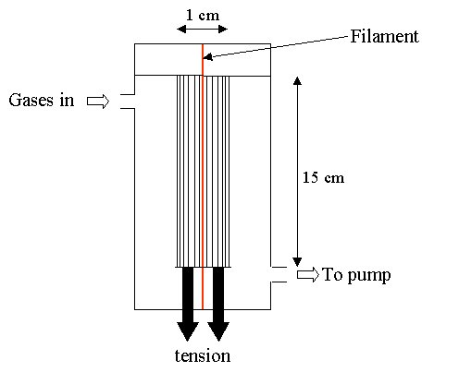

There are two types of carousel.

**Wire carousel**: The first type of carousel is for coating wires, and each houses ~20 tungsten wires (50-100 m diameter) which are threaded (sewn) through holes in the support and held in a spring-loaded clamp. Figure 2 is a schematic diagram showing one of these carousels. The filaments (red) and the substrate wires are under tension to ensure that they are kept straight and a constant distance apart (5 mm) during growth.

Figure 2 – wire carousel

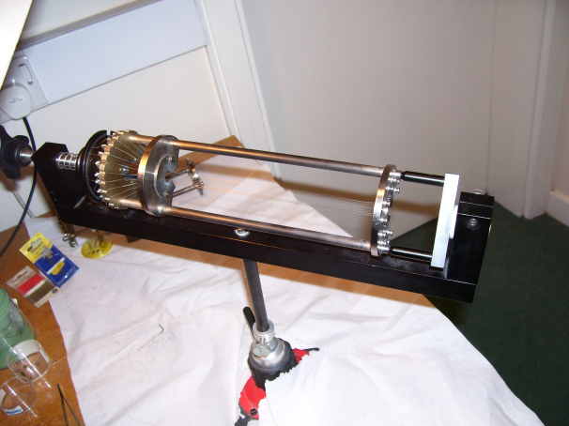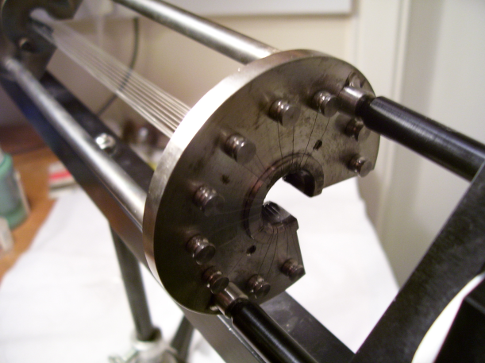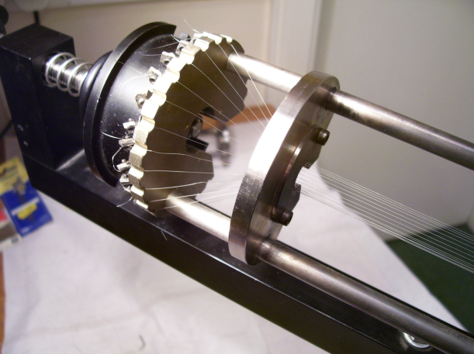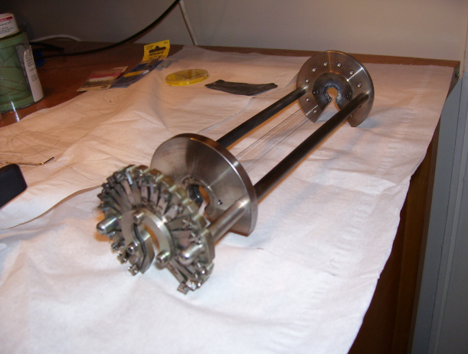

Figure 3 – photos of the wire carousel loaded with W wires

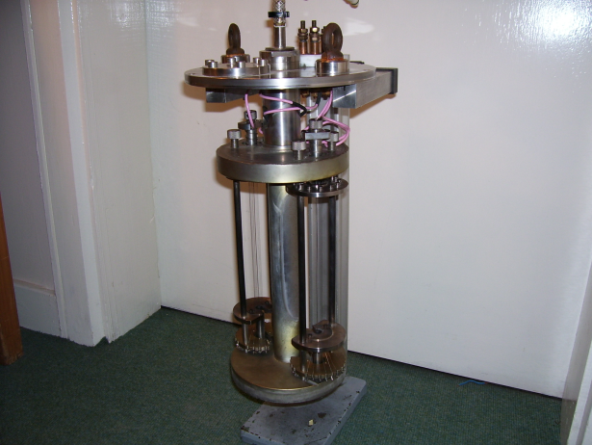

**Cutting Tool Carousel**: The second type of carousel houses about 10 tungsten carbide cutting tools. Each of these tools is clamped into place using a screw holder, and can be positioned and angled so as to allow the front surface (the cutting face) to be ~5 mm from the filament.

Each filament has 500 W of a.c. current passing through for the duration of the process. These growing conditions produce excellent quality diamond fibres at a rate of growth of approximately 0.5 m per hour.

**Standard Operating Procedure**

Opening reactor chamber:

Open lower cabinet door and close vacuum pump valve. Close cabinet door.

Slowly turn handle on the side of the reactor from “Vacuum” to “Close”, then to “Atmosphere”. Pressure (on readout on front panel of reactor cabinet, **9** in Figure 1) should gradually increase until atmospheric pressure (760 torr) is reached.

Remove transparent panel in front of reactor chamber.

Disconnect filament wires and water hose from the reactor chamber. Undo the bolts (with Allen key) and raise the reactor lid using the winch. The lid is very heavy and, when raised by the rope, tends to spin around and catch on the rim of the reactor, so the lid should be guided by hand as it is raised.

Loading samples and evacuating reactor chamber:

Remove used filament and insert new tungsten filament. Clamp filament firmly at the bottom, push top clamp down as far as possible, release slightly and close clamp. The wire should be pulled taut. Cut off excess wire at both the top and bottom clamp.

Load samples.

Lower the reactor lid carefully. The lid is very heavy and, when attached to the rope, tends to spin around and catch on the rim of the reactor. The lid should be guided by hand and lowered slowly into place. When lid is in place on the reactor chamber, ensure that the interlock has been activated (*i*.*e*. red light for “Reactor Chamber” interlock is on, **2** in Figure 1).

Insert bolts around rim of reactor chamber and tighten firmly with Allen key.

Connect filament wires and check electrical connection.

Connect water hose.

Replace transparent panel in front of reactor chamber.

Open lower cabinet door and open vacuum pump valve.

Close cabinet door, ensuring that the interlock is activated (*i*.*e*. red light for “Cabinet doors” interlock is on, **2** in Figure 1).

Ensure that red light is on to indicate that the vacuum pump is running. If not, press the green button labeled “Vacuum pump” (**11** in Figure 1).

Slowly turn the handle on the side of the reactor cabinet from “Close” to “Vacuum” so that the pressure gradually reduces. After several hours, the pressure readout on the front panel of the reactor cabinet (**9** in Figure 1) should go down to 1 torr and pressure gauge reading should reach ~ 8 × 10-2 torr.

Once the pressure falls below ~ 60 torr, the interlock for “Pressure” will be activated (*i*.*e*. red light for interlock will turn on, **2** in Figure 1). When this happens, reset interlocks by pressing reset button (**3** in Figure 1, red lights should change to green) and press the green button under the System Power switch (**1** in Figure 1); this will close the argon valve (*i*.*e*. green light for argon valve will turn off).

Running reactor:

Check that there is a sufficient supply of hydrogen for the run.

Open lower cabinet door and close vacuum pump valve.

Close cabinet door, ensuring that interlock is activated (*i*.*e*. red light for “Cabinet doors” interlock is on, **2** in Figure 1).

Turn on water flow until pressure is high enough to activate the interlock (*e*.*g*. red light for “Water Flow” interlock is on, **2** in Figure 1) then continue to increase water pressure a bit further (so that fluctuations in water pressure do not trip the interlock).

Reset interlocks by pressing reset button (**3** in Figure 1, red lights should change to green) and press the green button under the System Power switch (**1** in Figure 1); this will close the argon valve (*i*.*e*. green light for argon valve will turn off). All interlocks should now have a green light.

Open H2, CH4 and argon gas lines on the wall behind the reactor. Set methane and hydrogen gas flows (on the front panel of the reactor, **4** in Figure 1) to required values and set argon flow to > 0.

Open hydrogen and methane gas valves on front panel of reactor cabinet (**6** in Figure 1). This can sometimes trip the interlocks; generally, waiting several minutes after opening the first valve solves the problem. If the interlocks are tripped, press reset (**3** in Figure 1, red lights should change to green) and then press the green button under the System Power switch (**1** in Figure 1) to close the argon valve (*i*.*e*. green light for argon valve will turn off). Try again to open the gas valves.

Set pressure by turning dial on panel below pressure readout on front of reactor cabinet (**10** in Figure 1). A pressure setting of ~ 18 torr usually achieves an actual pressure of 20 torr, but this will need to be adjusted until a stable pressure is achieved.

Turn on “Reactor Heater” (by pressing the green button, **7** in Figure 1); the red light should turn on to indicate that the reactor heater is on. Switch required filament control panel(s) from “Shutdown” to “On” (**8a** in Figure 1). Reset filament timer if necessary. Ensure both lights (“Trip Reset” and “Standby Active”) at the bottom of the control panel are green; if not, press gently to reset.

Slowly turn up filament power (by turning dial labeled “Set Power” on filament control panel, **8b** in Figure 1) to 500.

Shutting down the reactor:

Close methane gas valve (**6** in Figure 1) and wait ~ 5 minutes.

Slowly turn down filament power to zero (**8b** in Figure 1). Switch filament control panel to “Shutdown” (**8a** in Figure 1) and turn off “Reactor Heater” (by pressing red button, **7** in Figure 1).

Close hydrogen gas valve (**6** in Figure 1), set argon flow to zero (**4** in Figure 1) and close all gas lines on the wall behind the reactor.

Set pressure to zero (**10** in Figure 1). Open lower cabinet door and open vacuum pump valve. Close cabinet door, ensuring that interlock is activated (*i*.*e*. red light for “Cabinet doors” interlock is on), reset interlocks (**3** in Figure 1, red lights should change to green) and then press the green button under the System Power switch (**1** in Figure 1) to close the argon valve (*i*.*e*. green light for argon valve will turn off). Wait several hours to pump out gases. After ~ 1 hour, turn off water flow.

Removing samples from the reactor:

Open lower cabinet door and close vacuum pump valve. Close cabinet door.

Slowly turn handle on side of reactor from “Vacuum” to “Close”, then to “Atmosphere”. Pressure (as seen on readout on front panel of reactor cabinet, **9** in Figure 1) should gradually increase until atmospheric pressure is reached.

Remove transparent panel in front of reactor chamber.

Disconnect filament wires and water hose from the reactor chamber. Undo the bolts and raise the reactor lid. The lid is very heavy and, when raised by the rope, tends to spin around and catch on the rim of the reactor, so the lid should be guided by hand as it is raised.

Remove samples and filament, close reactor chamber and pump down to vacuum (as described above).

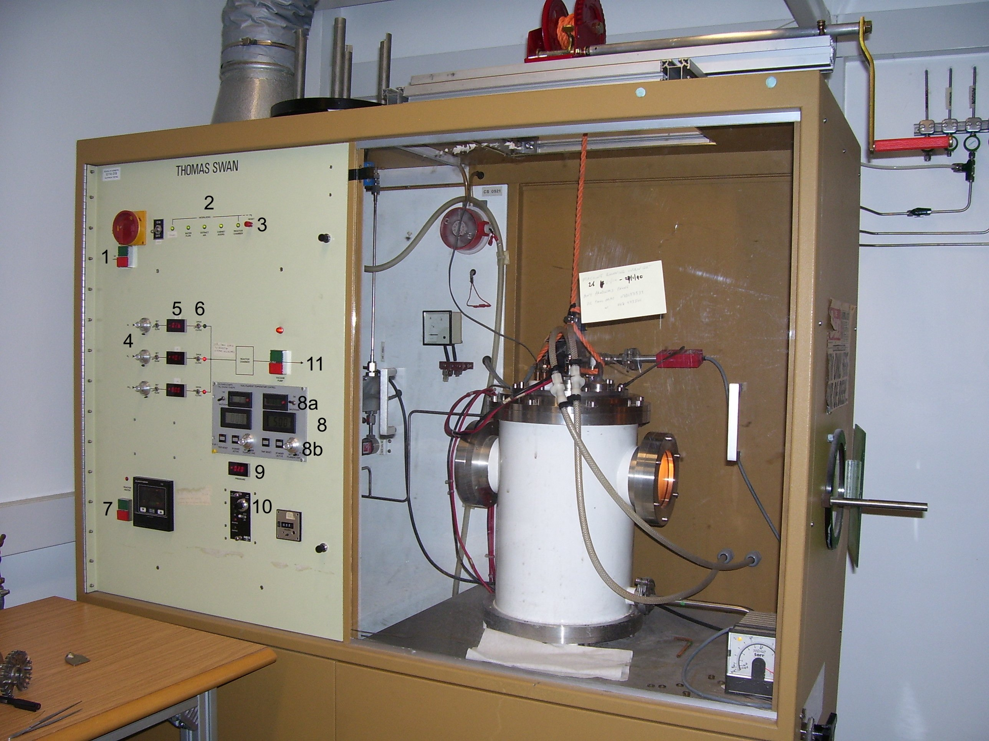

Figure 1: Reactor cabinet; **1**: system power switch; **2**: interlock status indicator lights (green – active, red – ready but needs to be reset; off – inactive, reactor cannot be started); **3**: interlock reset switch; **4**: dials for setting gas flows; **5**: gas flow readouts; **6**: gas valves; **7**: reactor heater switch (with status indicator light above); **8**: filament control panel; **8a**: filament switch (with filament timer adjacent); **8b**: filament power dial; **9**: chamber pressure readout; **10**: dial for setting chamber pressure; **11**: vacuum pump switch (with status indicator light above).