Chemistry 1S - Dr Paul May

Calculus Question for January Exam 2007

1. Consider the function: y(x) = (x + 2)³

(a) Differentiate this function (without multiplying out the brackets)
(3 marks)

(b) Multiply out the brackets in y(x), and then differentiate the new expression. Compare the result with that obtained in part (a).
(6 marks)

(c) Determine the co-ordinates (x,y) of the stationary point(s).
(6 marks)

(d) Do the stationary point(s) correspond to local maxima, minima, or point(s) of inflection?
(5 Marks)

(e) Hence sketch this function between x = -4 and x = +1.
(5 marks)

(f) What is the area under this function between x = 0 and x = 2?
(5 Marks)
Answers

3)
a) Using Func. Of Func. Rule, dy/dx = 3(x + 2)².(1) = 3(x + 2)²

(b) (x + 2)³ = x³ + 6x² + 12x + 8

So dy/dx = 3x² + 12x +12, which is the same as 3(x + 2)² in (a).

(c) At the t.p. dy/dx = 0, so 3(x + 2)² = 0, so there’s only 1 soln at x = -2.
Feeding x = -2 back into the original eqn, we get that the t.p is at: ( -2, 0)

(d) d²y/dx² = 6(x + 2), and at x = -2 this has a value of 0. So the t.p. is a point of inflection!
Checking the gradient either side of the t.p.: at x = -3, dy/dx = +3, so it’s increasing.
At x = -1, dy/dx = +3, so it’s increasing too.

(e) When x is very large and +ve, y is v. large and +ve. When x is large and –ve, y is large and –ve. When x = -2, y = 0, and this is the t.p. When x = 0, the intercept y = 8.
(The curve must be the right shape, the axes must be labelled, and the t.p. and y intercept must also be labelled to get the full 10 marks.)

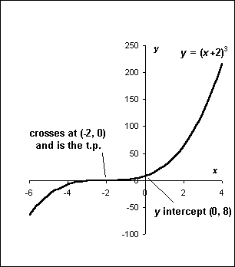

(f) $\text{Area}=\int_{0}^{2}{x^{3}+6x^{2}+\text{12}x+8\text{.}\text{dx} =} {\left[\frac{x^{4}}{4}+\frac{6x^{3}}{3}+\frac{\text{12}x^{2}}{2}+8x\right]}_{0}^{2}$
= (4+16+24+16) – (0)
Area = 60 sq. units.

