SCHOOL OF CHEMISTRY

CHEMISTRY 1S

Calculus I - Dr Paul May

Answers to Problems 1

1. (a) 5x4 (b) 4x (c) 21x2

(d) 2x3 (e) 1½x5 (f) 3400x33

(g) 43.8x² (h) 1.16x^{22.2} (i) 2×10⁴x³

2. Emphasise that we don’t always use x and y, other symbols, even strange, unfamiliar ones may be used in Chemistry...

(a) 6p² (b) 15 (c) 20h³

(d) 120z⁷ (e) 9x² (f) 4½λ⁵

(g) 36ξ¹⁷ (h) 1½² (g) 63☹²

3. Tutors should run through basic curve sketching ideas, such as trying simple values (0, ±1, ±∞, etc) to get an overall idea of the shape of the curve. Emphasise that a sketch does not involve a detailed plot.

(a) The 50 multiplier to the x² means the curve will be very steep. It is a +ve number so the parabola will be U-shaped, and it will be symmetrical about the y-axis because there’s no term in x. It will cross the y-axis at +2.

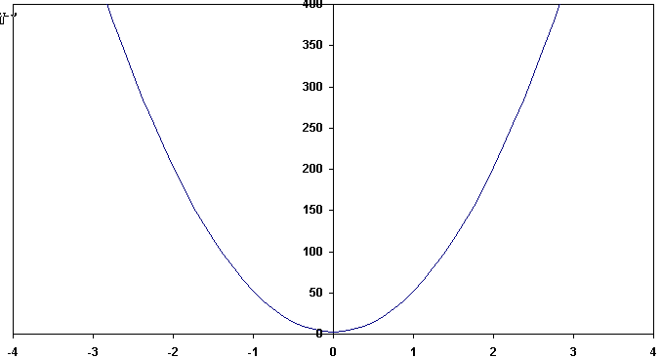

(b) The +0.1 multiplier makes it a very shallow U-shaped parabola, crossing the y-axis at -1000.

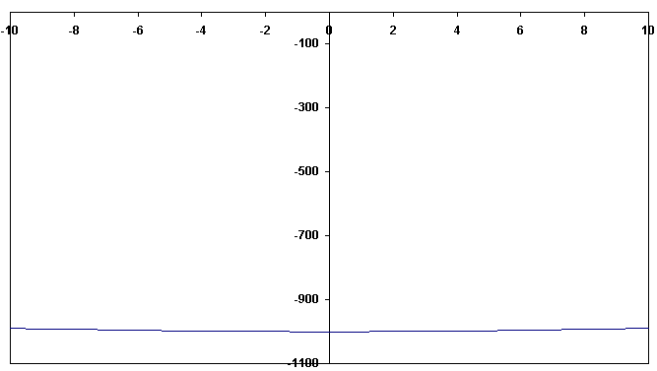

(c) The +2 multiplier makes it a sharpish U-shaped parabola, symmetric about the y-axis and crossing it at 0.0001.

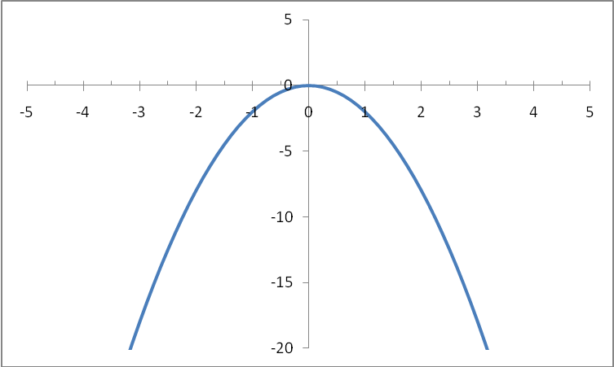

(d) Since it’s a +ve x² function with no x terms, it will be symmetric about the y-axis, and will always have +ve values (since there’s no constant). For x = ± large numbers, y will become very small, close to zero. For x = ±1, y = +1.
For x = ± numbers between 0 and 1, y will become very large, reaching infinity at x = 0.

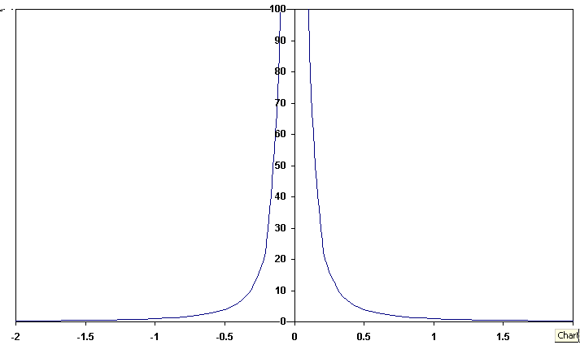

(e) Same as (d) above, except that the whole curve shifts up by +6 due to the constant.

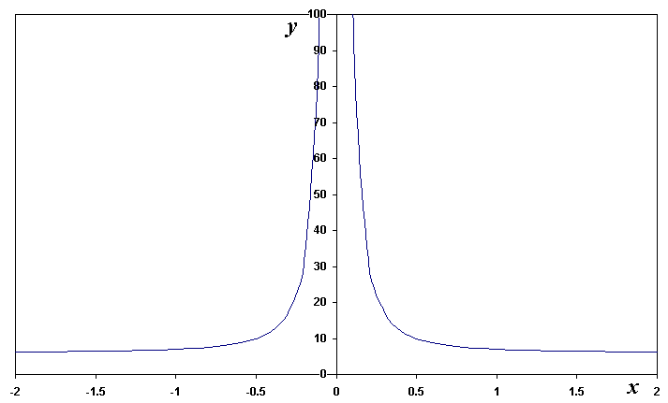

(f) Same as (e) except the graph is –ve this time, and 3 times more rapid.

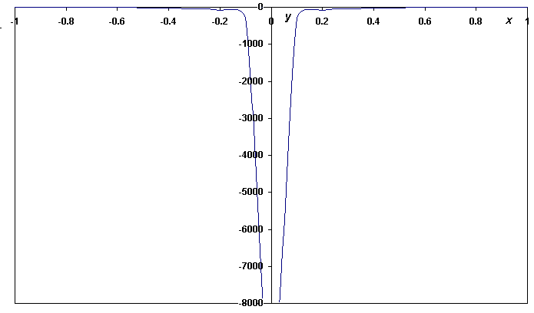

4. (a)
x | y = x3 - 2x + 1
-2 | -3
-1.5 | 0.625
-1 | 2
-0.5 | 1.875
0 | 1
0.5 | 0.125
1 | 0
1.5 | 1.375
2 | 5

For small values of x the leading term after the constant 1 is -2x. This has a negative multiplier, so the line passes through (x,y) = (0,1) with a negative slope. For large values of x the leading term is now x3 which is large and positive for positive large x; and is large and negative for large negative x. This explains the overall shape of the curve.

(b)

ω
7 | 0.5
9 | 1.25
10 | 2
11 | 2.5
12 | 2
13 | 1.25
15 | 0.5

Note: this curve is symmetrical about the line ω = 11. This is because the denominator can be written as [(ω-11)2 + 4], and is thus the sum of two squares.

5. (a)

Since y is the product of three factors it will take the value zero when any one of the factors is itself zero. This will occur for x = 2, x = 3, and x = 4. Furthermore, if x ≥ 4 all three factors will be positive and thus y will be positive, and for x ≤ 2 all three factors will be negative and thus y will be negative. This is therefore another cubic equation with a shape very similar to that of 1(a).

(b)
The numerator is zero for x = 0, so that the curve passes through the origin (0,0). The denominator is the sum of the square of x and a positive number, and is therefore always positive. Thus y will be positive for positive x, and negative for negative x. Finally, for large positive or negative x the denominator will become much larger than the numerator, so that y will tend to zero.

