Nitrotoluene

Paul May (paul.may@bris.ac.uk)
School of Chemistry, University of Bristol, UK

Nitrotoluene is a very interesting molecule. Its chemical formula is C₆H₅NO₂, and it comes in 3 varieties, ortho, meta and para. They are labelled according to the position of the NO₂ group from the methyl group (see diagram).

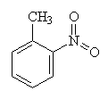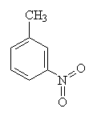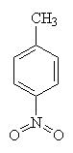
ortho meta para

This is a colour image of the structure.
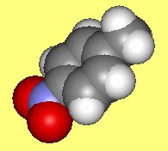

Click Here for next page.

