THE GUARDIAN.
RESPECTABLE TRADE OR ROGUES WAY OF LIFE.

Not long ago I went to Bristol, my objective was to decide if the slave trade was respectable.

WHERE I WENT.

We went to Bristol on the 22nd May. After a quick bus journey to Bristol we dismounted and the History and Geography students separated. Once located in Bristol we went to the industrial Museum to gather as much information about the slave trade that was humanly possible before lunch. This came from writing, pictures and a nice video about the middle passage. With plenty of information gathered we took a lunch break but I just wasn’t quick enough to get a bacon butty. After the hunger was banished we wet on a boat trip round the docks. With all this done it was back to base camp to write up what had been found out.

BRISTOL THE PAST.

Bristol was a trading city from 1300’s but really took off thanks to the Atlantic slave trade. To give you a clue as to how big the slave trade was in Bristol here is a quote by J.F. Nicholls. “There is not a brick in Bristol that was not cemented with the blood of a slave.” As you can gather the Slave trade was a profitable business. Below is a picture of the most common route a Slave trader would take.

Known as the triangular trade route (no points for guessing why). It would start with are merchant loading plenty of manufactured goods onto a boat. This would then sail to Africa were the goods were traded for slaves. The slaves themselves where usually prisoners of war although criminals could also be used. For example one criminal’s punishment was not only to be made a slave but also for his entire family to be made slaves. The second leg of the journey was known as the middle passage. On this part of the journey slaves are shipped from Africa to America and the West Indies. Here they are sold to the plantations and tobacco, cotton, sugar and other goods are bought and loaded onto the ship. The ship then sails to Britain sells its goods to the public. Bristol was well situated on the west coast of Britain. Not surprisingly Bristol became one of the biggest cities in Britain along with Liverpool and London. Of course the Slave Trade was abolished in 1807 and then Bristol started to decline. Also the coast of coming up the river Avon in the late 1800’s caused ships to go elsewhere. From then on despite a regeneration of the harbour in the 1990’s Bristol’s trading days were over.

SLAVERYS A GREAT THING, HONEST.

Now many believe that slavery had no good sides but a lot of people benefited from it. Just some of the people who benefited from the slave trade are:

- The Shipyard owners and workers who build the ships.
- Slave-ship owners. A ship could carry 700 slaves and make the owner £5000 a year.
- Industry as a whole gained as Slave Traders would invest money in many new and growing industries.
- Plantation owners benefited from the sale of their products.
- Banking gained as merchants wanted to know their considerable wealth was safe.
- Liverpool and Bristol owed their wealth to the slave trade plus London saw the construction of many new docks.

As you can see lots of people benefited from the slave trade. Even the Navy benefited as an extract from ‘Black Ivory’ written in 1971 explains. “Slaving vessels also provided a steady source of trained seamen who could be conscripted by the Royal Navy”. In fact a quote by Malachy Poslethwayt, an English economist sums up what I’ve been saying nicely. “The Negroe –Trade is a huge fund of wealth and power to Britain and is absolutely necessary for maintenance of are Empire and over commerce in the Indies”.

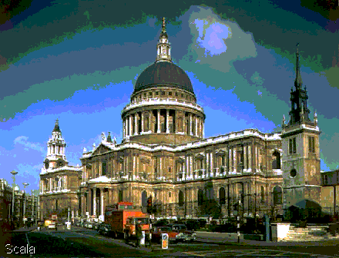

Of course there is still one question, did the slaves benefit at all? Well they may not have in the short term but in he long term they did gain. You see a quote from a Liverpool Corporation handbook written in 1957 says. “The transplanted slaves, whose descendants have, subsequently achieved in the New World, standards of education and civilization far ahead of their countrymen whom they left behind”. So there are the arguments for, now for the arguments against.

Slavery - The Bad Bits.

Probably one of the easiest thinks to argue against at this time is slavery. With all the acts of horrific cruelty and barbarism it appears down right savage to most people. The main problem with slavery was it violated are human rights. This was because slaves were viewed as sub-human and sometimes not human at all. A plantation owner called John Pinney shows the common belief of the time in part of a letter he wrote. “I was shock’d at the first appearance of human flesh for sale. But surely God ordained ‘em for the use and benefit of us”. As you can see blacks were viewed differently and that may explain a lot about how they were treated. The acts of cruelty started for the slaves when they bored the ship for the middle passage. This journey to America was probably the worst six weeks of their lives. One board the slaves were crammed below decks as the picture below shows you.

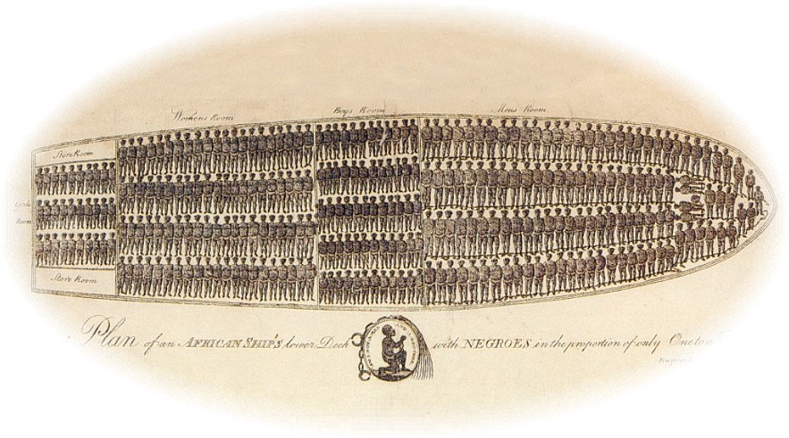

Below decks a slave could expect to have as little as 1.5 meters by 0.6 meters to move in and to be taken up on deck for exercise once a day. Some of the dreadful acts that went on at sea were:

- Being chained below decks.
- Being made to watch other slaves being wiped.
- Not being feed if they thought you wouldn’t survive the journey.
- Not being able to reach the loo.
- Being whipped for disobedient behaviour.
- Arms swelling from the ropes tightness.
- Being raped if you were a woman.

With conditions like these it’s not surprising many slaves jumped over board. There was one other problem and that was the temperature, below decks a thermometer could read 89 degrees Fahrenheit. Even after the journey the cruelty didn’t stop. Despite there being laws on the plantation to prohibit murder, mutilation, chaining and branding, acts of cruelty were still common. A quote I found at the Museum describes what happened to a slave who was caught running away. “Priscilla: for running away, both her ears cut off…. to recieve39 lashes the first Monday in each month for one year and to be worked in irons during this time”. As you can see the plantation owners dealt with their slaves viciously. Below is a picture of the type of irons Pricilla might have worn.

Another problem slaves faced was being understood. Many plantation owners who didn’t under stand their slaves thought they were being lazy and whipped them. Well that’s all the information now for my conclusion.

THE FINAL VERDICT.

So I’ve looked at all the information and now it’s time for me to state my views. Well personally I have decided that the Slave Trade was not a respectable trade. You see the reasons that lead me to this conclusion started with a simple saying that goes the results don’t justify the means. Sure millions of people benefited from the slave trade, but does that make the way these slaves are treated acceptable. These people were treated in ways that no human being should ever have to put up with. They were not and still aren’t different from us so why should they be treated second class. Slavery was not noble, or was it respectable. All that slavery did was destroy a nation and more importantly it destroyed a mans life and you have only one life on earth. One man, a potter called Josiah Wedgwood sent plagues around the world that said what every man had forgotten. The plagues had a black man on and said “Am I not a man or a brother?” I know it’s easy to look back and criticise what somebody did with the benefit of hindsight. But to see what they were doing they didn’t need hindsight; they needed common sense.

